.

FINAL PORTIFOLIO

The British College, Kathmandu

TEAM 2

TASTE BEST.COM

* Team Members

Bidya Joshi (C7202629)

Aditya Shah (C7202324)

Sabdika Ghimire (C7202623)

Ashish Pandey (C7202788)

Shivam Shah

Yogesh Bhattarai

Table of Contents Page No

1. 1.Initiation Phase 1

1.1 Team Contract……………………………………………………………… 1

1.2 Project Chater 6

1.2.1 Project Chater Version 1 6

1.2.2 Project Chater Version 2 8

1.3 Meeting Agenda 12

1. 2. Planning Phase 14

2.1 Belbin’s Analysis 14

2.1.1 Individual Belbin‘s Analysis 14

2.1.2 Team Belbin‘s Analysis 25

2.2 Skill Audit 27

2.2.1 Individual Skill Audit 27

2.2.2 Team Skill Audit 30

2.3 Project Management (MS Project)version1 32

2.3.1 Gantt Chart 33

2.3.2 Network Diagram 35

2.3.3 Timeline 39

2.3.4 Calendar **Error! Bookmark not defined.**

2.3.5 Resource Sheet 42

2.3.6 Project Task 43

2.3.7 Changing Working Time 44

2.4 Project Management ( MS Project) Version2………………………….........46

2.4.1 Calendar…………………………………………………………….......46

2.4.2 Changing Working Time……………………………………………….48

2.4.3 Gantt Chart……………………………………………………..............49

2.4.4 Network Diagram………………………………………………………50

2.4.5 Resource Sheet……………………………………………………....54

2.4.6 Task Sheet……………………………………………………………..55

2.4.7 Timeline…………………………………………………………………………….57

2.4 Communication and Collaboration Tools 46

1. 1. Execution Phase 46

3.1 Entity Relationship Diagram 47

3.1.1 Entity Relationship Diagram (ERD) 47

3.1.2 Extended Entity Relationship Diagram (EERD) 48

3.1.3 Final Composite Model 49

3.1.4 Logical Diagram 50

Updated Entity Relationship Diagram………………………………………………......63

3.1.5 Extended Entity Relationship Diagram (EERD) ………………………63

3.1.6 Entity Relationship Diagram (ERD)…………………………………….64

3.1.7 Final composite model…………………………………………………..65

3.2 Use Case Diagram 51

3.2.1 Overview Use Case Diagram 51

3.2.2 Customer Use Case Diagram 52

3.2.3 Trader Use Case Diagram 53

3.2.4 Management Use Case Diagram 54

3.3 Requirement Catalogue 55

3.3.1 Functional Requirement 55

3.3.2 Non-Functional Requirement 61

3.4 Website Mockup 62

3.4.1 Team Logo 62

3.4.2 Website Logo 62

3.4.3 Banner 63

3.4.4 Product Logo………………………………………………………………..63

3.5 Wireframe 64

3.5.1 Admin Dashboard**……………………………………………………….**65

3.5.2 Homepage**……….…………………………………………………….....**66

3.5.3 Login and register**……………….……………………………………….**67

3.5.4 Product page**…….……………………………………………………….**68

3.5.5 Trader dashboard**…………………….………………………………….**69

3.5.6 Trader page**………………………………………………………………**70

3.6 Product Development 70

3.6.1 Database Tables in Oracle 70

3.6.2 User 70

3.6.3 Shop 70

3.6.4 Category 71

3.6.5 Product 71

3.6.6 Discount 72

3.6.7 Cart 72

3.6.8 Order 73

3.6.9 Payment 73

3.6.10 Collection Slot…………………………………………............................74

3.7 Oracle Tables………………………………………………………………………………..90

3.7.1 Table Creation Script …………………………………………………………………..90

3.7.1 Cart…………………………………………………………………………..90

3.7.2 Cart Product…………………………………………………………..........91

3.7.3 Category…………………………………………………………………….92

3.7.4 Collection_Slot……………………………………………………………..92

3.7.5 Discount…………………………………………………………………….93

3.7.6 Orderr………………………………………………………………………93

3.7.7 Payment…………………………………………………………………….94

3.7.8 Product……………………………………………………………………...95

3.7.9 Review………………………………………………………………………96

3.7.10 Shop………………………………………………………………………...97

3.7.11 Usera………………………………………………………………………..98

3.7.2 Trigger and Sequence (for auto increment) ………………………………………...98

3.7.1 Cart……………………………………………………………………..….99

3.7.2 Category……………………………………………………………………100

3.7.4 Collection_Slot…………………………………………………………….101

3.7.5 Discount………………………………………………………………… 101

3.7.6 Orderr………………………………………………………………………102

3.7.7 Payment……………………………………………………………………103

3.7.8 Product……………………………………………………………………104

3.7.9 Review…………………………………………………………………….104

3.7.10 Shop………………………………………………………………………105

3.7.11 Usera……………………………………………………………………..105

3.8 Risk Factor…………………………………………………………………..........106

4. Project Monitoring and Controlling……………………………………………………………106

4.1 Testing and Evaluation…………………………………………………………………..106

4.1.1 Customer ( USER) Excel Sheet(Screenshot) …………………......108-109

4.1.2 Trader (PHP) Excel Sheet (Screenshot) ……………………………106-107

4.2 User Guide…………………………………………………………………………………110

4.2.1 Trader (PHP)…………………………………………………………110-123

4.2.2 Customer(PHP)…………………………………………………….124-144

4.2.3 Management Interface Manual (APEX)…………………………146-151

4.2.4 Trader (Oracle)………………………………………………………157-163

4.2.5 Xampp Installation Guide……………………………………..164-173

# 1. Initiation Phase

* 1. Team Contract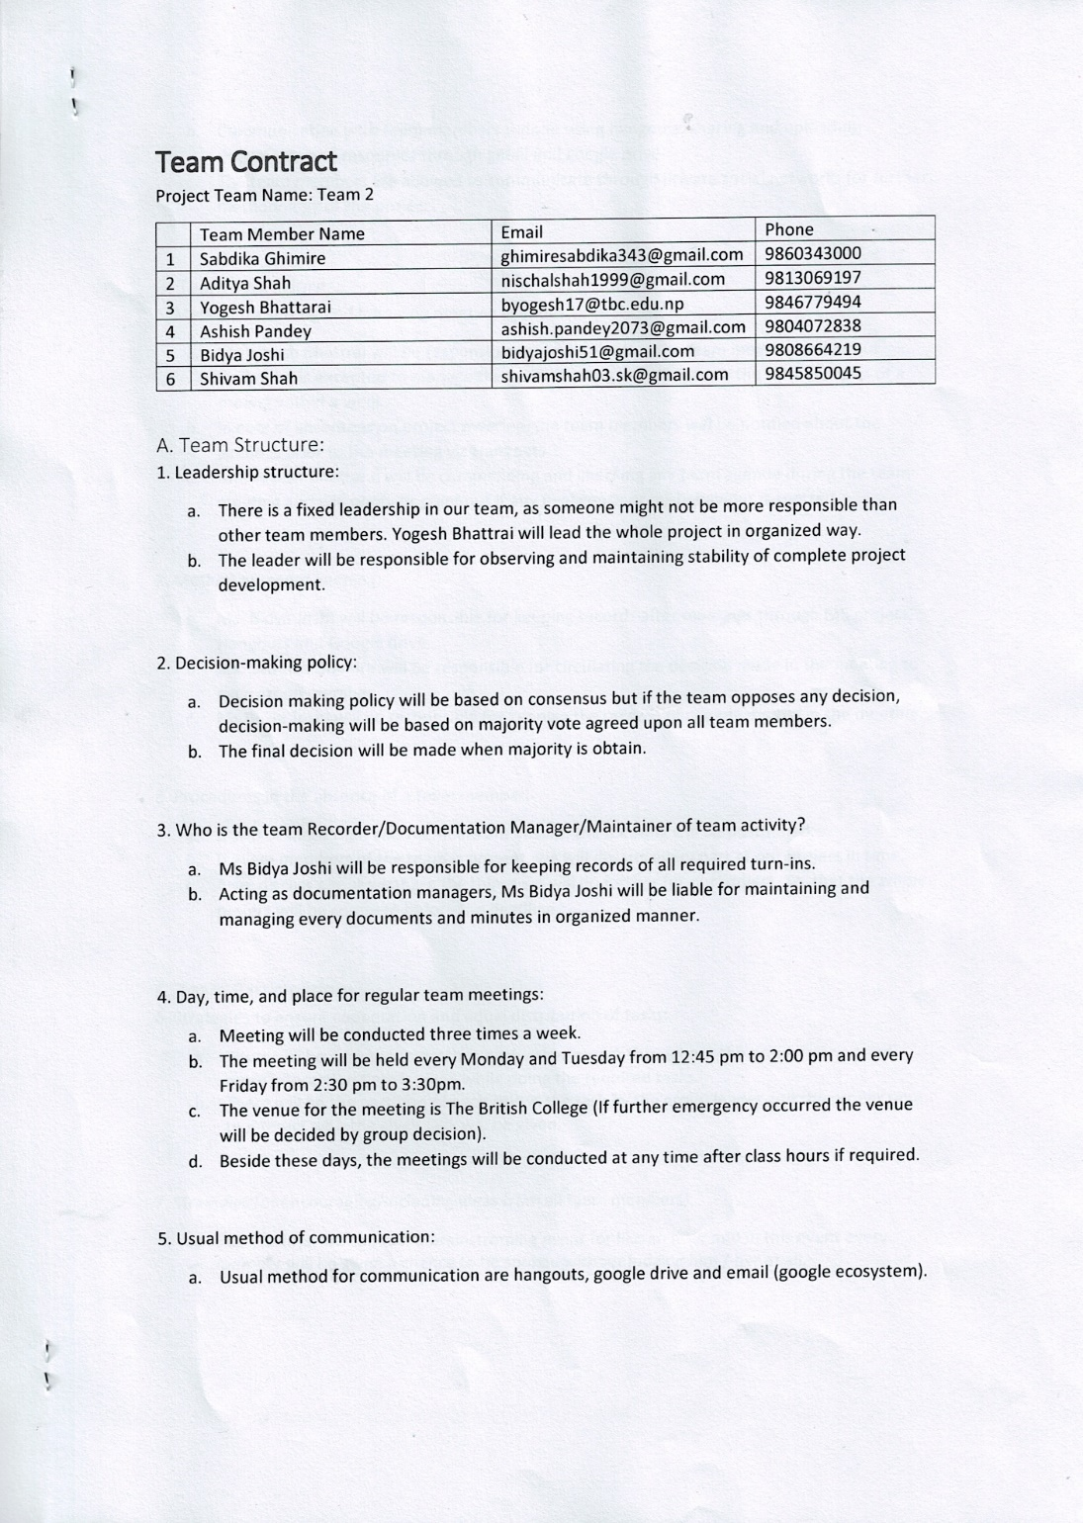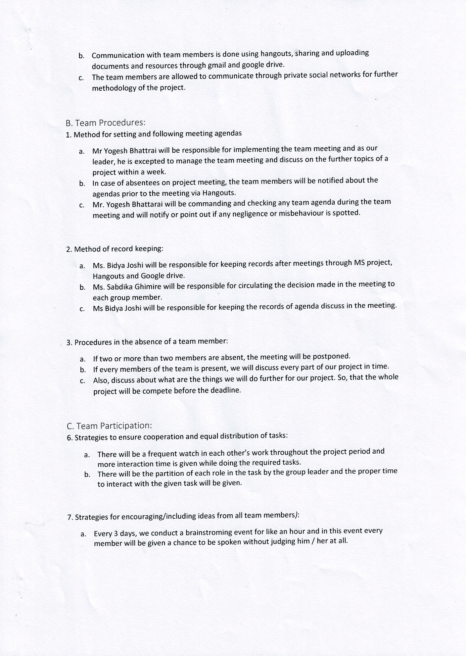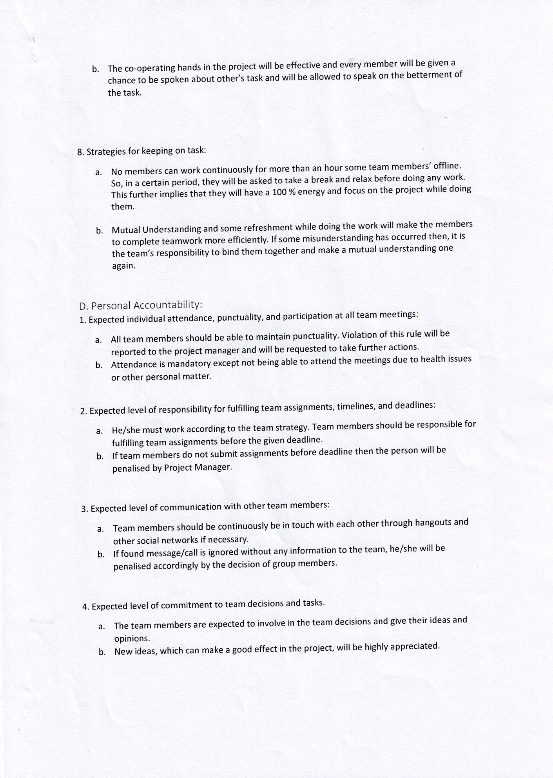

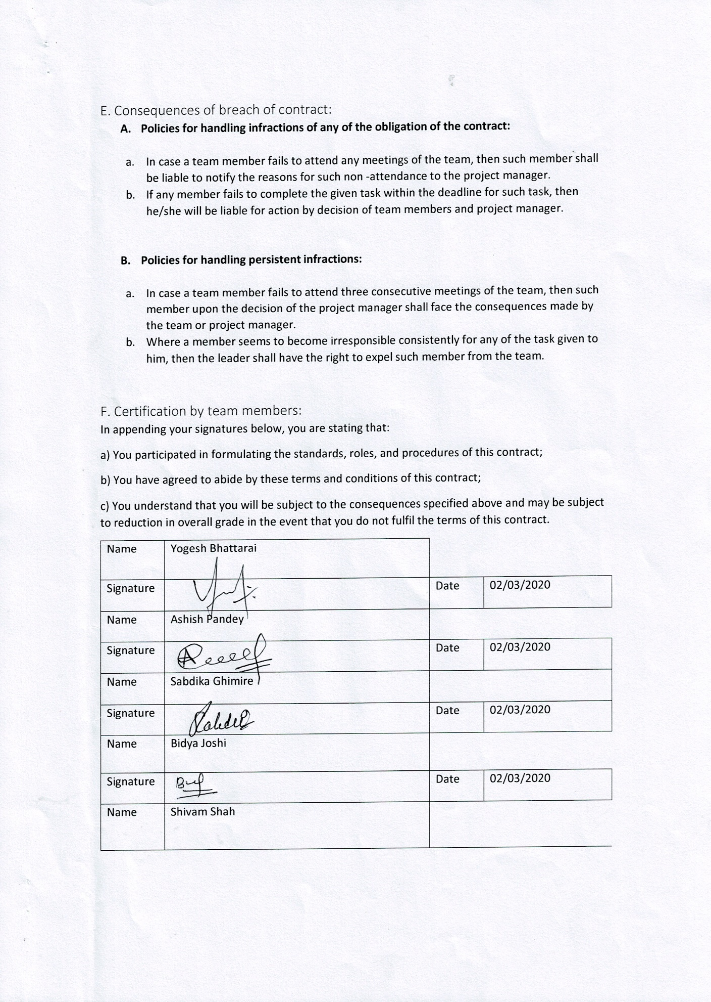

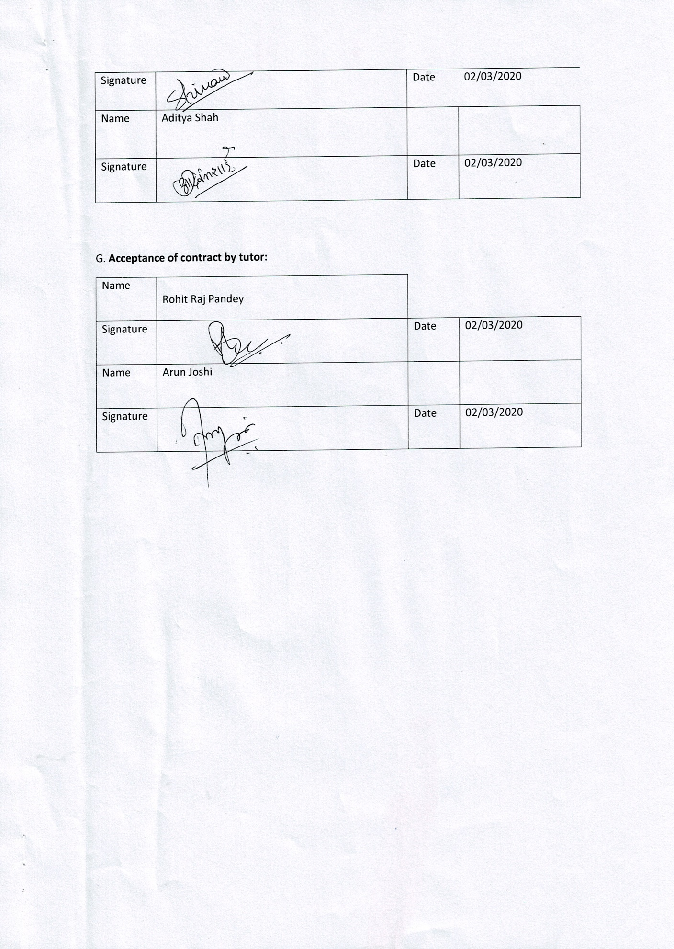

## 1.2 Project Charter

## 1.2.1 Project Charter Version 1

|  |
| --- |
| Project Title : Pioneering An E-commerce Platform in Cleckhuddersfax  Project Sponsor: The British College, Kathmandu  Project Manager: Mr Rohit Raj Pandey |

Version Control

|  |  |  |
| --- | --- | --- |
| Version | Date | Summary of changes |
| V1 | 2/25/2020 | All the scope have been defined for project according to the case study. |
|  |  |  |
|  |  |  |

Project Justification

|  |
| --- |
| Simply, the project is all about e-commerce website for the customers and traders of Cleckhuddersfax. The e-commerce platform consist of customer interface, trader interface and management interface. The joint agreement between the traders in the area leads the traders to sell their products direct to the consumers through systematic and pioneering ecommerce web interface.  This web interface permit local residents to buy products from the native traders. This system lend a helping hand to local people who are unable to purchase goods locally during the regular opening hours. The creation of the e-commerce website will enable the traders to sell their goods in the competitive retail market without loss or misplacement of their income to the national chain.  Customers can save their time with the utilization of timeslot. Timeslot allows the customer to collect their product from collection point after placing and paying for their order by identifying the respective collection slot that must be at least 24 hours after placement of order. Similarly, there will be bunch of facility for traders and customers. The major target will be to provide a convenient user experience.  *.* |

Project Scope

|  |
| --- |
| *The Scope of this Project is to full fill all the requirements and produce a e-web for the facility of locals in Cleckhuddersfax . This Project is based on requirements given by the stores of Cleckhuddersfax.*  The main objectives:   * Maintain time values by giving fast and efficient shopping for peoples. * Manages customer choice by giving various options according to their need * Increase the number of customers by giving new platform of shopping. * Be useful for management to monitor the shop. |
| ***High level requirements***  Customer Interface:   * Customer should be able to navigate to products by shop or by product type. * Customer should be able to view the website in various devices. Hence, resulting the site as responsive. * Users should be required to register before they can place an order and be logged in to access the basket   Trader Interface:   * Traders should be able to manage their products and information on their shops via a web interface. They should be able to add/delete/update * Traders should be able login to the database on a daily basis to view reports on orders and stock levels etc. * Traders should have a trader login that allows them access to their details only.   Management Interface:   * e |
| Major deliverables:   * E-Commerce website with customer and trader interface. * Admin facility for traders to add, update and delete their products. * Add to cart functionality with billing system with PayPal Integration. * Database linked to e-commerce site with management interface. |

Duration

|  |  |  |  |  |  |  |  |  |  |  |
| --- | --- | --- | --- | --- | --- | --- | --- | --- | --- | --- |
| |  |  | | --- | --- | | NAME | DATE |  |  |  | | --- | --- | | Initiation of Project | 06/02/2020 | | Work in Progress submission | 24/03/2020 | | Final Project presentation | 02/05/2020 | | Team Portfolio and Individual Report submission | 10/05/2020 | |

Estimated Budget

|  |  |  |  |  |  |  |  |  |  |  |  |  |  |  |  |  |  |  |  |  |  |
| --- | --- | --- | --- | --- | --- | --- | --- | --- | --- | --- | --- | --- | --- | --- | --- | --- | --- | --- | --- | --- | --- |
| |  |  |  | | --- | --- | --- | | *Name* | *Daily(hours)* | *Weekly(5 Days)(hours)* | | Ashish Pandey | *4* | *20* | | Sabdika Ghimire | *4* | *20* | | Yogesh Bhattarai | *4* | *20* | | Shivam Shah | *3* | *15* | | Bidya Joshi | *3* | *15* | | Aditya Shah | *4* | *20* |   No initial hardware requirements.  Hours per week per person: 15-20  Total number of team members: 6  Total hours per day by total team members: 6*3=18 hrs  Hence total hours min: 15*6*12=1080 hours max: 20*6*12 = 1440 hours |

Roles and Responsibilities

|  |  |
| --- | --- |
| Name | Role |
| Aditya Shah | Resource Investigator, Shaper, Team worker |
| Bidya Joshi | Resource Investigator, Co-ordinator, Shaper |
| Yogesh Bhattrai | Team-Worker, Specialist, Implementer, plant |
| Sabdika Ghimire | Team-Worker, Co-ordinator, Monitor Evaluator, Specialist |
| Ashish Pandey | Plant, Specialist, Completer Finisher |
| Shivam Shah | Monitor Evaluator, Completer Finisher |

## 1.2.2 Project Charter Version 2

|  |
| --- |
| Project Title : Pioneering An E-commerce Platform in Cleckhuddersfax  Project Sponsor: The British College, Kathmandu  Project Manager: Mr Rohit Raj Pandey |

Version Control

|  |  |  |
| --- | --- | --- |
| Version | Date | Summary of changes |
| V1 | 2/25/2020 | All the scope have been defined for project according to the case study. |
| V2 | 3/23/2020 | Belbin’s Analysis, Skill Audit, EERD, Use Case Diagram and Wireframe Design were all completed. |
|  |  |  |

Project Justification

|  |
| --- |
| Simply, the project is all about e-commerce website for the customers and traders of Cleckhuddersfax. The e-commerce platform consist of customer interface, trader interface and management interface. The joint agreement between the traders in the area leads the traders to sell their products direct to the consumers through systematic and pioneering ecommerce web interface.  This web interface permit local residents to buy products from the native traders. This system lend a helping hand to local people who are unable to purchase goods locally during the regular opening hours. The creation of the e-commerce website will enable the traders to sell their goods in the competitive retail market without loss or misplacement of their income to the national chain.  Customers can save their time with the utilization of timeslot. Timeslot allows the customer to collect their product from collection point after placing and paying for their order by identifying the respective collection slot that must be at least 24 hours after placement of order. Similarly, there will be bunch of facility for traders and customers. The major target will be to provide a convenient user experience.  *.* |

Project Scope

|  |
| --- |
| *The Scope of this Project is to full fill all the requirements and produce a e-web for the facility of locals in Cleckhuddersfax . This Project is based on requirements given by the stores of Cleckhuddersfax.*  The main objectives:   * Maintain time values by giving fast and efficient shopping for peoples. * Manages customer choice by giving various options according to their need * Increase the number of customers by giving new platform of shopping. * Be useful for management to monitor the shop. |
| ***High level requirements***  Customer Interface:   * Customer should be able to navigate to products by shop or by product type. * Customer should be able to view the website in various devices. Hence, resulting the site as responsive. * Users should be required to register before they can place an order and be logged in to access the basket   Trader Interface:   * Traders should be able to manage their products and information on their shops via a web interface. They should be able to add/delete/update * Traders should be able login to the database on a daily basis to view reports on orders and stock levels etc. * Traders should have a trader login that allows them access to their details only.   Management Interface:   * e |
| Major deliverables:   * E-Commerce website with customer and trader interface. * Admin facility for traders to add, update and delete their products. * Add to cart functionality with billing system with PayPal Integration. * Database linked to e-commerce site with management interface. |

Duration

|  |  |  |  |  |  |  |  |  |  |  |
| --- | --- | --- | --- | --- | --- | --- | --- | --- | --- | --- |
| |  |  | | --- | --- | | NAME | DATE |  |  |  | | --- | --- | | Initiation of Project | 06/02/2020 | | Work in Progress submission | 24/03/2020 | | Final Project presentation | 02/05/2020 | | Team Portfolio and Individual Report submission | 10/05/2020 | |

Estimated Budget

|  |  |  |  |  |  |  |  |  |  |  |  |  |  |  |  |  |  |  |  |  |  |
| --- | --- | --- | --- | --- | --- | --- | --- | --- | --- | --- | --- | --- | --- | --- | --- | --- | --- | --- | --- | --- | --- |
| |  |  |  | | --- | --- | --- | | *Name* | *Daily(hours)* | *Weekly(5 Days)(hours)* | | Ashish Pandey | *4* | *20* | | Sabdika Ghimire | *4* | *20* | | Yogesh Bhattarai | *4* | *20* | | Shivam Shah | *3* | *15* | | Bidya Joshi | *3* | *15* | | Aditya Shah | *4* | *20* |   No initial hardware requirements.  Hours per week per person: 15-20  Total number of team members: 6  Total hours per day by total team members: 6*3=18 hrs  Hence total hours min: 15*6*12=1080 hours max: 20*6*12 = 1440 hours |

Roles and Responsibilities

|  |  |
| --- | --- |
| Name | Role |
| Aditya Shah | Resource Investigator, Shaper, Team worker |
| Bidya Joshi | Resource Investigator, Co-ordinator, Shaper |
| Yogesh Bhattrai | Team-Worker, Specialist, Implementer, plant |
| Sabdika Ghimire | Team-Worker, Co-ordinator, Monitor Evaluator, Specialist |
| Ashish Pandey | Plant, Specialist, Completer Finisher |
| Shivam Shah | Monitor Evaluator, Completer Finisher |

## 1.3 Meeting Minutes

Date: Thursday, February 27

Time: 12:30PM

Location: The British College

|  |  |  |
| --- | --- | --- |
| Date | Work done | Agenda |
| 02/27/2020 | Planning | We held the team meeting and Planning the main activities of this week. Refreshing the main topic of the project. Overview of the main task of Belbin analysis and skill audit. Clarify outline the purpose and objective of the meeting. |
| 02/28/2020 | Implementation | Discuss about all the information of the task that what are the things that we should be done in Belbin analysis and skill audit. Distributing the tasks and responsibilities between the team members. Discuss each and every part of Belbin analysis and skill audit that needs to discussed and debated in the meeting. We also discuss about what are the skills required that we need to make our website desirable. |
| 02/28/2020 | Conclusion | At the final stage, main task is all about merging the every divided task given by team member, finalizing that and submitting. |

**ERD**

|  |  |  |
| --- | --- | --- |
| Date | Work done | Agenda |
| 03/09/2020 | Planning | We held the team meeting and discussed the possible entity and attributes and problems that might come across the ERD following the case study. We discussed about ERD, Composite model, EERD and MoSCoW We planned and divided work for each team member. |
| 03/10/2020 | Implementation | Erstwhile planning and work was divided on Monday. So we implemented entity, attribute and possible outcome in QSEE application on Tuesday. We solved problems that came through MoSCow. We asked help to module tutor for some problems came whilst implementing ERD. |
| 03/13/2020 | Conclusion | In Friday we held the team meeting before the class in college and discuss about the case study again and finalize the ERD, EERD, composite model and MoSCow. And one zip folder was made consisting all of them and Screenshot of ERD, EERD, Composite model and zip folder was submitted to VLE on 13th march. |

**Use Case**

|  |  |  |
| --- | --- | --- |
| 03/13/2020 | Planning | Team meeting was done on Friday after the college where we discuss about the system, actors, use cases and relationship according to case study. UML use case diagram was planned focusing the case study and every member was given their task. |
| 03/15/2020 | Implementation and Conclusion | Our team members stayed for hours and we finalized the UML Use case diagram solving error and updating use case diagram because of submission date. |

# 2. Planning Phase

## 2.1 Individual Belbin’s Analysis

|  |  |  |
| --- | --- | --- |
| Version:1.0 **Belbin’s Analysis** Date reviewed: 29-02-2020 | | |
| Primary role | Aditya Shah | Resources Investigator |
| Secondary role | Aditya Shah | Shaper |
| Least likely role | Aditya Shah | Team worker |

**Your Name: Aditya Shah**

|  |  |  |
| --- | --- | --- |
| Do you think the descriptions of these roles are an accurate description of your behaviour in teams? How do you see yourself differently? |  | I believe that I can explore outside resources and develop contact that may be helpful to the team. Also, I seek for new opportunities maintaining harmony with the team by providing resources and learning material that are helpful in project. In my opinion I also can give shape and form to the team’s activities without hurting team member feelings whilst providing better direction in discussion. |
| Are there roles identified by Belbin that you might like to develop in yourself more? Which ones and why? |  | I want to develop more as a Plant because I want to act as a prime source of ideas and innovation for the team. Being Plant I can help individual members to achieve and maintain effectiveness by building on suggestions and focusing on major strategic issues. As a plant I can focused on practical solutions and will do what is required to achieve the desired outcome by solving possible problems. |
| What possible situations in the coming months can you identify where you could work on developing these skills? |  | In coming months our team might go through various problem and issues regarding the project. In those situations, I will be providing every resource and materials needed for our team members to complete the project. I will unite the ideas or objectives of our team members taking the positive action to overcome any situation. So that I can bring the enthusiasm amongst the team member and drive to team effort. Doing this I can support my team members and also further improve my role as a resource investigator, shaper and Team worker. |
| Considering your team working, how do you think you could improve your effectiveness in group work and in contributing to the success of teams that you work in? |  | In my opinion every team member has to perform their best in order to complete the task in time. As a resource investigator I can improve my effectiveness in group work by providing new resources and materials needed in project. If any member face difficulties I can find ideas to bring back the team on track. Also I will set up external contacts to carry out any future problem. I believe I also has ability to respond to people and situations and to promote team spirit as a Team worker by counselling. With my courage I can give shape and form to the team’s activities as a shaper during the project. |
| Are the results of this inventory consistent with how you worked in the Foundation Project in your small groups for discussions and presentations? |  | The results are consistent compared to the previous project or group discussion because previous group work were not planned and properly managed due to which we could not complete in time but in this project we are learning new way of executing project in proper manner by focusing on budget, quality and time. |
| How well do you want to contribute to group presentations? |  | The bigger the project, the more linked and interdependent are the people and the task. I want to make sure all team members who are assigned to their roles and responsibility are capable enough for describing during the presentation. I will prepare a concise summary of the major points and supporting facts of my speech. |

## 

## 2.1.1 Team Belbin‘s Analysis

|  |  |  |
| --- | --- | --- |
| Version:1.0 **Belbin’s Analysis** Date reviewed: 3/1/2020 | | |
| Primary role | Sabdika Ghimire | Monitor Evaluator and Specialist |
| Yogesh Bhattrai | Specialist and Plant |
| Ashish Pandey | Plant and Team Worker |
| Bidya Joshi | Co-ordinator and Complete Finisher |
| Aditya Shah | Resource Investigator |
| Shivam Shah | Implementor |
| Secondary role | Sabdika Ghimire | Co-ordinator |
| Yogesh Bhattrai | Implementor |
| Ashish Pandey | Specialist |
| Bidya Joshi | Resource Investigator |
| Aditya Shah | Shaper |
| Shivam Shah | Monitor Evaluator |
| Least likely role | Sabdika Ghimire | Team Worker |
| Yogesh Bhattrai | Team Worker |
| Ashish Pandey | Completer Finisher |
| Bidya Joshi | Shaper |
| Aditya Shah | Team Worker |
| Shivam Shah | Complete Finisher |
| Do you think the descriptions of these roles are an accurate description of your behaviour in teams? How do you see yourself differently? | Sabdika Ghimire | Yes, I think the roles completely match with my behaviour, performance and way of acting because I can provide specialist knowledge and skills. Being sober, prudent and discerning, I can observe all the options and evaluate accurately to achieve the project goals. As I believe, my contribution to the team is very critical. I am a person who can listens and averts friction, to help the team to materialize. |
| Yogesh Bhattrai | Yes, I do think the descriptions of these roles are an accurate description of my behaviour in teams because I have been doing the front-end specialist and I am much more confident and passion for this role. My Primary role is “Plant” because I am the one who decides and makes the website creativity come in real life. As an “Implementer”, I also focus on my other teammates to up their confidence to do the work more efficiently. As a team-worker, I collaborate with my team to come up with new plans and strategies to overcome the problems while doing the project. |
| Ashish Pandey | Yes, Of course that is the reason why I chose these roles. As a plant of our group I need to highly creative than other team members in our group and need to solve the team problems in the unconventional ways. |
| Bidya Joshi | I think the description of these roles are accurate description of my behaviour. I think being the Co-ordinator gives me a certain responsibilities how to co-ordinate with the team members and I will be responsible to representative work appropriately in the team and as a Resource Investigator I would be able to generate creative ideas and solve different problems. |
| Aditya Shah | I believe that I can explore outside resources and develop contact that may be helpful to the team. Also, I seek for new opportunities maintaining harmony with the team by providing resources and learning material that are helpful in project. In my opinion I also can give shape and form to the team’s activities without hurting team member feelings whilst providing better direction in discussion. |
| Shivam Shah | I think the description of the role are an accurate description, because I have much knowledge about my roles as I have capacity of implementation of our objectives and strategy which we have to do in my team and in the project. |
| Are there roles identified by Belbin that you might like to develop in yourself more? Which ones and why? | Sabdika Ghimire | The roles identified by the Belbin are very important for the completion of project. Besides my role in the team, I have desire to develop the role of plant. As I want to generate creative and imaginative ideas, I want to develop the role of plant. Similarly, I wish to flourish the difficult problem solving skill in unconventional ways by acting as plant. |
| Yogesh Bhattrai | Yes, I find Specialist more of an opportunity to be myself and keep more learning on the fact that I need to work on this project like a Specialist. It develops my mental strategy to create more of a patterns to work and to focus on one work that is necessary to work as a team. |
| Ashish Pandey | I found the roles identified by Belbin is very fruitful for the team to complete the project. So, if I want to work in project like this in future, definitely development of skill to full fill the role is required.  In my mind, plant is the most suitable role for me because I like to be creative all the time and generate new ideas according to the need of the team. |
| Bidya Joshi | Co-ordinator is the role identified by Belbin that I would like to develop in myself. I think this the most important role to work as a team, without a good co-ordinating it is hard to work as a team so, I would like to improve my ability  to ensure that the team will get good co-ordinate and I want to be committed towards it, to gain the depth knowledge about it. |
| Aditya Shah | I want to develop more as a Plant because I want to act as a prime source of ideas and innovation for the team. Being Plant I can help individual members to achieve and maintain effectiveness by building on suggestions and focusing on major strategic issues. As a plant I can focused on practical solutions and will do what is required to achieve the desired outcome by solving possible problems. |
| Shivam Shah | I would like to contribute my team as a plant. I wish to be creative and come out with solution that would solve the problem and make our team much more productive and efficient. |
| What possible situations in the coming months can you identify where you could work on developing these skills? | Sabdika Ghimire | Achieving success in the team project is very much challenging task. Challenging task is key point to sharpen our skills. There may arise the situations like lack of communication with team members, late submission of respective task by team members and absence of team members while conducting meetings. These situations helps to co-ordinate with the team members by inspiring them and lending the helping hands to solve their difficult problems that helps in development of skills. Similarly, listening to the opinion of every team members helps to develop mutual understanding and co-operation. |
| Yogesh Bhattrai | In upcoming months, I could be facing with a lot of problem in the project but as a Team -Worker we could fight with those problems in a team. That way we could have more brains on the project’s problem and try more to keep up with perfect designs that the content is wanting us to do. As working on this project I could get the ability to get more creative and more functional because I will be doing a lot of research and going around the world to find the most reliable designs for the project. |
| Ashish Pandey | As a group member I need to develop my skills day by day. So, in coming months I would definitely expect my skills to develop and contribute to the project. |
| Bidya Joshi | In the coming months, I would able to develop my skill as a team leader to improve my creativity to work as a leader in a team, problem solving skills, co-ordinating skills, time management for improvement of the project. |
| Aditya Shah | In coming months, our team might go through various problem and issues regarding the project. In those situations, I will be providing every resource and materials needed for our team members to complete the project. I will unite the ideas or objectives of our team members taking the positive action to overcome any situation. So that I can bring the enthusiasm amongst the team member and drive to team effort. Doing this I can support my team members and also further improve my role as a resource investigator, shaper and Team worker. |
| Shivam Shah | In coming days we could require to implement fireworks and plugins on our website. Therefore, I can contribute my learning and implementing on our website. |
| Considering your team working, how do you think you could improve your effectiveness in group work and in contributing to the success of teams that you work in? | Sabdika Ghimire | The success of team project is due to the contribution and dedication of each team members by following the ground rules. I would improve my effectiveness by being punctual, sober, discerning, dedicated and strategic. I could develop clear objectives, define roles for each member, communicate efficiently, keep good records, stick to the plan and troubleshoot the problems in right way for the success of team. |
| Yogesh Bhattrai | Working in a team is not as easy as it sounds but a team can make it easier while maintaining the mutual co-operation and understanding between the team members of the project. While working as a team I could be interacting more, learning new things more and will be trying to make a mutual co-operation with the team members and that will help me to develop myself more. |
| Ashish Pandey | Team’s main goal is to develop the good output. So, in order to do that every members of the team including me should improve themselves in terms of skills, ideas and many more and I believe if I work hard and be determined I will be able to contribute more and more for my team. |
| Bidya Joshi | I think I could improve my communication and understanding skills and I must have to be friendly to every members of the team to contribute the success of the team. I would improve my effectiveness by being punctual. |
| Aditya Shah | In my opinion, every team member has to perform his or her best in order to complete the task in time. As a resource investigator, I can improve my effectiveness in-group work by providing new resources and materials needed in project. If any member face difficulties, I can find ideas to bring back the team on track. In addition, I will set up external contacts to carry out any future problem. I believe I also has ability to respond to people and situations and to promote team spirit as a Team worker by counselling. With my courage, I can give shape and form to the team’s activities as a shaper during the project. |
| Shivam Shah | With the team, I will always make sure that I have contributed 100% to my team. I will give all information about project that I have researched for my team and work with them. |
| Are the results of this inventory consistent with how you worked in the Foundation Project in your small groups for discussions and presentations? | Sabdika Ghimire | The result of this inventory is not consistent with the tiny foundation project. There is vast difference between foundation project and team project. The success in foundation project was achieved by small contribution of team members but in this teamwork, every member should work hard in more organized pattern in each five phases of project management. We must consider initiation, planning, executing, monitoring and controlling and closing phase for proper success of project, which was not in foundation project. |
| Yogesh Bhattrai | Yes and Even more, I found Team working person and myself more qualified than I have ever before. On the Foundation Projects, we use to have a small group that have to do a work like these but in this Project I found myself more engaging and more Team working type of person than I ever was. These Projects have always helped me to up my standards and have a qualified skill for myself. |
| Ashish Pandey | There is a lot difference between the past foundation projects and present project. Present project is much more professional and strict about the deadline. However, Surely Foundation Project has helped a lot by giving experiences on how to deal in projects, which will surely help in this project. |
| Bidya Joshi | As per my view, I think result of this inventory is not consistent with the previous project because we did not have any plans about the outcomes of our project. |
| Aditya Shah | The results are consistent compared to the previous project or group discussion because previous group work were not planned and properly managed due to which we  could not complete in time but in this project we are learning new way of executing project in proper manner by focusing on budget, quality and time. |
| Shivam Shah | To make our work consistent we will follow our same routine to whole project and each group member should participate with group regularly. |

## 2.2 Skill Audit

Individual Skill Audit

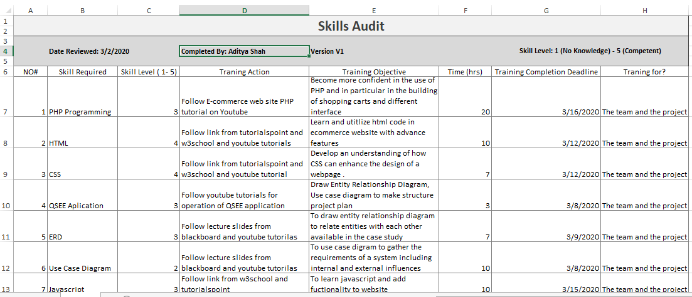

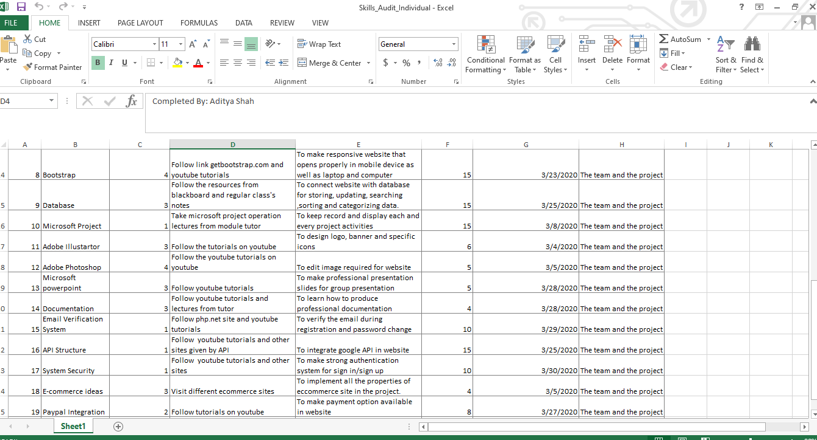

## 2.2.1 Team Skill Audit

|  |  |  |  |  |  |  |  |
| --- | --- | --- | --- | --- | --- | --- | --- |
| **Skills Audit** | | | | | | | |
|
|  |  |  |  |  |  | **Skill Level: 1 (No Knowledge) - 5 (Competent)** | |
|  | **Date Reviewed: 3/2/2020** | | **Completed By: Team 2** | **Version V1** |  |
|  |  |  |  |  |  |
| NO# | Skill Required | Skill Level ( 1- 5) | Traning Action | Training Objective | Time (hrs) | Training Completion Deadline | Traning for? |
| 1 | PHP Programming | 3 | Follow E-commerce web site PHP tutorial on Youtube | Become more confident in the use of PHP and in particular in the building of shopping carts and different interface | 23 | 3/20/2020 | The team and the project |
| 2 | HTML | 3 | Follow link from tutorialspoint and w3school and youtube tutorials | Learn and utitlize html code in ecommerce website with advance features | 8 | 3/12/2020 | The team and the project |
| 3 | CSS | 3 | Follow link from tutorialspoint and w3school and youtube tutorial | Develop an understanding of how CSS can enhance the design of a webpage . | 8 | 3/14/2020 | The team and the project |
| 4 | QSEE Aplication | 3 | Follow youtube tutorials for operation of QSEE application | Draw Entity Relationship Diagram, Use case diagram to make structure project plan | 4 | 3/4/2020 | The team and the project |
| 5 | ERD | 3 | Follow lecture slides from blackboard and youtube tutorilas | To draw entity relationship diagram to relate entities with each other available in the case study | 8 | 3/5/2020 | The team and the project |
| 6 | Use Case Diagram | 2 | Follow lecture slides from blackboard and youtube tutorilas | To use case digram to gather the requirements of a system including internal and external influences | 8 | 3/6/2020 | The team and the project |
| 7 | Javascript | 3 | Follow link from w3school and tutorialspoint | To learn javascript and add fuctionality to website | 10 | 3/24/2020 | The team and the project |
| 8 | Bootstrap | 3 | Follow link getbootstrap.com and youtube tutorials | To make responsive website that opens properly in mobile device as well as laptop and computer | 10 | 3/23/2020 | The team and the project |
| 9 | Database | 3 | Follow the resources from blackboard and regular class's notes | To connect website with database for storing, updating, searching ,sorting and categorizing data. | 18 | 3/25/2020 | The team and the project |
| 10 | Microsoft Project | 2 | Take microsoft project operation lectures from module tutor | To keep record and display each and every project activities | 13 | 3/8/2020 | The team and the project |
| 11 | Adobe Illustartor | 3 | Follow the tutorials on youtube | To design logo, banner and specific icons | 5 | 3/10/2020 | The team and the project |
| 12 | Adobe Photoshop | 4 | Follow the youtube tutorials on youtube | To edit image required for website | 5 | 3/3/2020 | The team and the project |
| 13 | Microsoft powerpoint | 3 | Follow youtube tutorials | To make professional presentation slides for group presentation | 5 | 3/21/2020 | The team and the project |
| 14 | Documentation | 1 | Follow youtube tutorials and lectures from tutor | To learn how to produce professional documentation | 8 | 3/28/2020 | The team and the project |
| 15 | Email Verification System | 1 | Follow php.net site and youtube tutorials | To verify the email during registration and password change | 10 | 3/29/2020 | The team and the project |
| 16 | API Structure | 1 | Follow youtube tutorials and other sites given by API | To integrate google API in website | 15 | 3/25/2020 | The team and the project |
| 17 | System Security | 1 | Follow youtube tutorials and other sites | To make strong authentication system for sign in/sign up | 12 | 3/30/2020 | The team and the project |
| 18 | E-commerce ideas | 3 | Visit different ecommerce sites | To implement all the properties of eccommerce site in the project. | 4 | 3/5/2020 | The team and the project |
| 19 | Paypal Integration | 2 | Follow tutorials on youtube | To make payment option available in website | 9 | 3/27/2020 | The team and the project |
| 20 | Adobe XD | 1 | Follow the youtube tutorials on youtube | To make the wireframes for developing websites | 6 | 3/10/2020 | The team and the project |

## Individual Skill Audit

|  |  |  |  |  |  |  |  |
| --- | --- | --- | --- | --- | --- | --- | --- |
| **Skills Audit** | | | | | | | |
|
|  |  |  |  |  |  | **Skill Level: 1 (No Knowledge) - 5 (Competent)** | |
|  | **Date Reviewed: 3/2/2020** | | **Completed By: Aditya Shah** | **Version V1** |  |
|  |  |  |  |  |  |
| NO# | Skill Required | Skill Level ( 1- 5) | Traning Action | Training Objective | Time (hrs) | Training Completion Deadline | Traning for? |
| 1 | PHP Programming | 3 | Follow E-commerce web site PHP tutorial on Youtube | Become more confident in the use of PHP and in particular in the building of shopping carts and different interface | 20 | 3/16/2020 | The team and the project |
| 2 | HTML | 4 | Follow link from tutorialspoint and w3school and youtube tutorials | Learn and utitlize html code in ecommerce website with advance features | 10 | 3/12/2020 | The team and the project |
| 3 | CSS | 4 | Follow link from tutorialspoint and w3school and youtube tutorial | Develop an understanding of how CSS can enhance the design of a webpage . | 7 | 3/12/2020 | The team and the project |
| 4 | QSEE Aplication | 3 | Follow youtube tutorials for operation of QSEE application | Draw Entity Relationship Diagram, Use case diagram to make structure project plan | 3 | 3/8/2020 | The team and the project |
| 5 | ERD | 3 | Follow lecture slides from blackboard and youtube tutorilas | To draw entity relationship diagram to relate entities with each other available in the case study | 7 | 3/9/2020 | The team and the project |
| 6 | Use Case Diagram | 2 | Follow lecture slides from blackboard and youtube tutorilas | To use case digram to gather the requirements of a system including internal and external influences | 10 | 3/8/2020 | The team and the project |
| 7 | Javascript | 3 | Follow link from w3school and tutorialspoint | To learn javascript and add fuctionality to website | 10 | 3/15/2020 | The team and the project |
| 8 | Bootstrap | 4 | Follow link getbootstrap.com and youtube tutorials | To make responsive website that opens properly in mobile device as well as laptop and computer | 15 | 3/23/2020 | The team and the project |
| 9 | Database | 3 | Follow the resources from blackboard and regular class's notes | To connect website with database for storing, updating, searching ,sorting and categorizing data. | 15 | 3/25/2020 | The team and the project |
| 10 | Microsoft Project | 1 | Take microsoft project operation lectures from module tutor | To keep record and display each and every project activities | 15 | 3/8/2020 | The team and the project |
| 11 | Adobe Illustartor | 3 | Follow the tutorials on youtube | To design logo, banner and specific icons | 6 | 3/4/2020 | The team and the project |
| 12 | Adobe Photoshop | 4 | Follow the youtube tutorials on youtube | To edit image required for website | 5 | 3/5/2020 | The team and the project |
| 13 | Microsoft powerpoint | 3 | Follow youtube tutorials | To make professional presentation slides for group presentation | 5 | 3/28/2020 | The team and the project |
| 14 | Documentation | 3 | Follow youtube tutorials and lectures from tutor | To learn how to produce professional documentation | 4 | 3/28/2020 | The team and the project |
| 15 | Email Verification System | 1 | Follow php.net site and youtube tutorials | To verify the email during registration and password change | 10 | 3/29/2020 | The team and the project |
| 16 | API Structure | 1 | Follow youtube tutorials and other sites given by API | To integrate google API in website | 15 | 3/25/2020 | The team and the project |
| 17 | System Security | 1 | Follow youtube tutorials and other sites | To make strong authentication system for sign in/sign up | 10 | 3/30/2020 | The team and the project |
| 18 | E-commerce ideas | 3 | Visit different ecommerce sites | To implement all the properties of eccommerce site in the project. | 4 | 3/5/2020 | The team and the project |
| 19 | Paypal Integration | 2 | Follow tutorials on youtube | To make payment option available in website | 8 | 3/27/2020 | The team and the project |
| 20 | Adobe XD | 1 | Follow the youtube tutorials on youtube | To make the wireframes for developing websites | 8 | 3/10/2020 | The team and the project |

## 

## 2.3 Project Management (MS Project)

## 2.3.1 Gantt Chart

Gantt chart 1

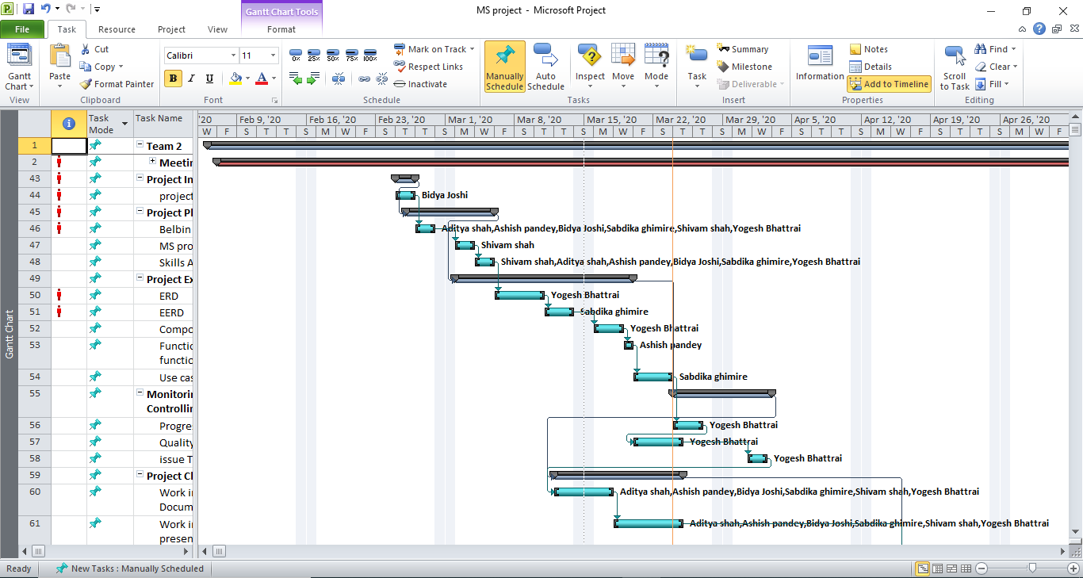

Gantt chart 2

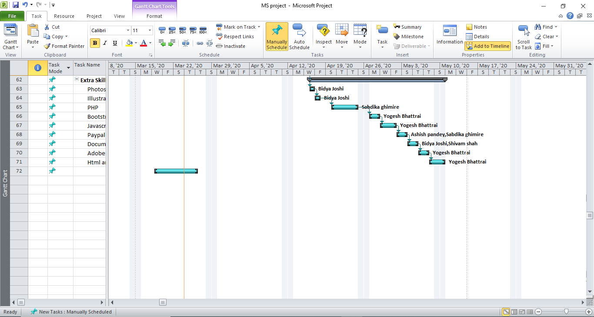

Gantt chart 3

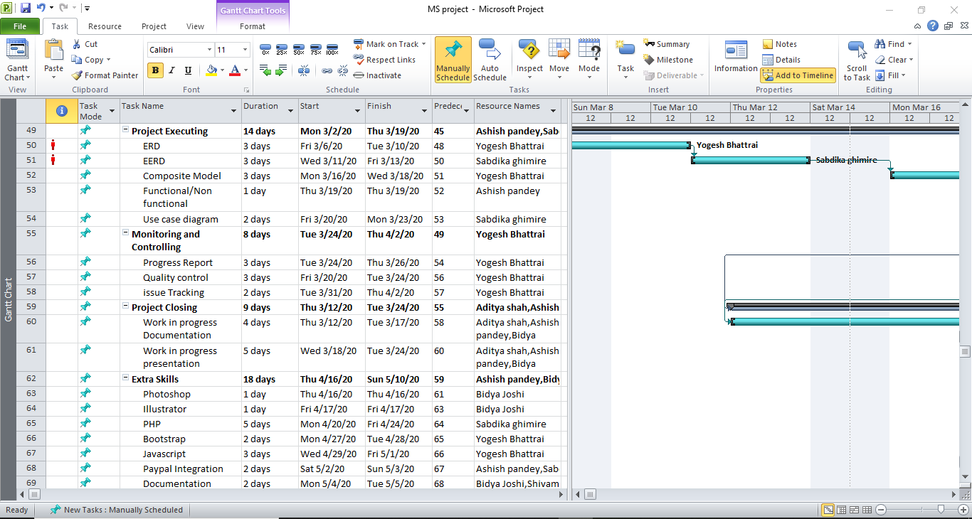

Gantt chart 4

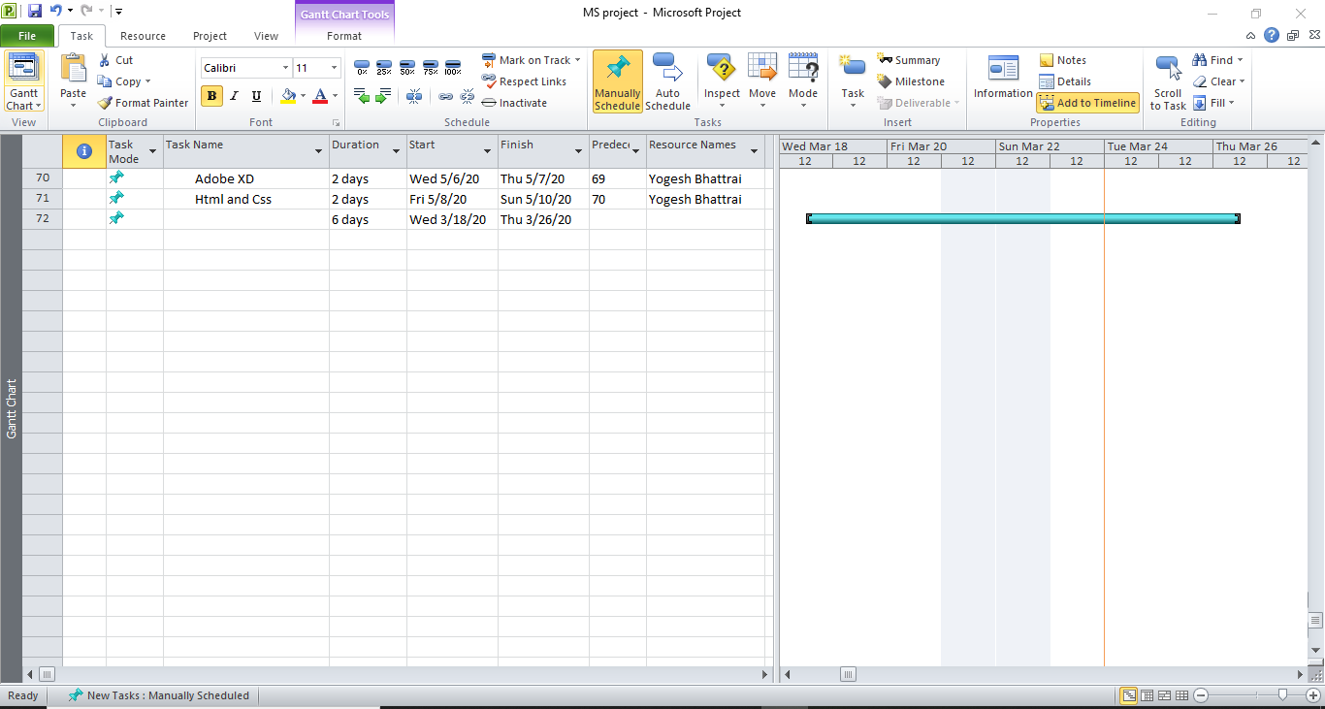

## 

## 2.3.2 Network Diagram

Network diagram 1

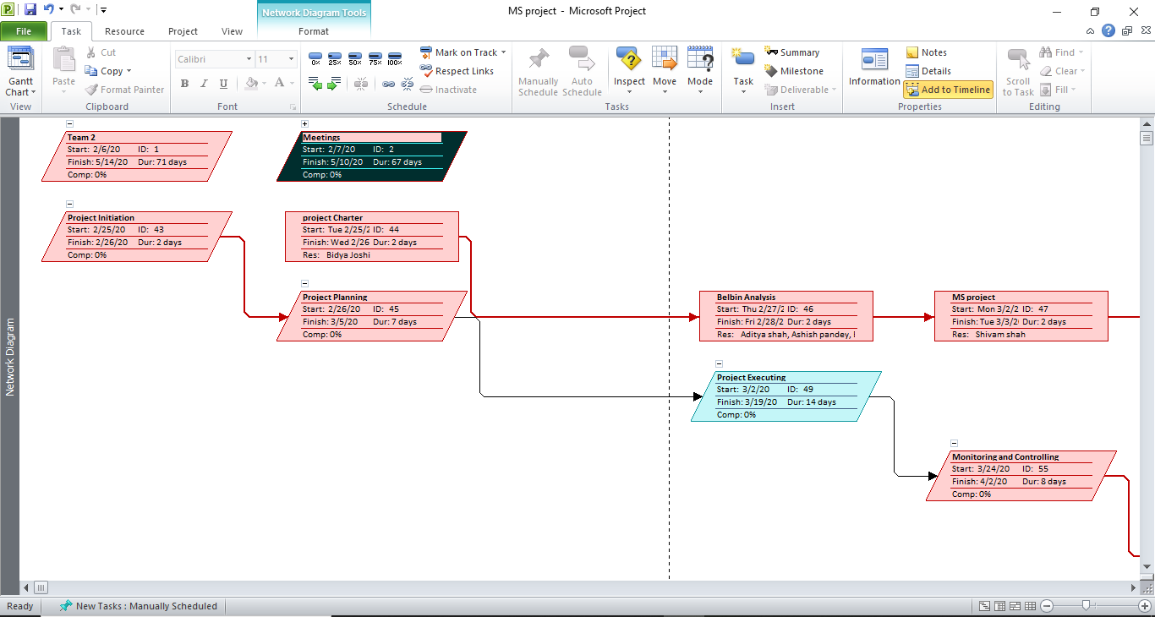

Network diagram 2

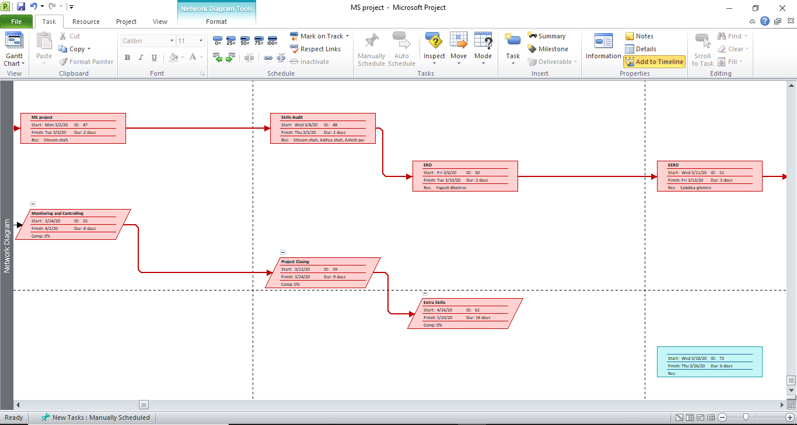

Network diagram 3

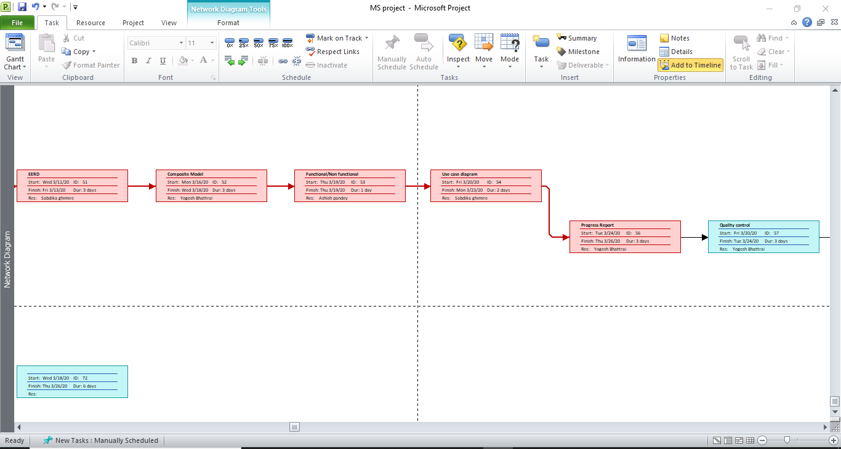

Network diagram 4

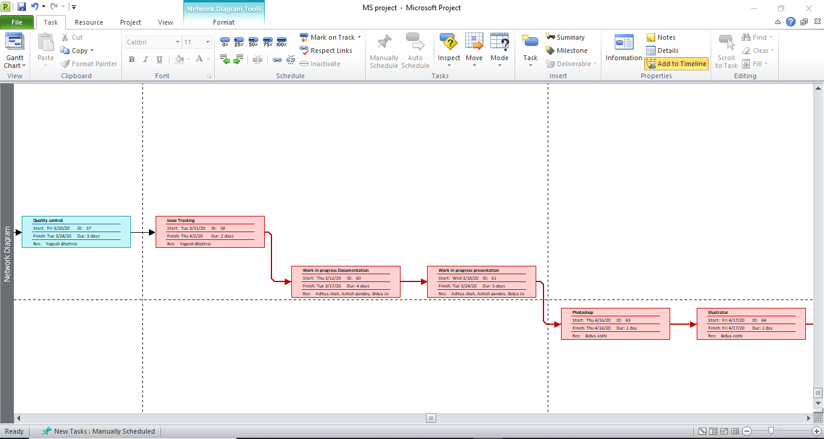

Network diagram 5

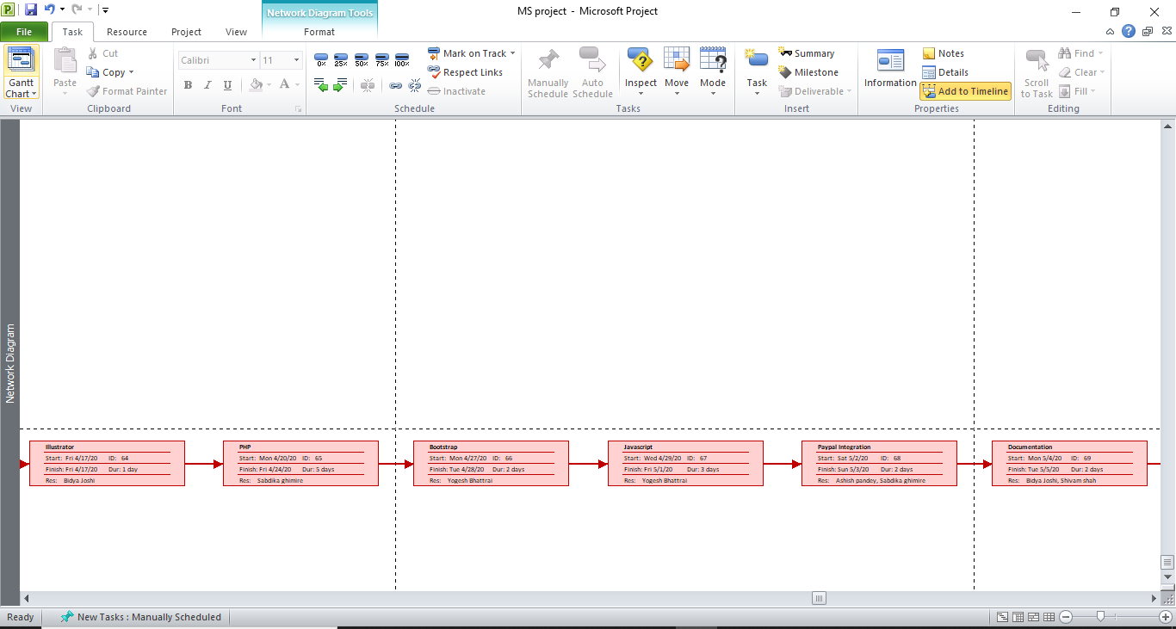

Network diagram 6

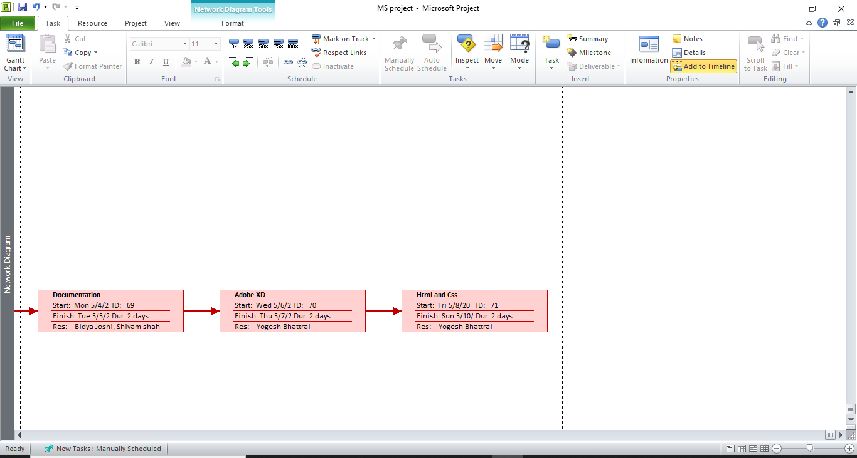

## 2.3.3 Timeline

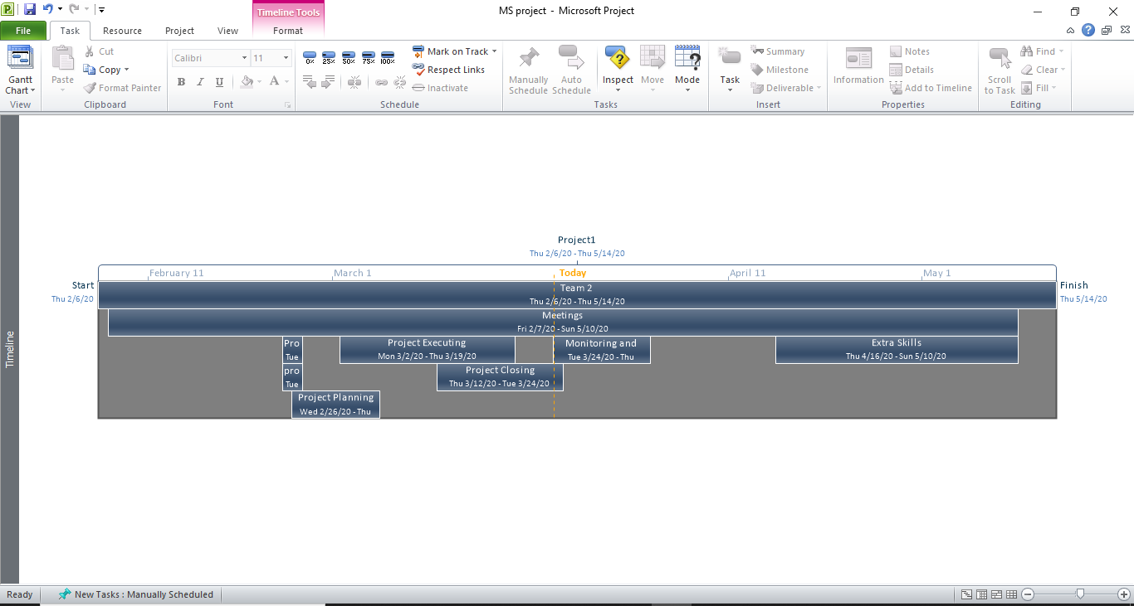

## 2.3.4 Calendar

Calendar 1

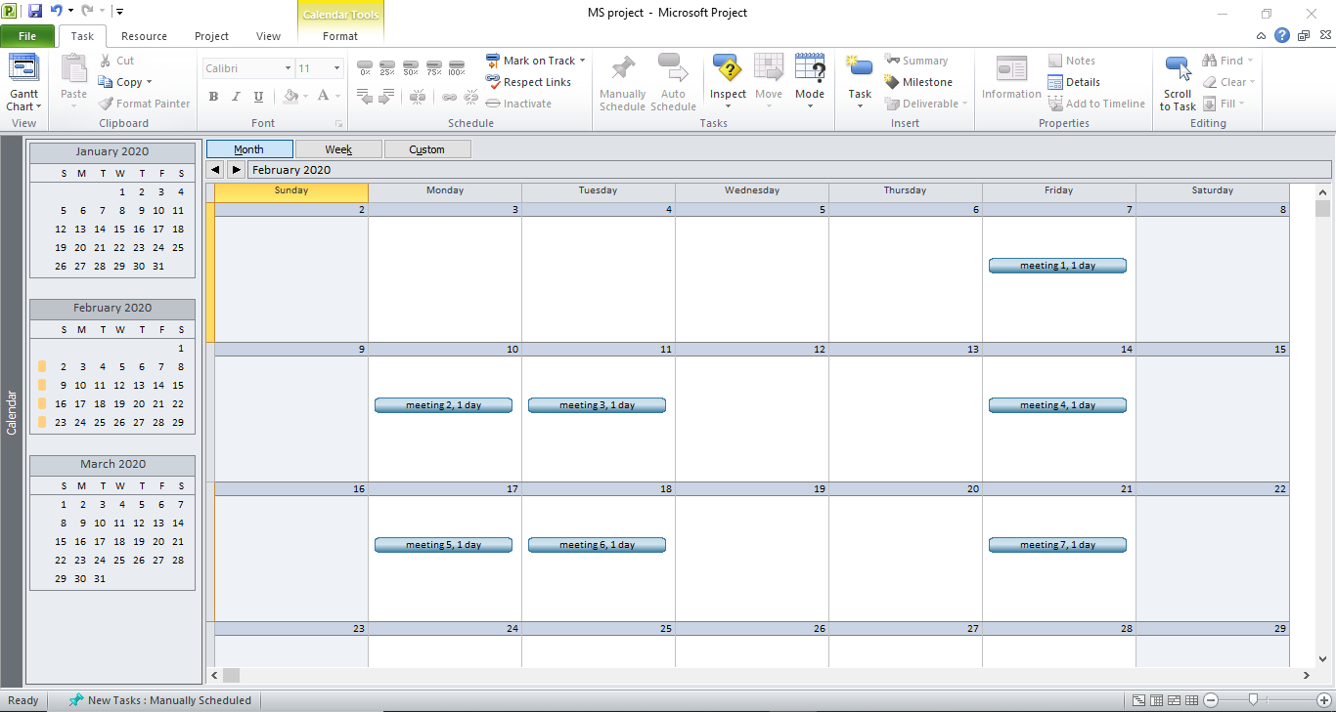

Calendar 2

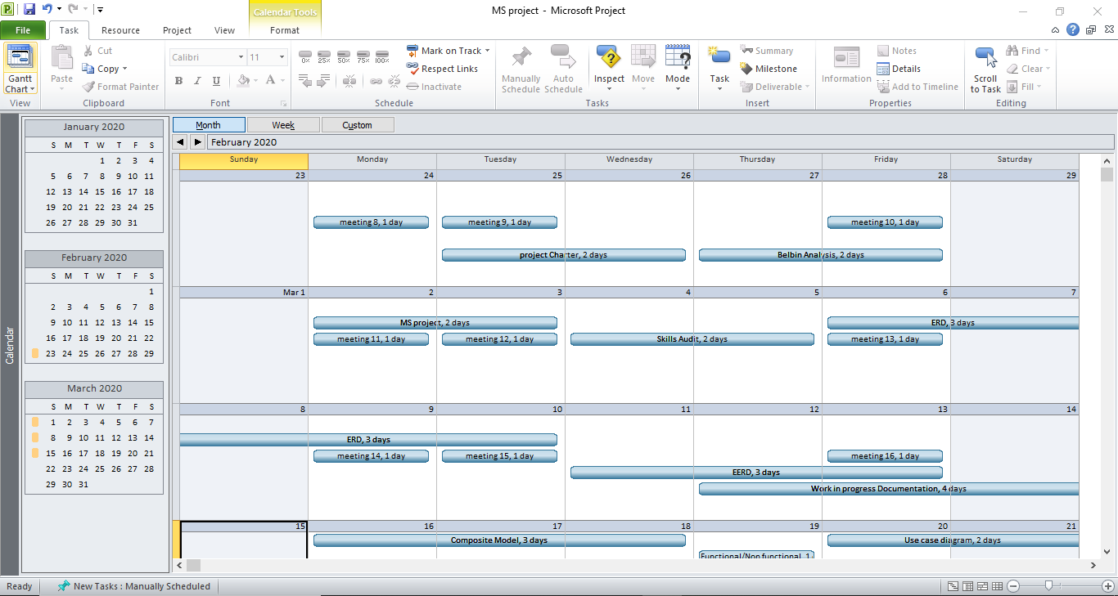

Calendar 3

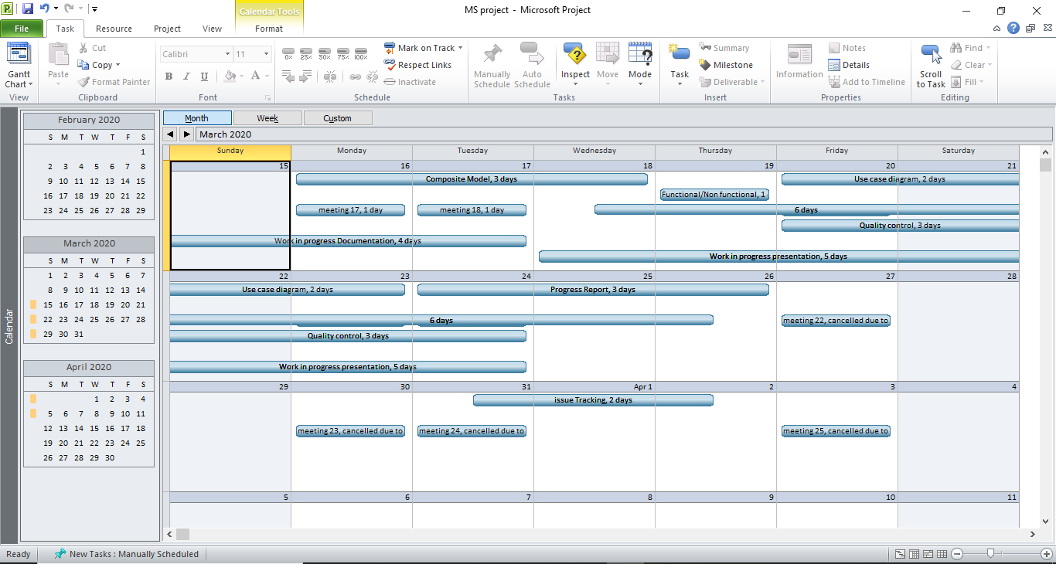

Calendar 4

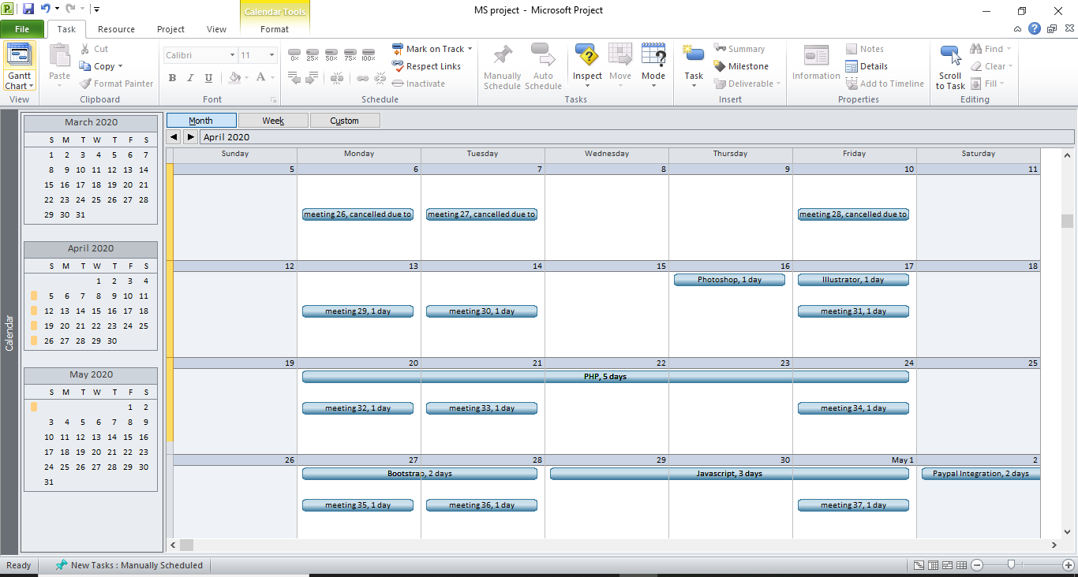

Calendar 5

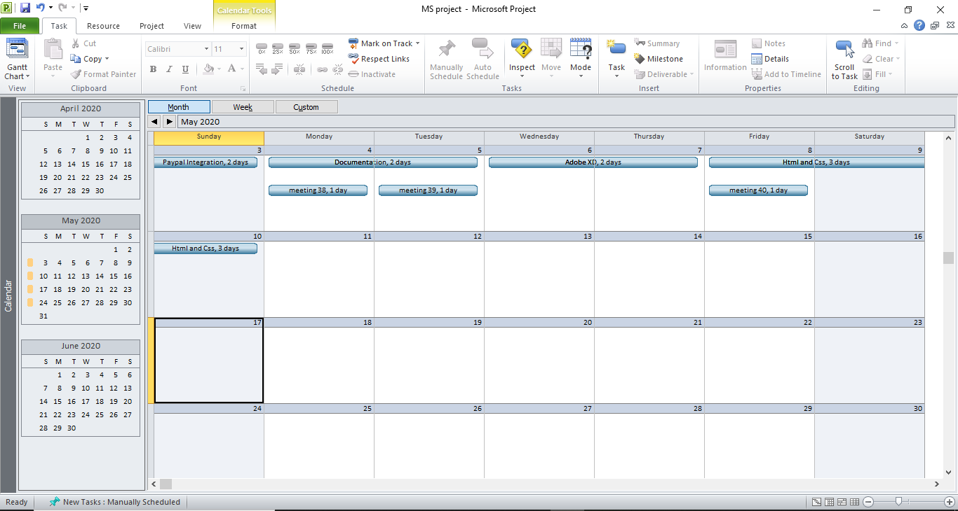

## 2.3.5 Resource Sheet

Resource sheet 1

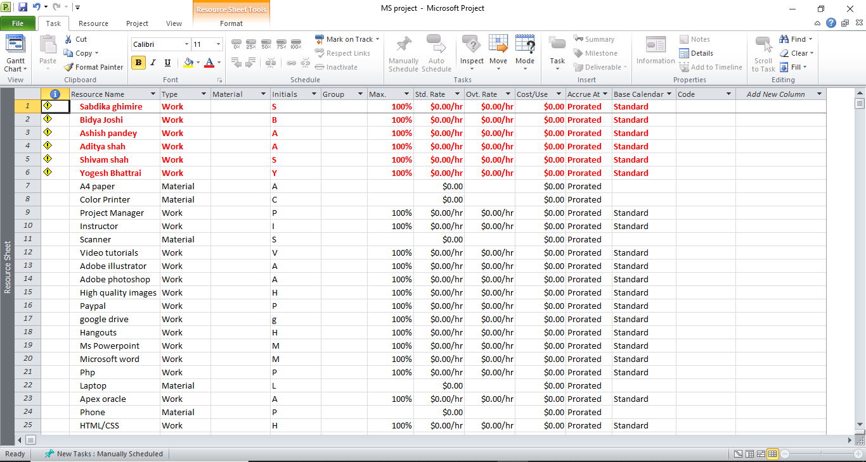

Resource sheet 2

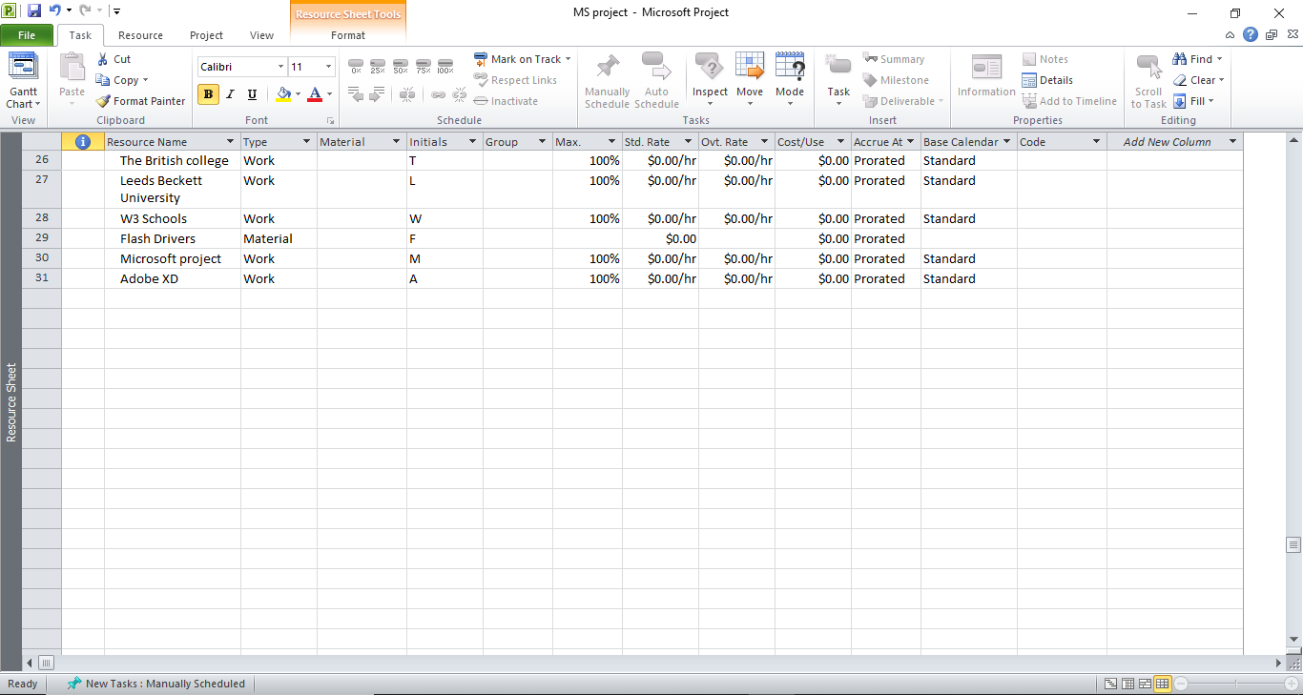

## 2.3.6 Project Task

Task sheet 1

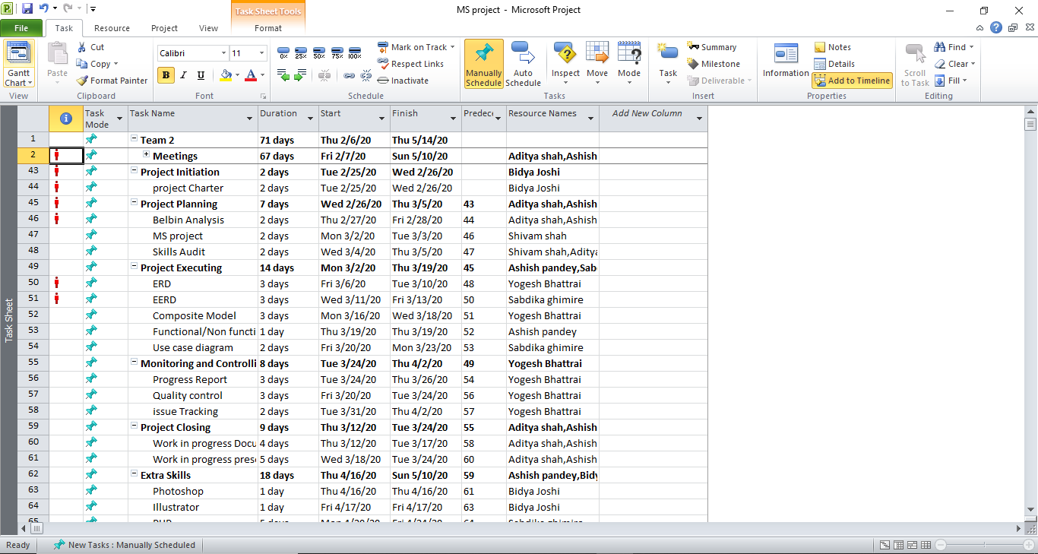

Task sheet 2

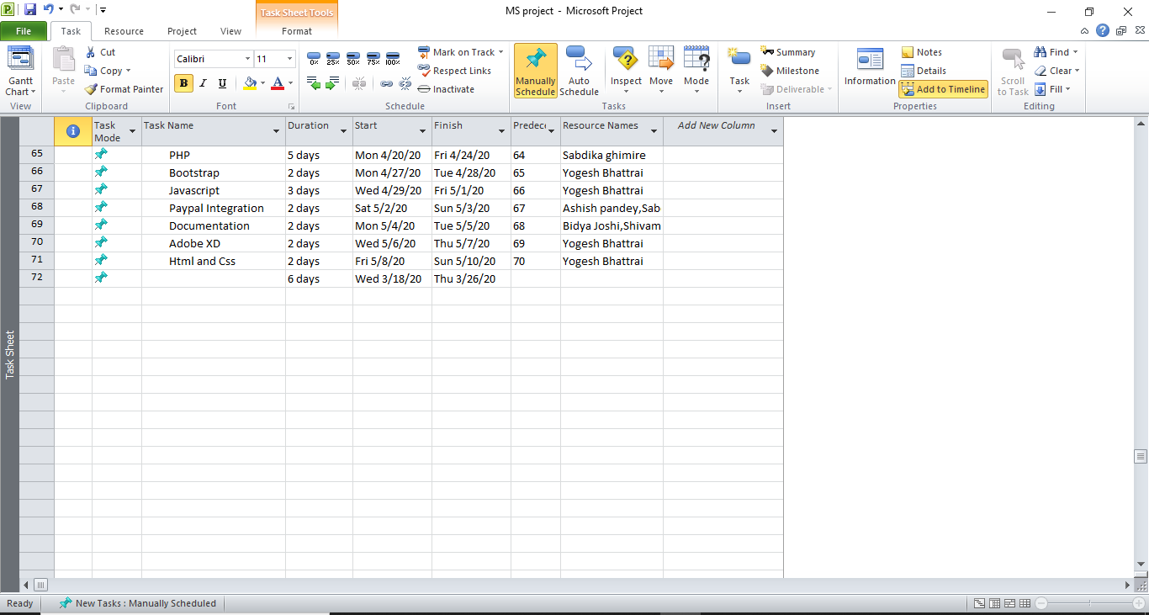

## 

## 2.3.7 Changing Working Time

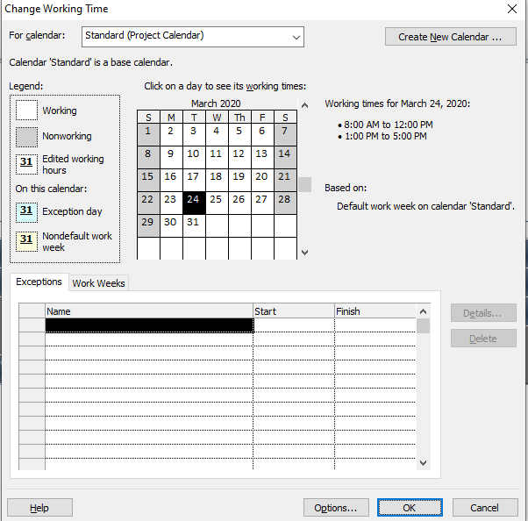

Project Management (MS Project) Version2

Calendar 1

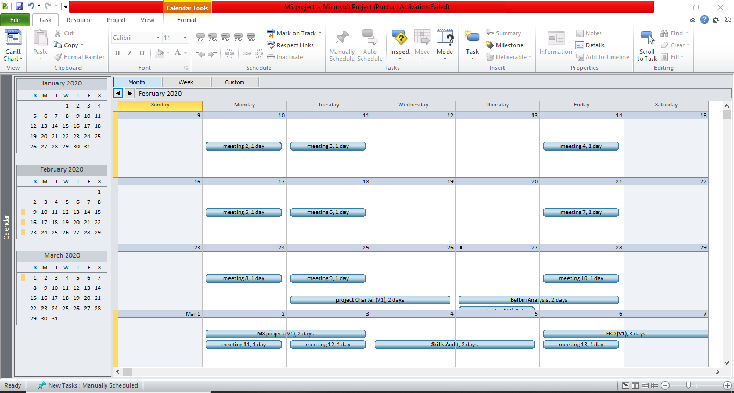

Calendar 2

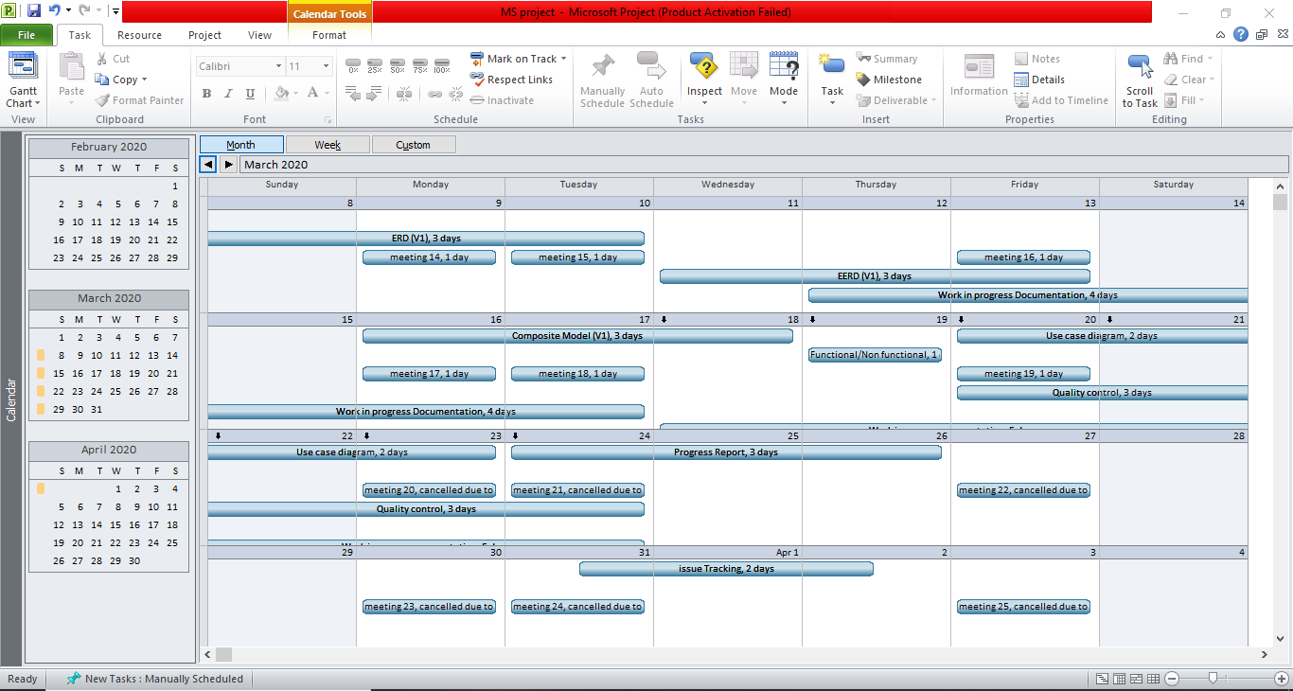

Calendar 3

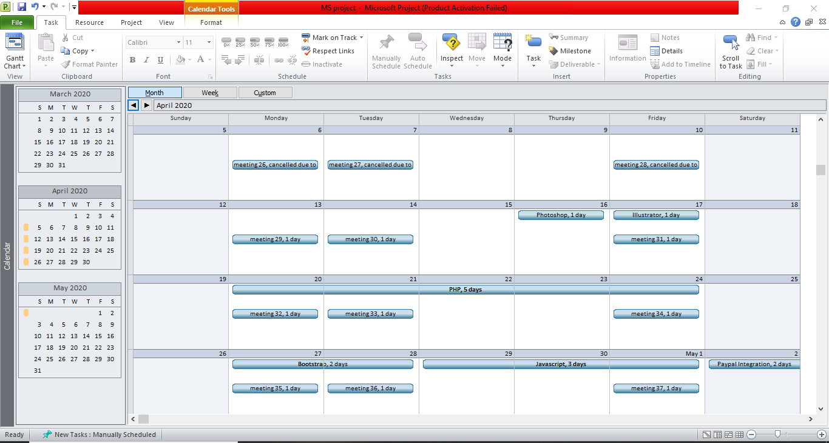

Calendar 4

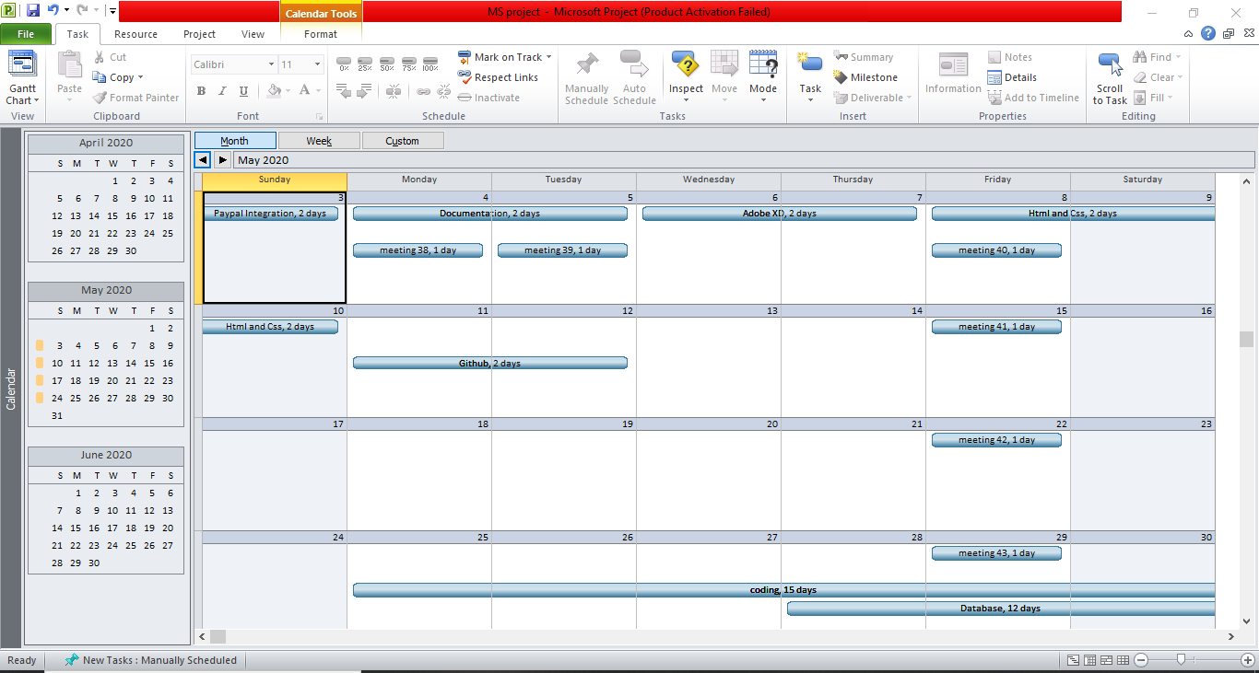

Calendar 5

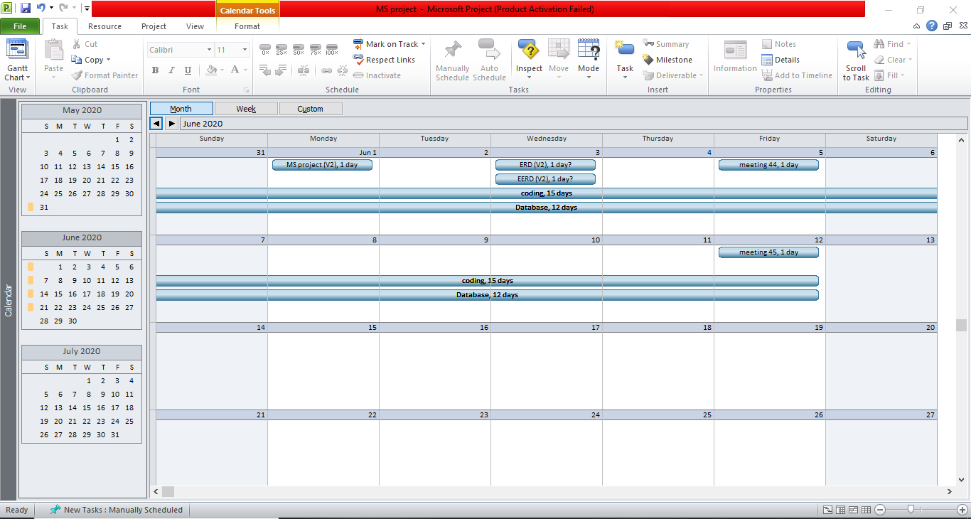

Change Working Time

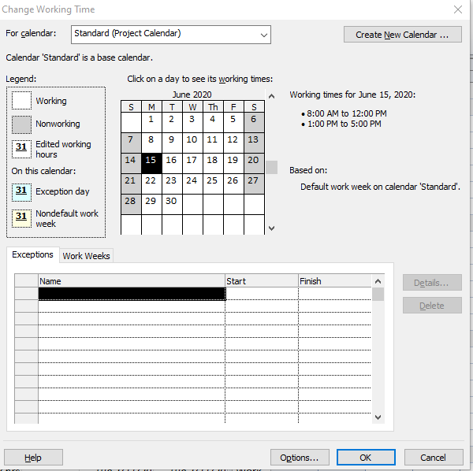

Gantt chart 1

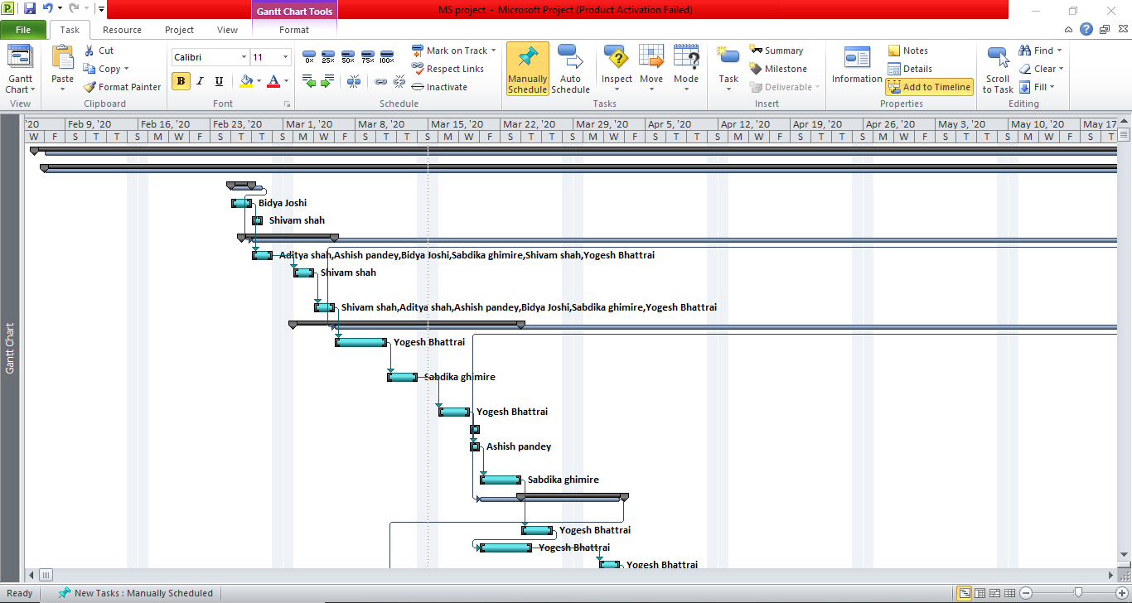

Gantt chart 2

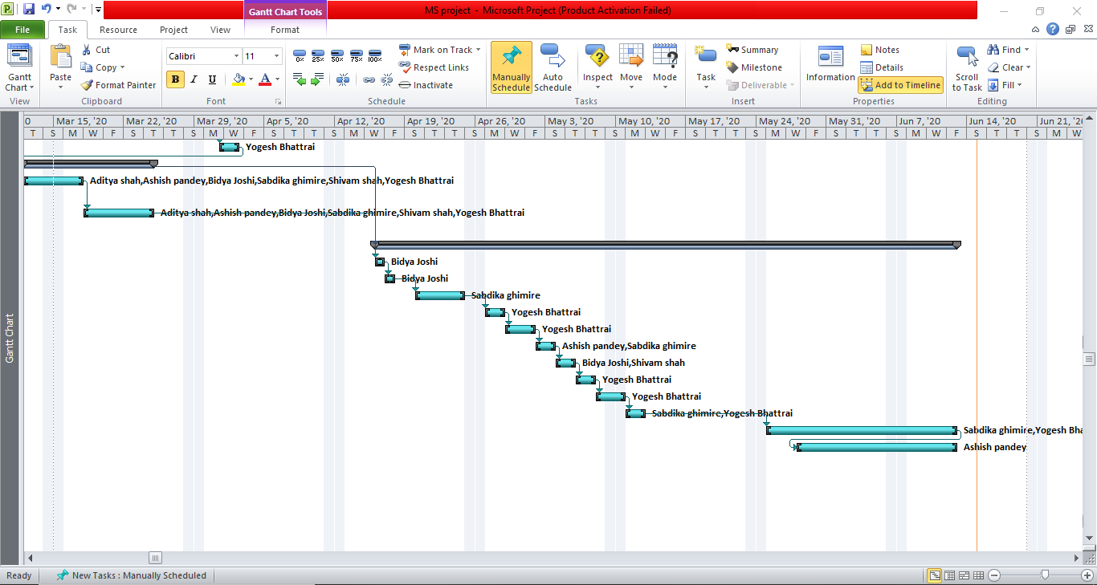

Network Diagram 1

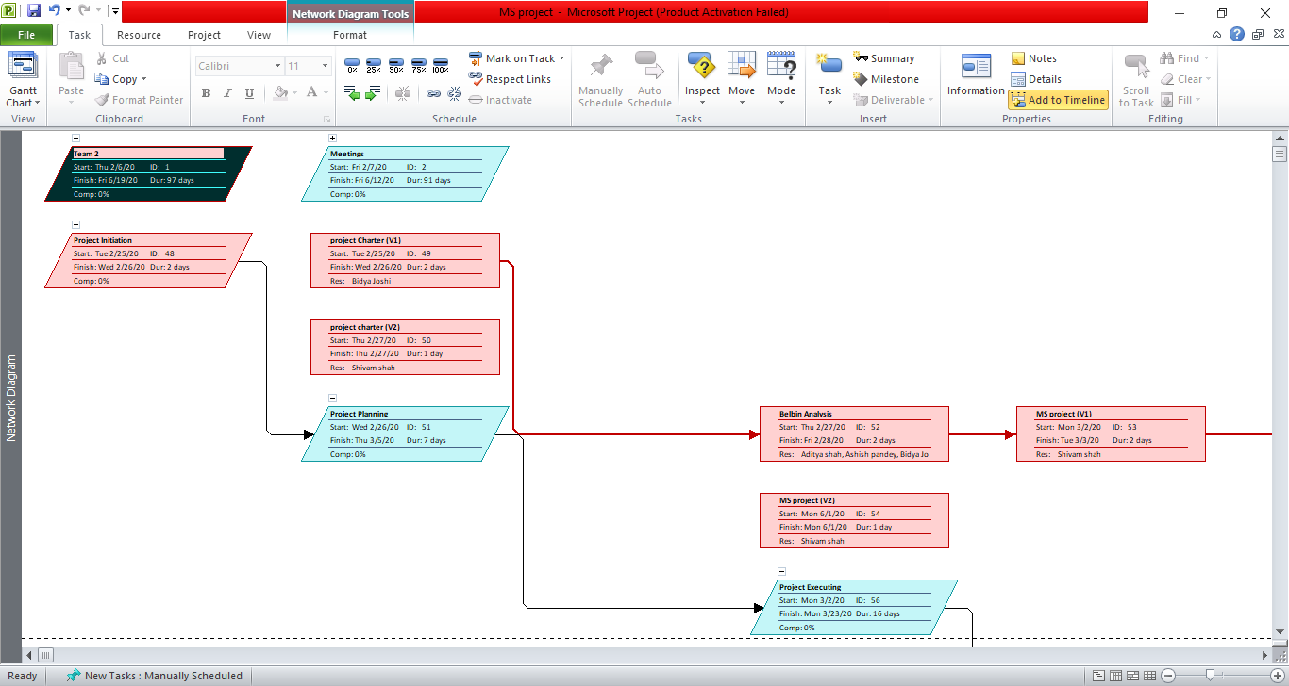

Network Diagram 2

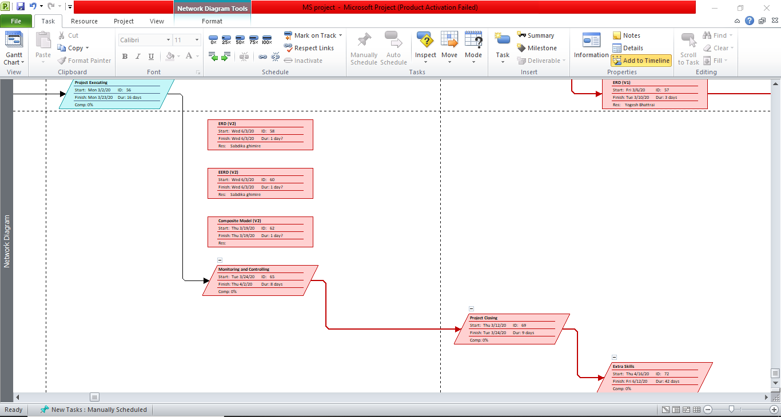

Network Diagram 3

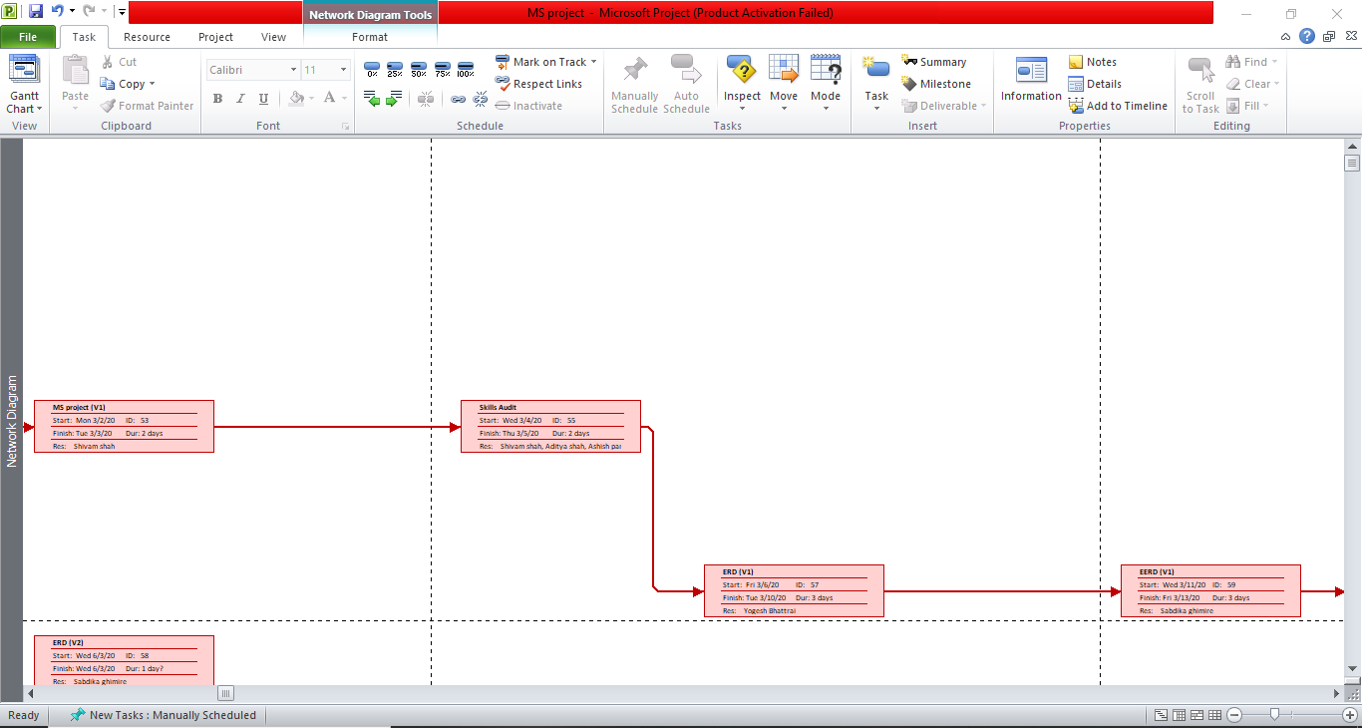

Network Diagram 4

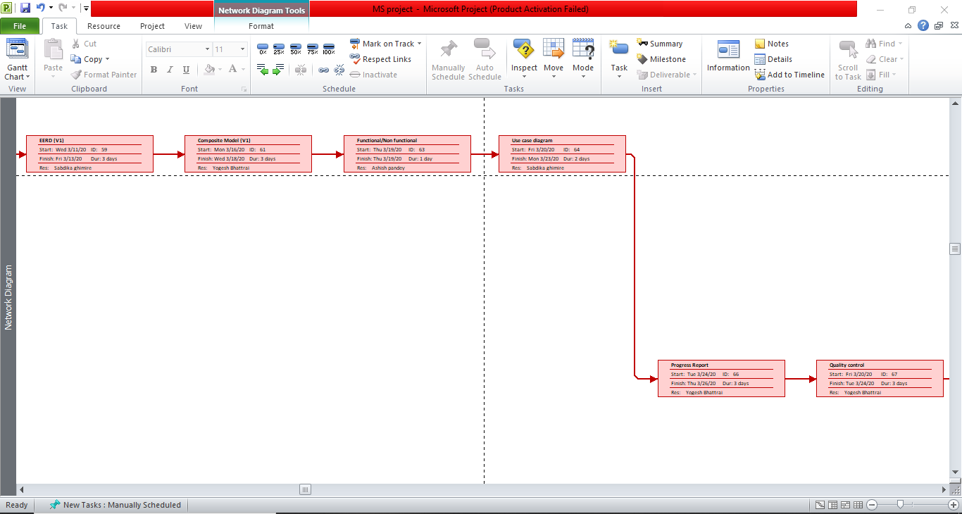

Network Diagram 5

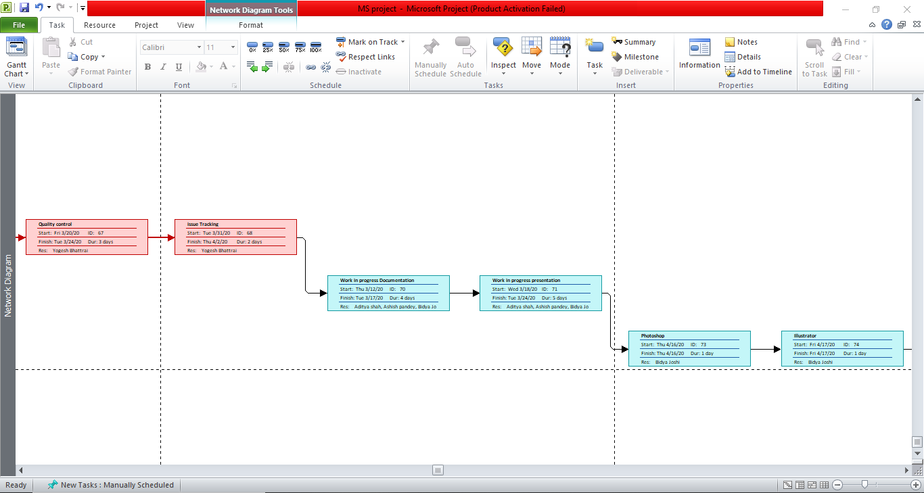

Network Diagram 6

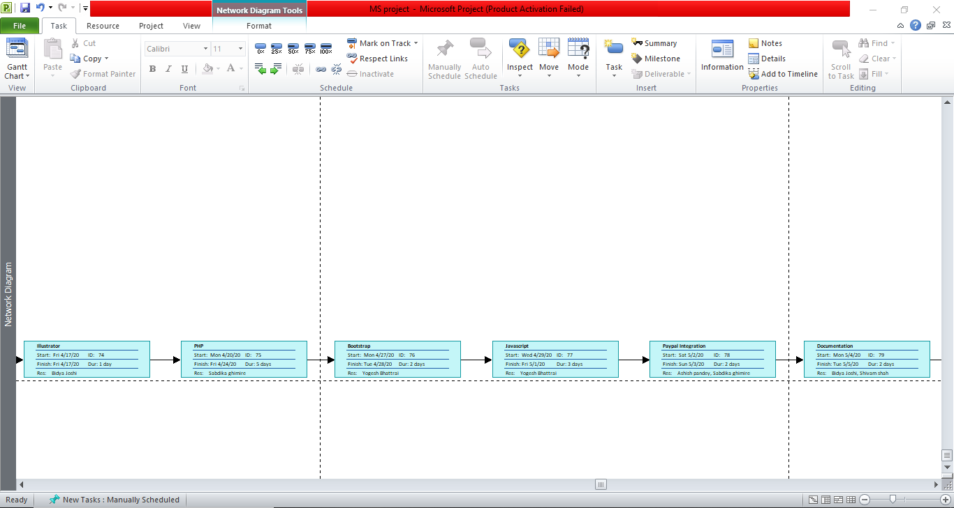

Network Diagram 7

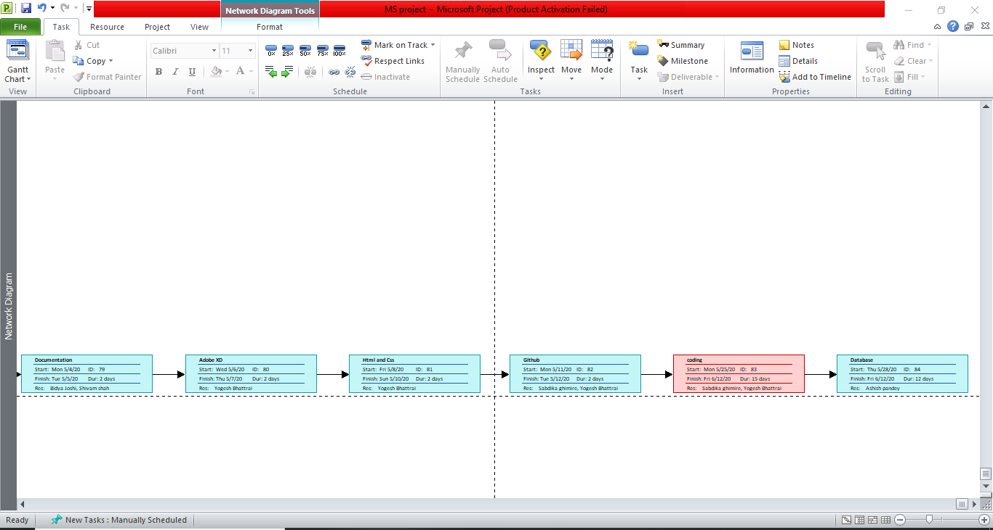

Resource Sheet 1

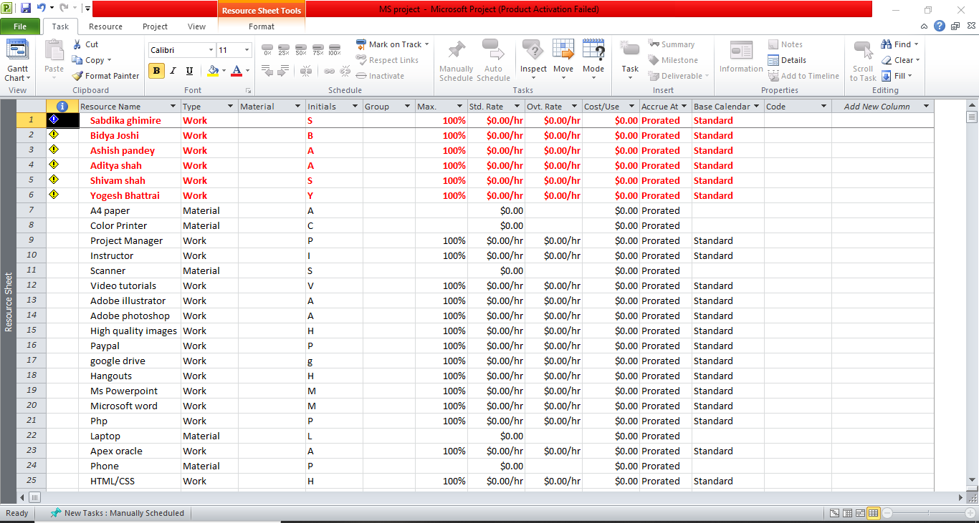

Resource Sheet 2

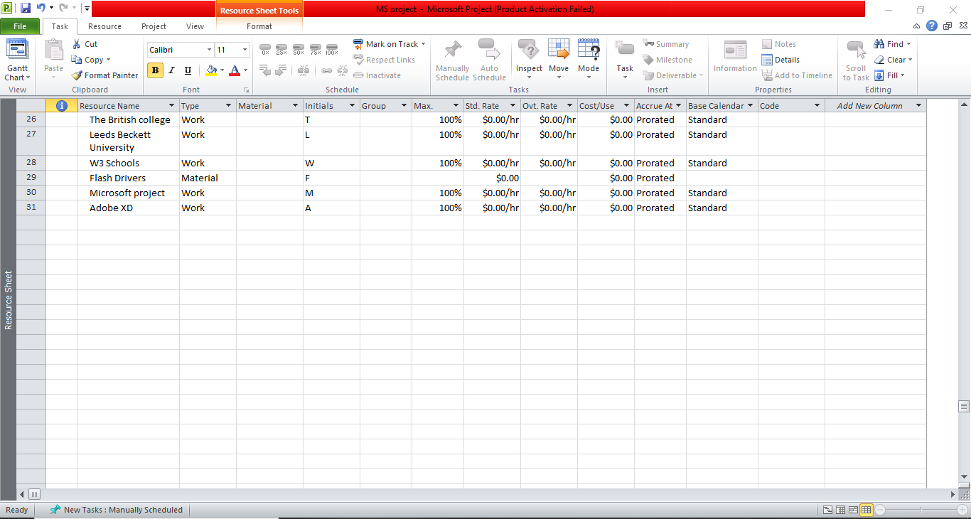

Task Sheet 1

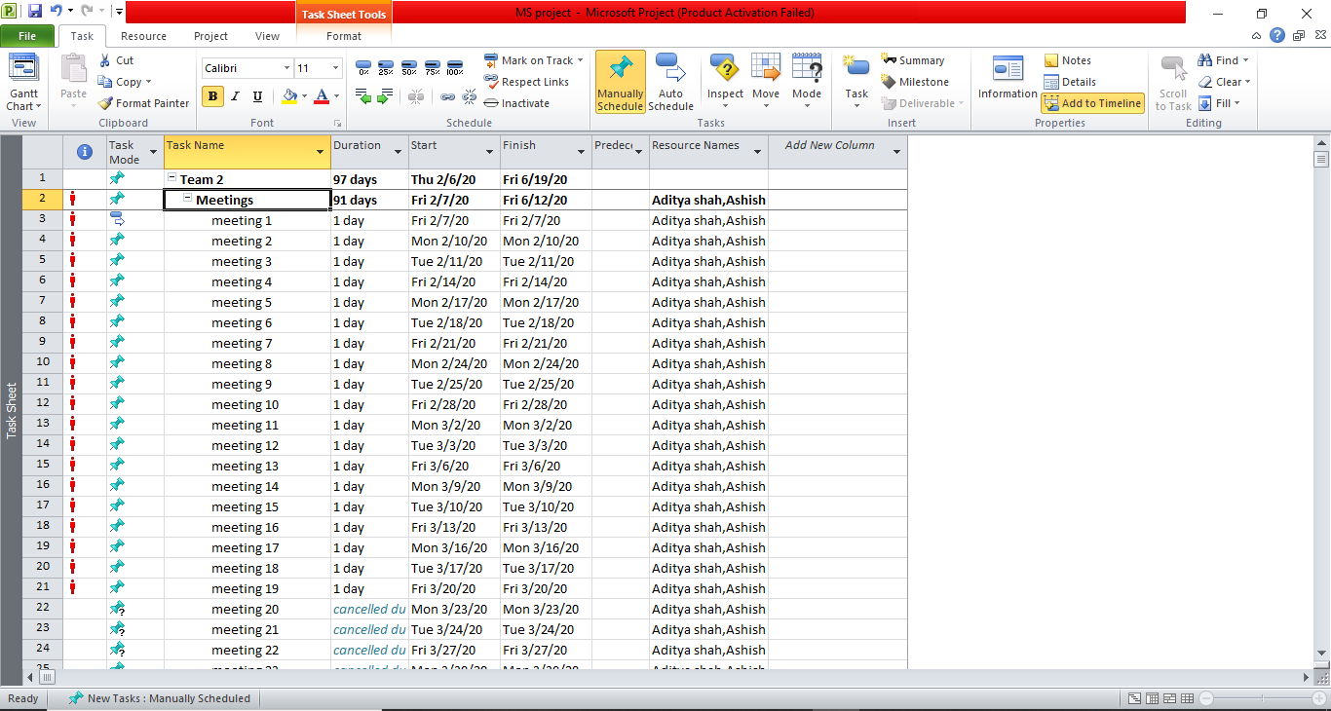

Task Sheet 2

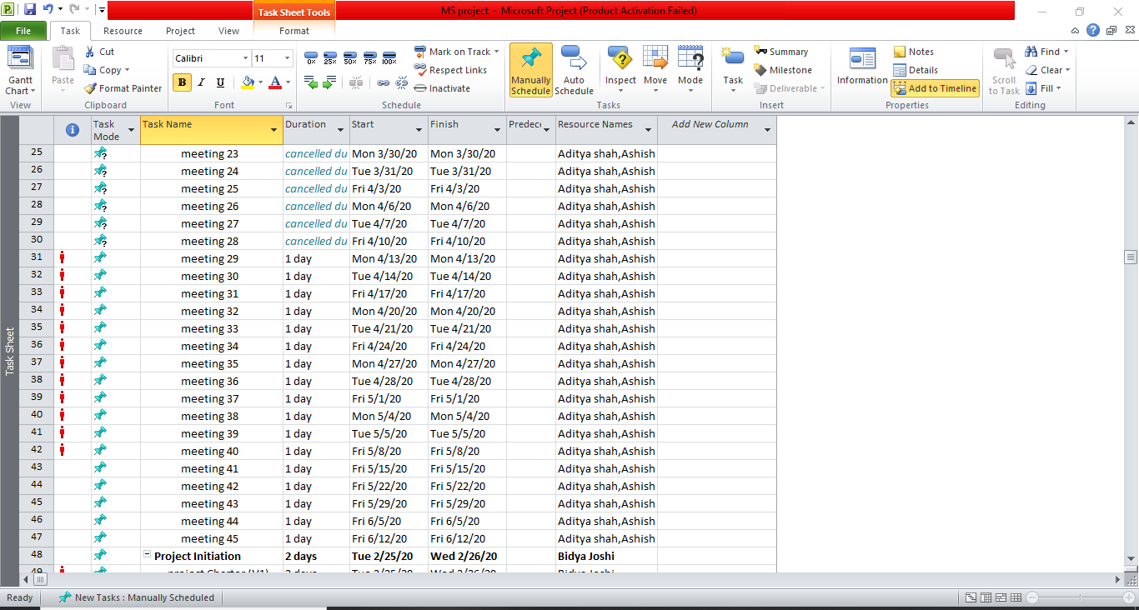

Task Sheet 3

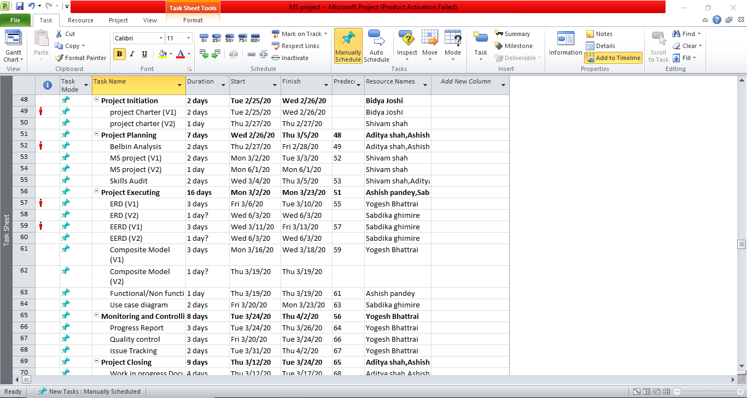

Task Sheet 4

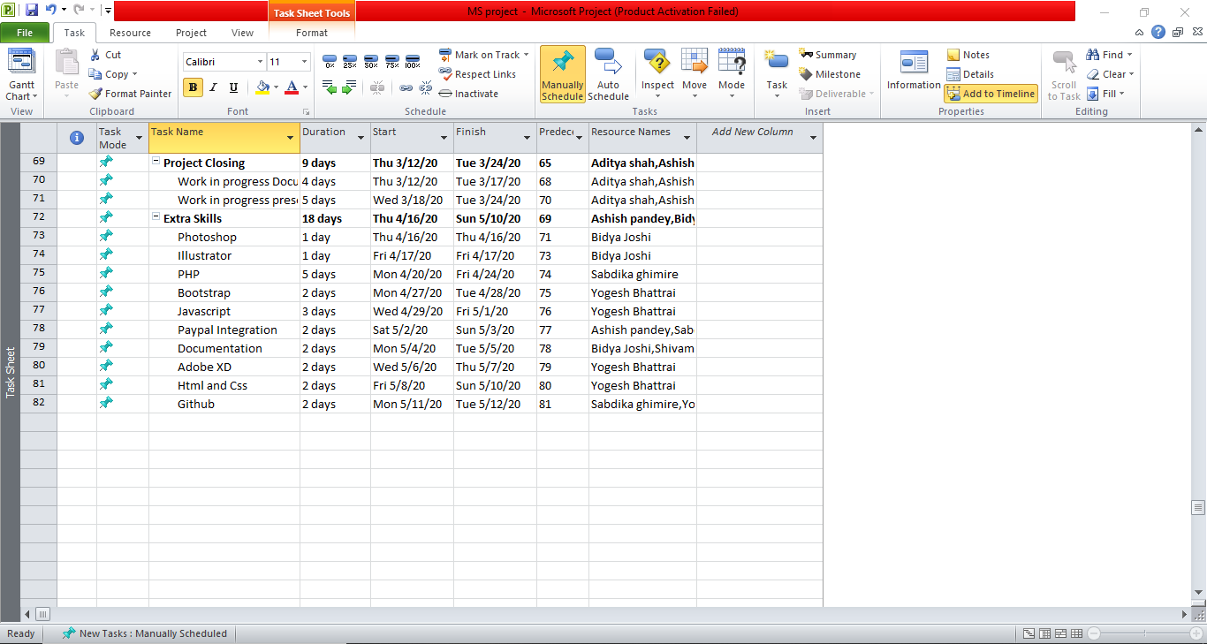

Timeline

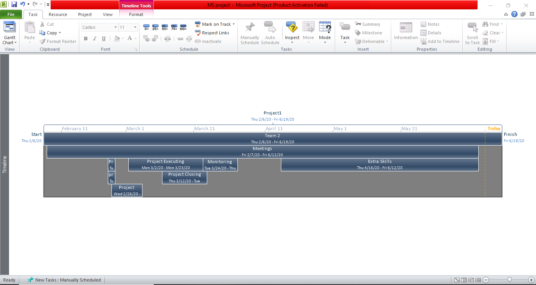

## Communication and Collaboration Tools

|  |
| --- |
| The communication means of between our team members are Hangout, Google Drive, Gmail and Github.  Hangout is the platform of communication where we discuss, make strategy and plan the ideas and creativity for the project.  Whilst Gmail is also the platform used to share document and content needed for our project. However, Google Drive is also used to share documentation and file needed for our project.    We will report higher level of management and to clients by providing screenshot of communication and documentation shared during the making of project.  Team meeting is going to be after the college time where we will be planning and doing work for the project.  Thus, Github will be repository where we will be keeping our backup, documents will be shared, and master copies are kept. |

# 1. Execution Phase

## Entity Relationship Diagram

## Entity Relationship Diagram (ERD)



## Extended Entity Relationship Diagram (EERD)



## Final Composite Model



## Logical Diagram

**INDEX:**

1. Red font: Primary key
2. Cursive bold yellow font: Foreign key
3. Bold black font: table name

* **User** (User_Id, Username, User_password, User_phone, User_address, User_email, User_type, User_image, User_description)
* **Customer** (Customer_Id, ***User_Id***)
* **Trader** (Trader_Id, trader_products, trader_type, ***User_Id***)
* **Admin** (Admin_id, admin_type, ***User_Id***)
* **Payment** (Payment_id, Payment_status, Payment_type, Payment_date, Payment_time, ***User_Id***, ***Customer_Id***)
* **Orde**r (order_id, order_quantity, order_status, order_date, order_time, order_description***, cart_id***, ***Payment_id***, ***slot_id***)
* **Collection_Slot** (slot_id, slot_time, slot_date, slot_status)
* **Cart** (cart_id, total_price)
* **Review** (review_id, review_comment, rating_review, review_time, review_date, ***Customer_Id***)
* **Cart_Product (*cart_id*, *product_id*)**
* **Product** (product_id, product_name, product_type, product_description, product_price, product_status, product_image, product_keywords, min_order, max_order, allery_information, ***Trader_Id***, ***shop_id, Category_id***, ***review_id***, ***order_id***, ***discount_id, Customer_Id***)
* **Shop** (shop_id, shop_type, shop_description, shop_image, ***Trader_Id***)
* **Category** (Category_id, Category_name, Products_quantity, category_type)
* **Discount** (discount_id, discount_percentage, discount_name, ***Trader_Id***)

Updated Entity Relationship Diagram

3.1.5 Extended Entity Relationship Diagram



3.1.6 Entity Relationship Diagram



3.1.7 Final Composite Model

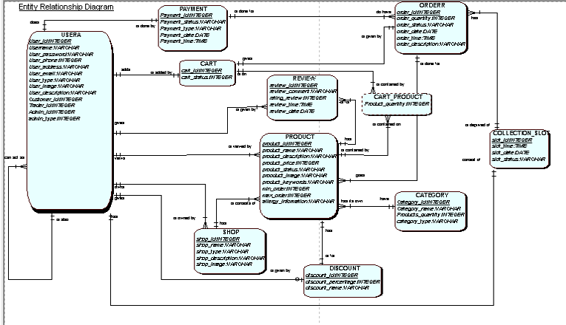

## 

## 3.2 Use Case Diagram

## 3.2.1 Overview Use Case Diagram



## 3.2.2 Customer Use Case Diagram



## 3.2.3 Trader Use Case Diagram



## 3.2.4 Management Use Case Diagram



## 

## 3.3 Requirement Catalogue

## 3.3.1 Functional Requirement

* Part A: Customer Interface

| Requirement ID | Description | MoSCoW |
| --- | --- | --- |
| A1 | **An interface to allow customers to view items.** |  |
| A1-01 | Customers will able to display items by category. | M |
| A1-02 | Users should be able to navigate to products by shop or by product type. | M |
| A1-03 | Customers will able to search for items to find product instantly. | M |
| A1-04 | Customers will able to sort things displayed fittingly like: price, date, alphabetical etc. | S |
| A1-05 | Customers will able to search items by alphabetical. | S |
| A2 | **Login and Registration** |  |
| A2-01 | Customers should be provided with a register form before they can place an order. | M |
| A2-02 | Customers will be able to review and update their account details. | M |
| A2-03 | Registration and account updates should be confirmed through interaction with emails. | M |
| A2-04 | If customer want to register again with the same email address, and unfortunately, if the customer forget their email, they can easily reset their password. | S |
| A3 | **Cart functionality for customers** |  |
| A3-01 | Customers should be provided with a single basket that holds goods that spans all traders and requires a single payment. | M |
| A3-02 | Customers has facility to update and delete products from cart list. | M |
| A3-03 | Customers can register or login their account before they can order and be logged into access the basket. | M |
| A3-04 | A virtual cart that allows customers to select multiple products at once before checkout. | S |
| A3-05 | A view cart page for reviewing the selected items. | S |
| A4 | **Payment system for customers** |  |
| A4-01 | Customers has facility with an online payment system. | M |
| A4-02 | Customers will able to provide with a bill of products in their cart before checking out. | M |

* Part B: Trader Interface

|  |  |  |
| --- | --- | --- |
| Requirement ID | Description | MoSCoW |
| **B1** | **An interface for traders** |  |
| B1-01 | Traders should be able to manage their products and information on their shops via a web interface. | M |
| B1-02 | Traders will be able to deactivate their account. | M |
| B1-03 | Traders should be able to view their products and also update their account details. | M |
| **B2** | **Registration for traders** |  |
| B2-01 | Server-side validation of all form objects to ensure none of the fields are empty. | S |
| B2-02 | Verifying traders by validating their email. | M |
| B2-03 | Before storing the password in the database it should be encrypted. | C |
| **B3** | **Login portal for traders** |  |
| B3-01 | A login form to collect username/email and password. | M |
| B3-02 | An option for forget password which redirects to the link for changing password to the user email. | W |
| **B4** | **An interface to use the CRUD functionality for traders** |  |
| B4-01 | Traders will be able to add/delete/update their products. | M |
| B4-02 | Traders will be able to manage their products and information. | M |
| B4-03 | All products added will have a unique ID and will be associated with the traders. | M |
| B4-04 | Traders will have the option for providing discounts on their products. | S |
| **B5** | **An interface for reports and accessibility** |  |
| B5-01 | Traders will get their daily/weekly/monthly invoice for their sales in their website. | M |
| B5-02 | Traders can see the ratings on their products. | C |
| B5-03 | Traders will be able to get their financial report and the statement on request. | C |
| B5-04 | Traders can change their collection slot. | W |

* Part C: User Interface

|  |  |  |
| --- | --- | --- |
| Requirement ID | Description | MoSCoW |
| **D1** | **Registration interface** |  |
| D1-01 | A form that collects detail of the user. | M |
| D1-02 | QR code shall be provided for signing in. | W |
| **D2** | **Login interface** |  |
| D2-01 | The user will be able to view the products. | M |
| D2-02 | The user will be able to search and also sort items accordingly with their requirement. | M |
| D2-03 | A categorize option is also available to the user. | M |

#### Part C: Management

| Requirement ID | Description | MoSCoW |
| --- | --- | --- |
| C1 | **Management Dashboard** |  |
| C1-01 | The management dashboard link will be provided that display the activities of traders. | M |
| C1-02 | Traders can get access to view daily and periodic reports via management dashboard. | M |
| C1-03 | When the traders will login, management will provide the report that will identify the ordered goods along with their quantities. | M |
| C1-04 | Management will furnish the traders with weekly financial report that will identify payments to be made. | M |
| C1-05 | The report should cover only orders that have been collected from collection slot. | M |
| C1-06 | Monthly product sales report will be presented to traders by the management with the provision of sorting. | M |
| C1-07 | The management will get daily turnover report in the dashboard. | C |
| C2 | **Login Privilege** |  |
| C2-01 | Login form will be provided to the management that will direct to the management dashboard. | M |
| C2-02 | Management will be able to access the e-commerce website. | M |
| C3 | **Management Accessibility** |  |
| C3-01 | The management will be able to delete inappropriate products in the website. | M |
| C3-02 | The management will be able to accept or decline new trader requests. | S |
| C3-03 | Management can do deactivation of traders and customers account. | S |
| C3-04 | The management will be able to send email verification to customers and traders. | M |
| C3-05 | The management will be able to provide new login credentials. | S |

## 3.3.2 Non-Functional Requirement

| Requirement ID | Description | MoSCoW |
| --- | --- | --- |
| D1 | **Web Interface** |  |
| D1-01 | The user will be given good design with proper value proposition place. | M |
| D1-02 | The website should be user friendly according to the needs and requirements. | S |
| D1-03 | The responsive website will give more clarity to a bug free website. | M |
| D1-04 | A proper HTML/CSS template will be constructed throughout the website. | M |
| D1-05 | A proper JQuery and JavaScript functionality will be applied throughout the website to give more functionality. | M |
| D2 | **Miscellaneous Functions** |  |
| D2-01 | Offer banner will be displayed on home page and top of every main page. | S |
| D2-02 | Discount should be given to every user on their special order placed. | C |
| D2-03 | Ratings will be shown on each product while hovering. | S |

## 3.4 Website Mockup

## 3.4.1 Team Logo



## 3.4.2 Website Logo



## 3.4.3 Banner





## 3.5 Website Wireframe

3.5.1 Admin Dashboard

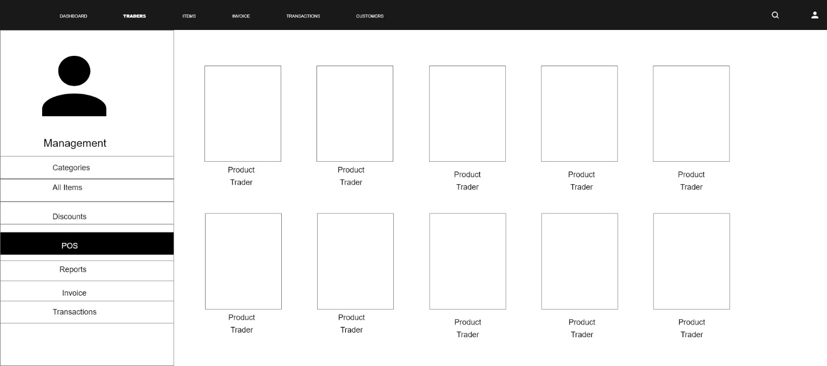

3.5.2 Homepage

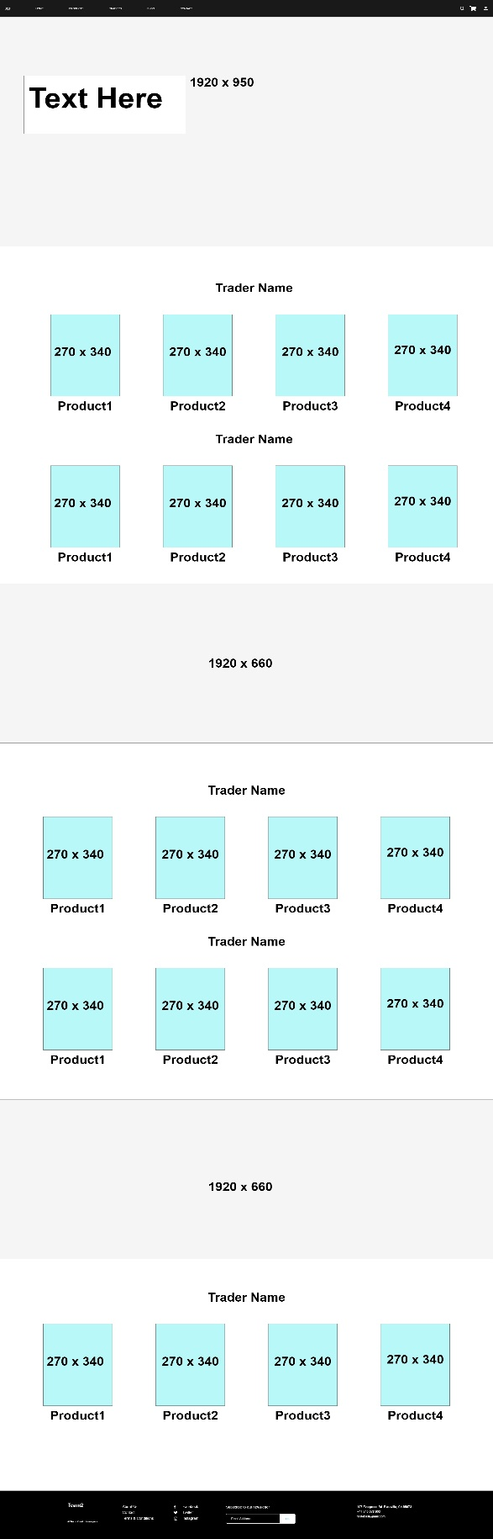

3.5.3 Login and register

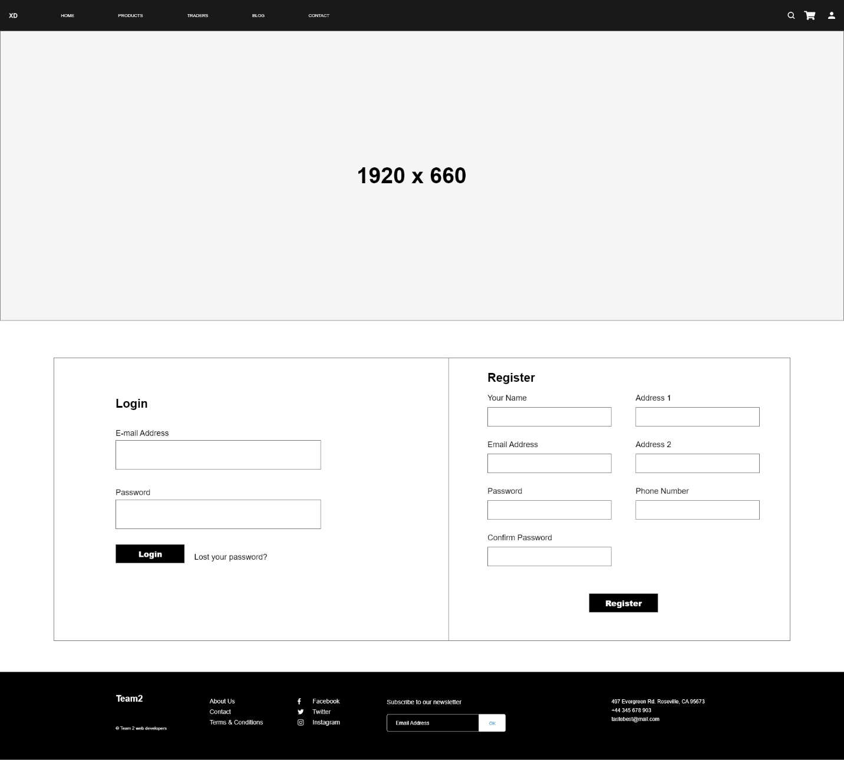

3.5.4 Product page

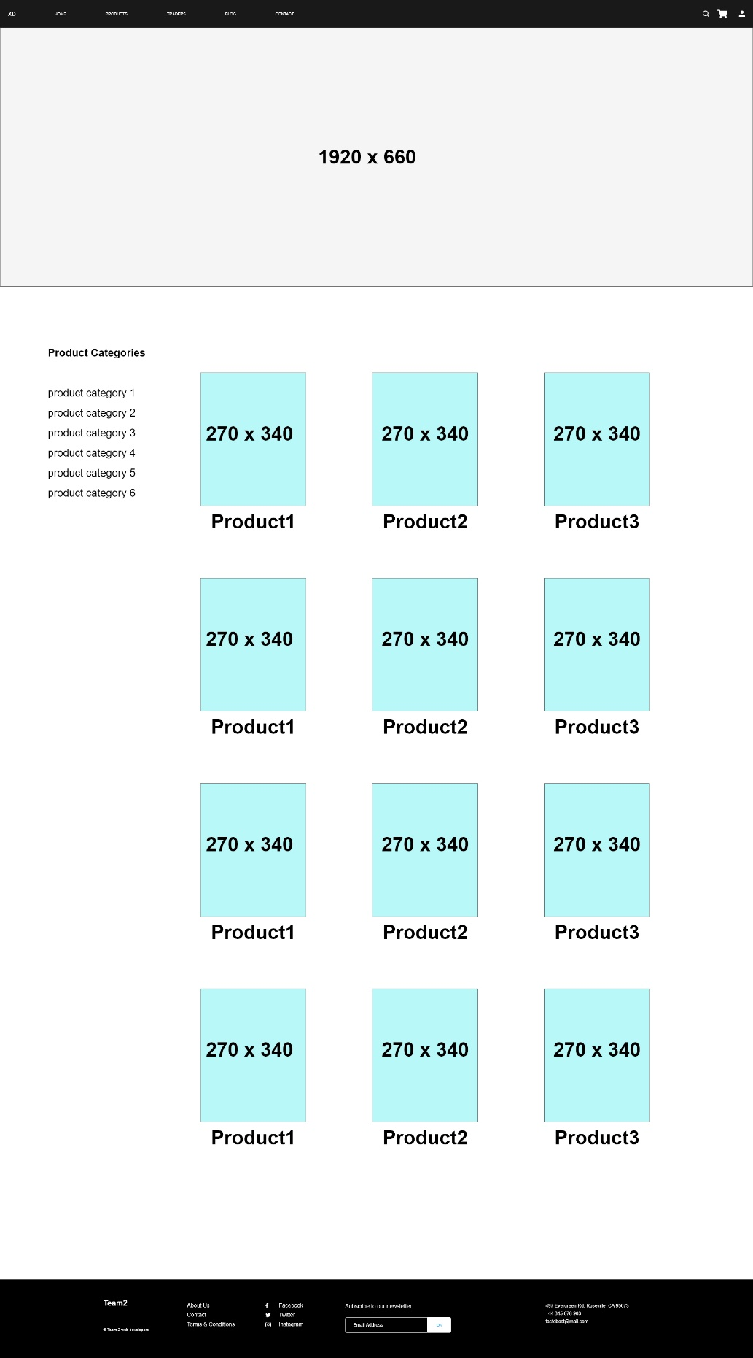

3.5.5 Trader Dashboard

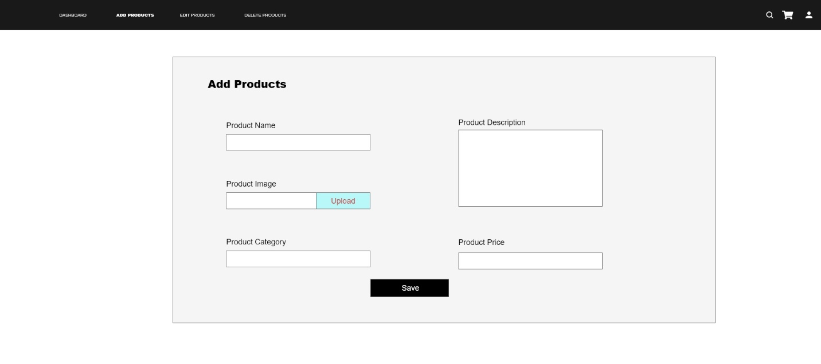

3.5.6 Trader Page

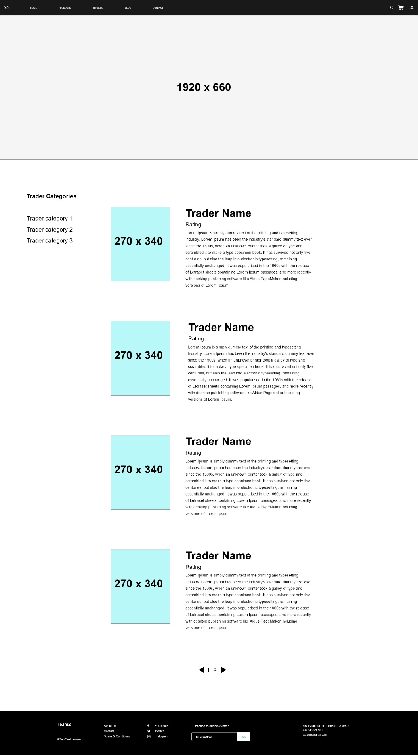

## 3.6 Product Development

## 3.6.1 Database Tables in Oracle

## 3.6.2 User

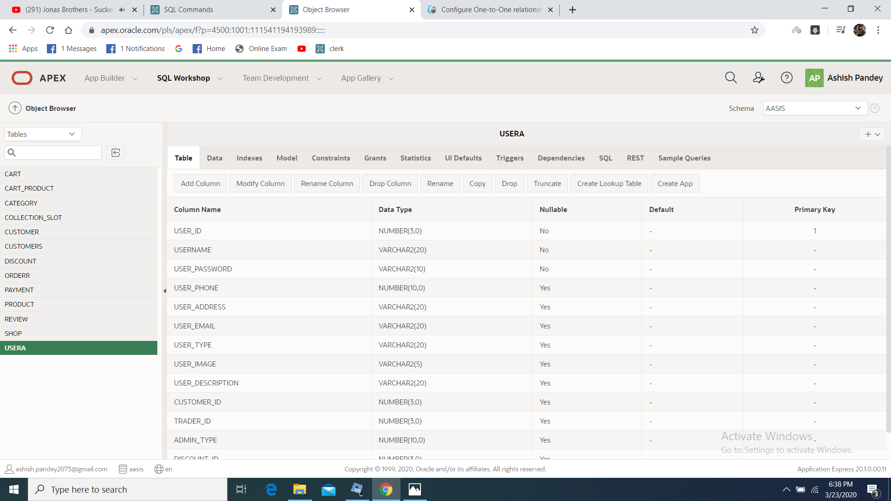

## 3.6.3 Shop

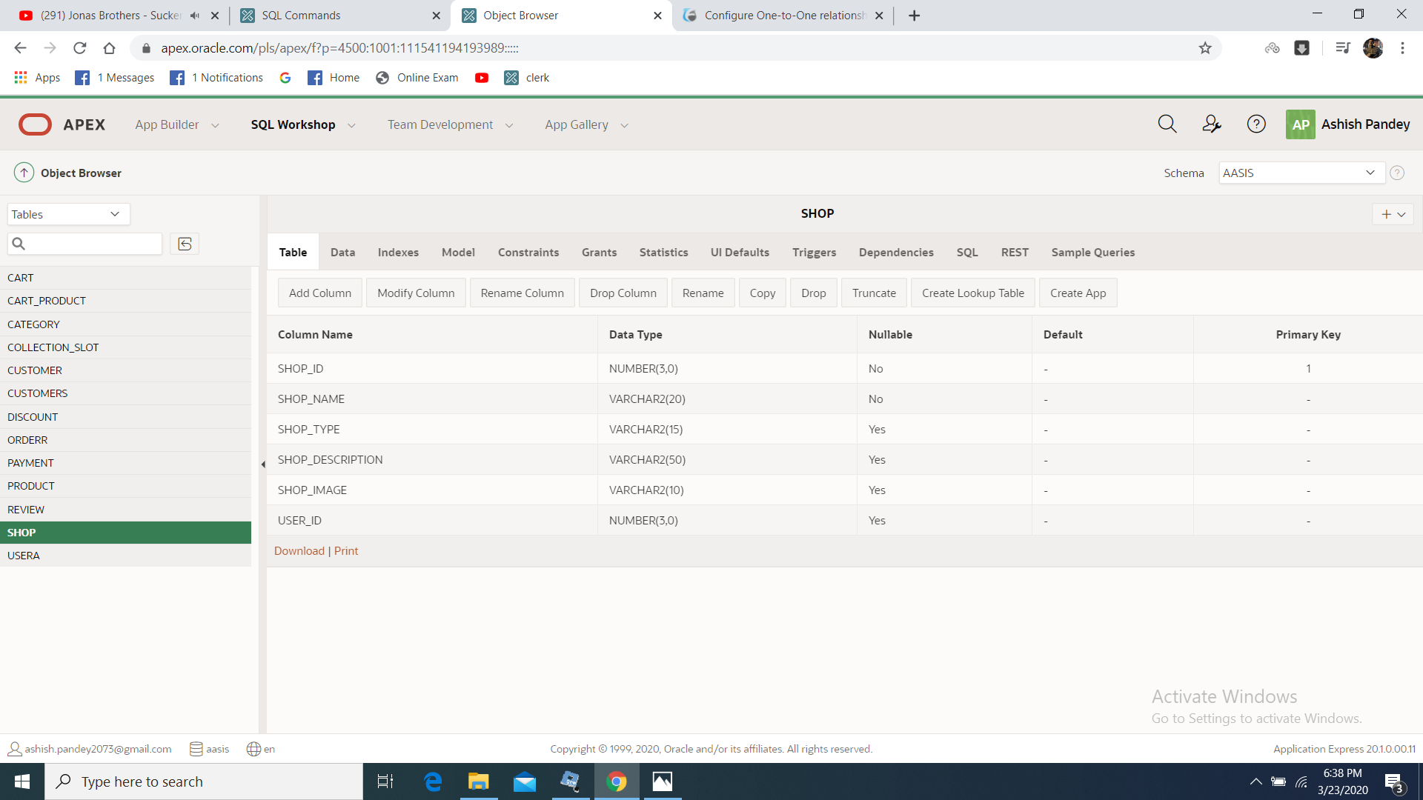

## 3.6.4 Category

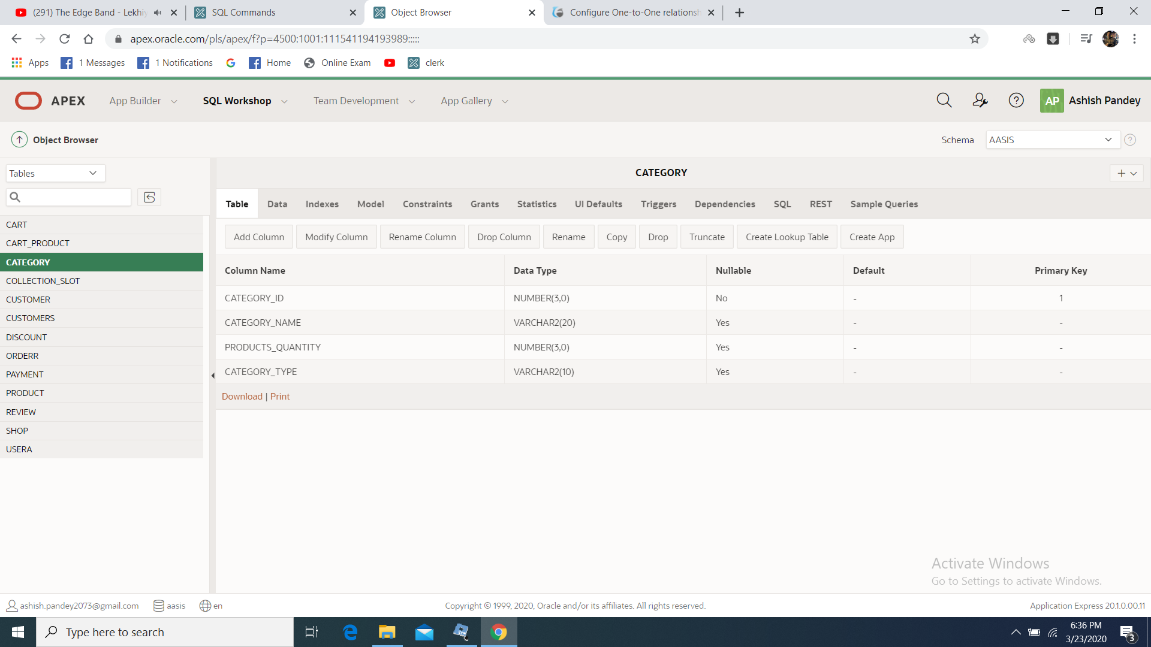

## 3.6.5 Product

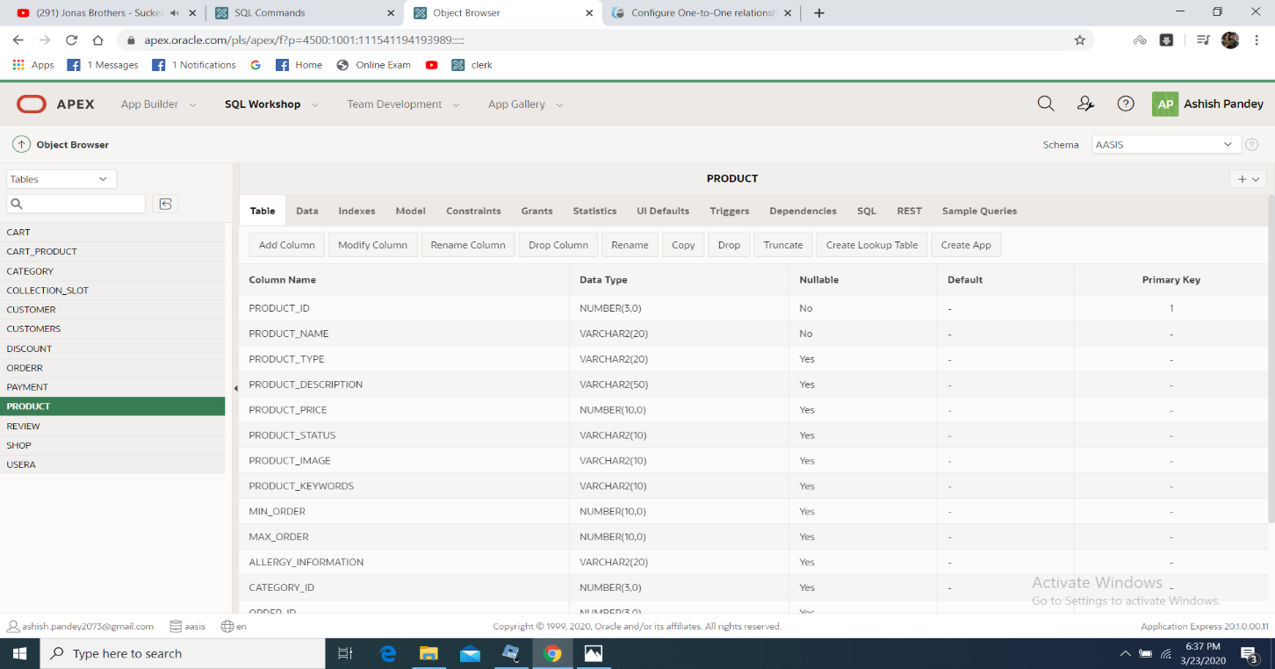

## 3.6.6 Discount

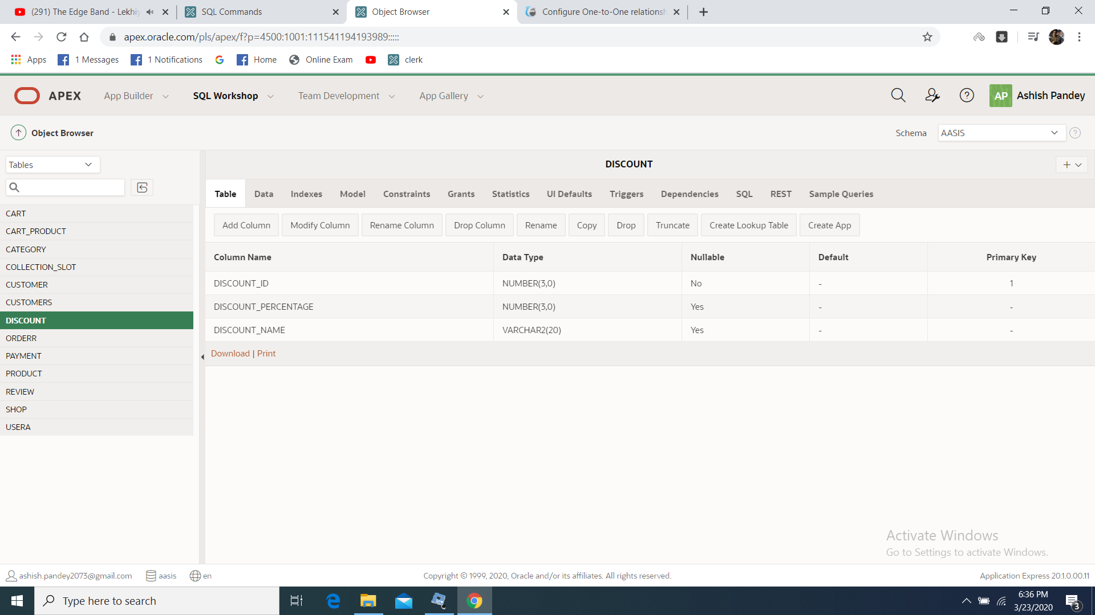

## 3.6.7 Cart

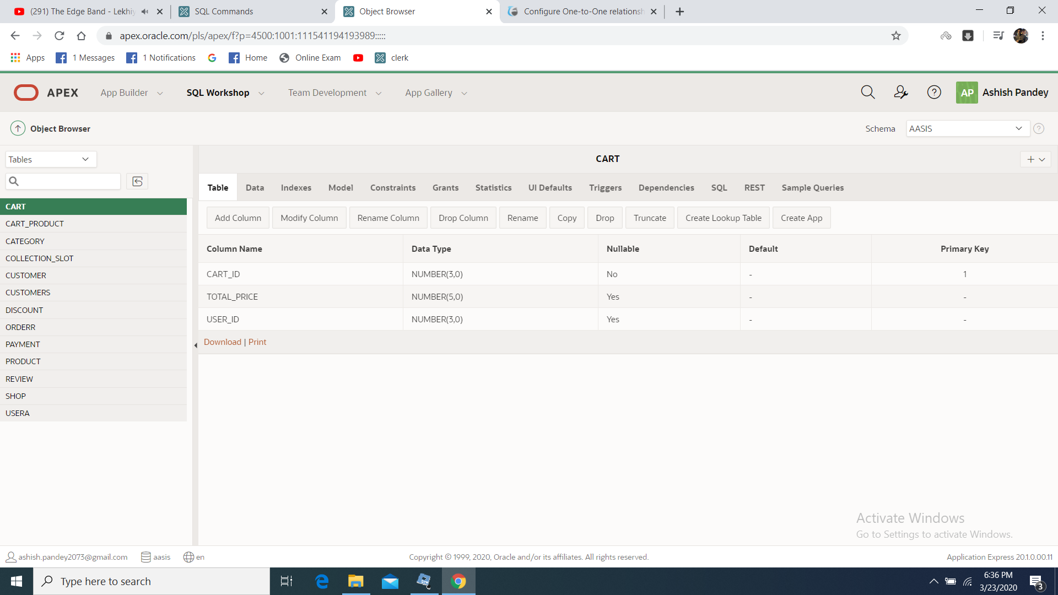

## 3.6.8 Order

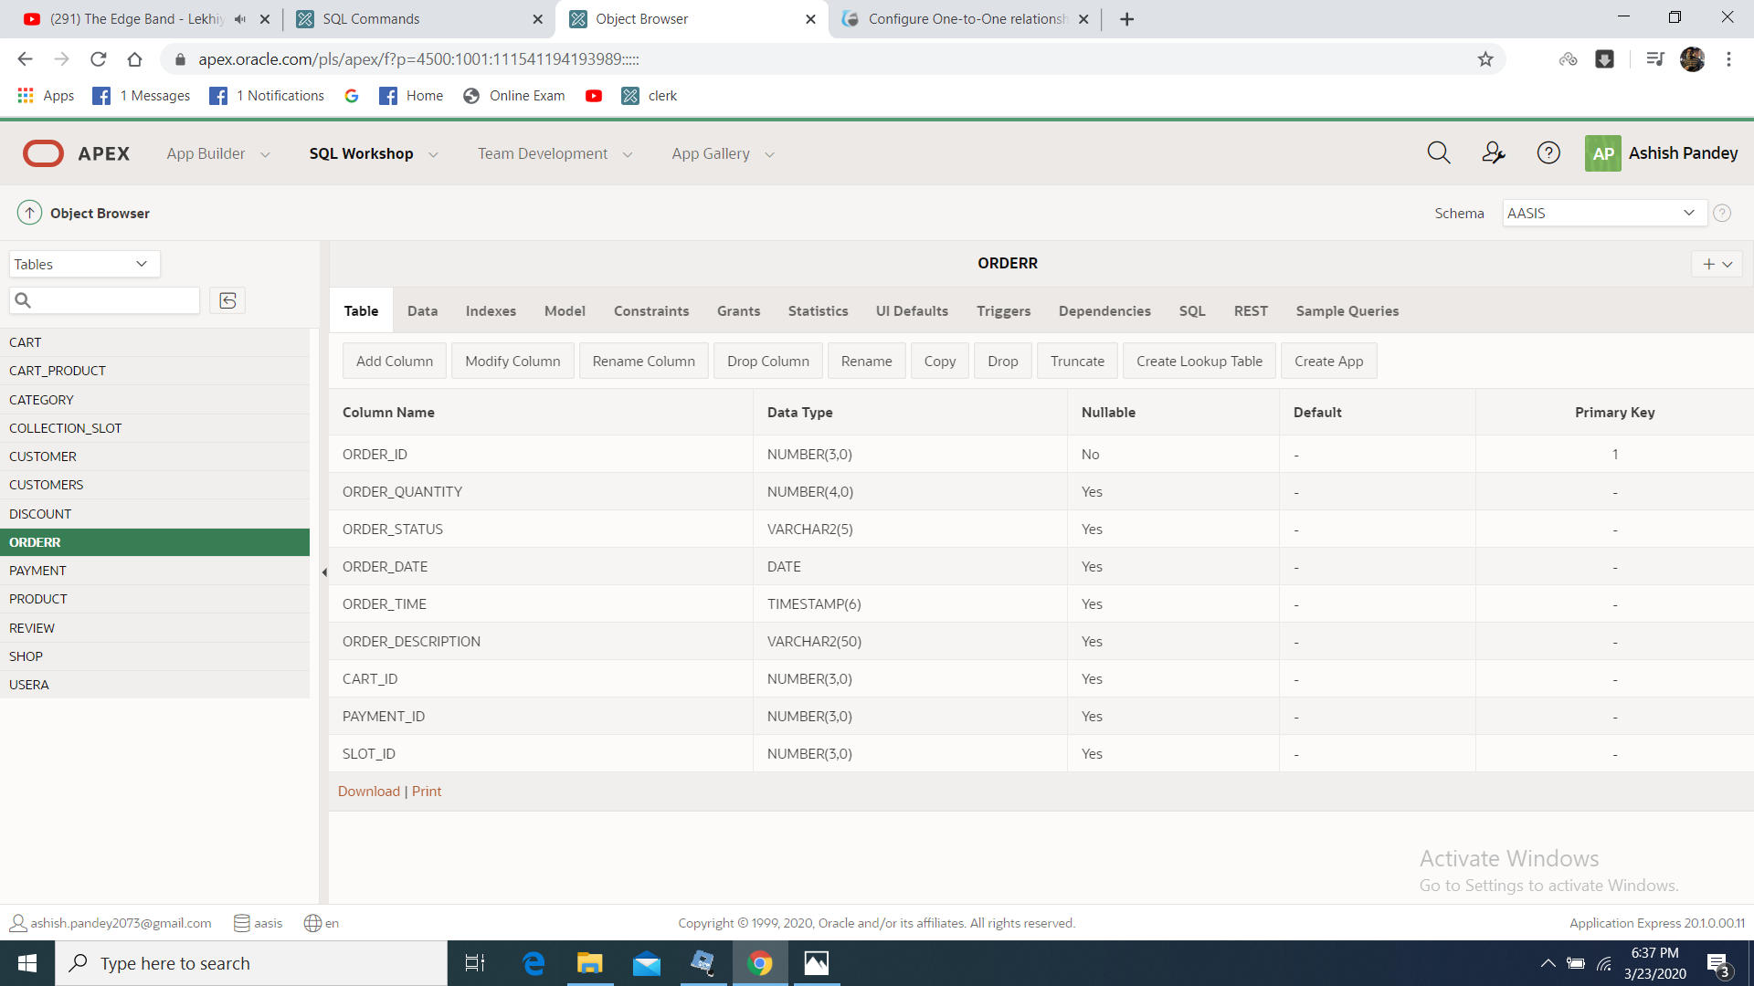

## 3.6.9 Payment

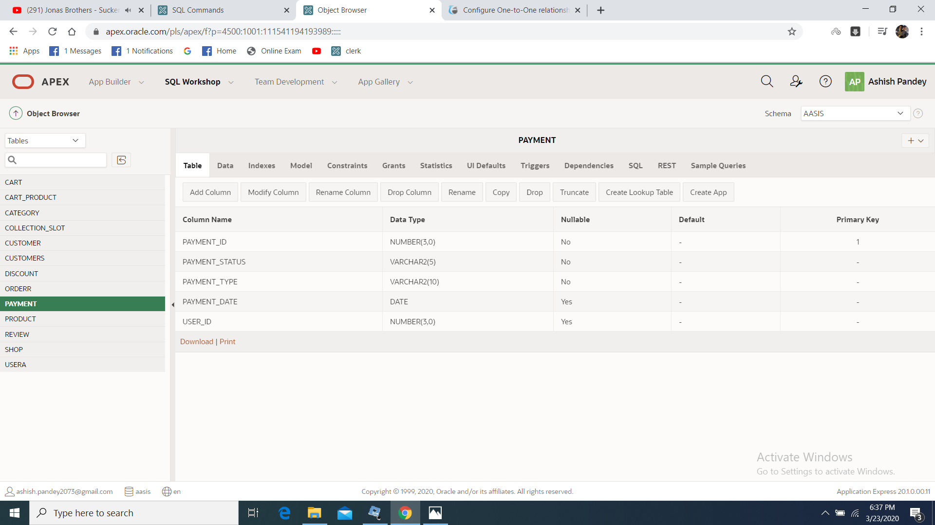

## 3.6.10 Collection Slot

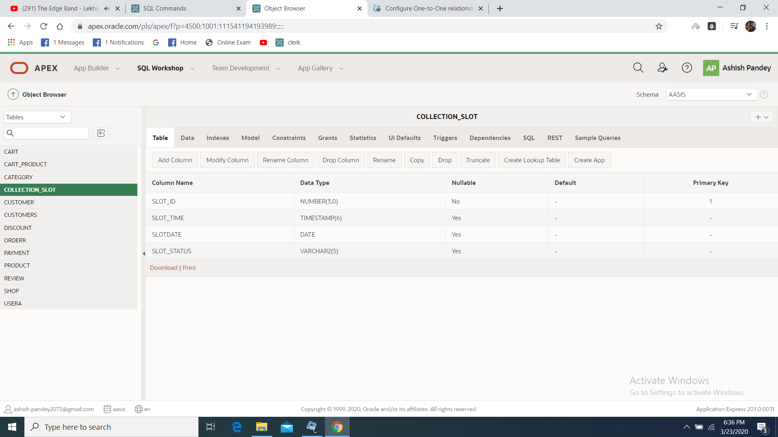

3.7 Oracle Tables

3.7.1 Table Creation Script

CART

CREATE TABLE "CART"

( "CART_ID" NUMBER(30,0),

"CART_STATUS" NUMBER(30,0),

"USER_ID" NUMBER(30,0),

CONSTRAINT "PK_CART" PRIMARY KEY ("CART_ID") ENABLE

)

/

ALTER TABLE "CART" ADD FOREIGN KEY ("USER_ID")

REFERENCES "USERA" ("USER_ID") ENABLE

/

CART_PRODUCT

CREATE TABLE "CART_PRODUCT"

( "CART_ID" NUMBER(30,0),

"PRODUCT_ID" NUMBER(30,0),

"PRODUCT_QUANTITY" NUMBER,

"STATUS" NUMBER

)

/

ALTER TABLE "CART_PRODUCT" ADD FOREIGN KEY ("CART_ID")

REFERENCES "CART" ("CART_ID") ENABLE

/

ALTER TABLE "CART_PRODUCT" ADD FOREIGN KEY ("PRODUCT_ID")

REFERENCES "PRODUCT" ("PRODUCT_ID") ENABLE

/

CATEGORY

CREATE TABLE "CATEGORY"

( "CATEGORY_ID" NUMBER(30,0),

"CATEGORY_NAME" VARCHAR2(500) NOT NULL ENABLE,

"PRODUCTS_QUANTITY" NUMBER(30,0),

"CATEGORY_TYPE" VARCHAR2(500),

CONSTRAINT "PK_CATEGORY" PRIMARY KEY ("CATEGORY_ID") ENABLE

)

/

COLLECTION_SLOT

CREATE TABLE "COLLECTION_SLOT"

( "SLOT_ID" NUMBER,

"SLOT_TIME" VARCHAR2(500),

"SLOT_DATE" VARCHAR2(500),

"SLOT_STATUS" VARCHAR2(500),

"USER_ID" NUMBER,

CONSTRAINT "PK_COLLECTION_SLOT" PRIMARY KEY ("SLOT_ID") ENABLE

)

/

ALTER TABLE "COLLECTION_SLOT" ADD FOREIGN KEY ("USER_ID")

REFERENCES "USERA" ("USER_ID") ENABLE

/

DISCOUNT

CREATE TABLE "DISCOUNT"

( "DISCOUNT_ID" NUMBER(30,0),

"DISCOUNT_PERCENTAGE" NUMBER(30,0),

"DISCOUNT_NAME" VARCHAR2(500),

CONSTRAINT "PK_DISCOUNT" PRIMARY KEY ("DISCOUNT_ID") ENABLE

)

/

ORDERR

CREATE TABLE "ORDERR"

( "ORDER_ID" NUMBER(30,0),

"ORDER_QUANTITY" NUMBER(30,0),

"ORDER_STATUS" VARCHAR2(500),

"ORDER_TIME" VARCHAR2(30),

"ORDER_DATE" VARCHAR2(30),

"ORDER_DESCRIPTION" VARCHAR2(500),

"CART_ID" NUMBER(30,0),

"PAYMENT_ID" NUMBER(30,0),

"SLOT_ID" NUMBER(30,0),

CONSTRAINT "PK_ORDERR" PRIMARY KEY ("ORDER_ID") ENABLE

)

/

ALTER TABLE "ORDERR" ADD FOREIGN KEY ("CART_ID")

REFERENCES "CART" ("CART_ID") ENABLE

/

ALTER TABLE "ORDERR" ADD FOREIGN KEY ("PAYMENT_ID")

REFERENCES "PAYMENT" ("PAYMENT_ID") ENABLE

/

ALTER TABLE "ORDERR" ADD FOREIGN KEY ("SLOT_ID")

REFERENCES "COLLECTION_SLOT" ("SLOT_ID") ENABLE

/

PAYMENT

CREATE TABLE "PAYMENT"

( "PAYMENT_ID" NUMBER(30,0),

"PAYMENT_STATUS" VARCHAR2(500) NOT NULL ENABLE,

"PAYMENT_TYPE" VARCHAR2(500) NOT NULL ENABLE,

"PAYMENT_DATE" VARCHAR2(500),

"USER_ID" NUMBER(30,0),

CONSTRAINT "PK_PAYMENT" PRIMARY KEY ("PAYMENT_ID") ENABLE

)

/

ALTER TABLE "PAYMENT" ADD FOREIGN KEY ("USER_ID")

REFERENCES "USERA" ("USER_ID") ENABLE

/

PRODUCT

CREATE TABLE "PRODUCT"

( "PRODUCT_ID" NUMBER(30,0),

"PRODUCT_NAME" VARCHAR2(500) NOT NULL ENABLE,

"PRODUCT_DESCRIPTION" VARCHAR2(500),

"PRODUCT_PRICE" NUMBER(30,0),

"PRODUCT_STATUS" VARCHAR2(500),

"PRODUCT_IMAGE" VARCHAR2(500),

"PRODUCT_KEYWORDS" VARCHAR2(500),

"MIN_ORDER" NUMBER(30,0),

"MAX_ORDER" NUMBER(30,0),

"ALLERGY_INFORMATION" VARCHAR2(500),

"CATEGORY_ID" NUMBER(30,0),

"ORDER_ID" NUMBER(30,0),

"SHOP_ID" NUMBER(30,0),

"USER_ID" NUMBER(30,0),

"DISCOUNT_ID" NUMBER(30,0),

"REVIEW_ID" NUMBER(30,0),

CONSTRAINT "PK_PRODUCT" PRIMARY KEY ("PRODUCT_ID") ENABLE

)

/

ALTER TABLE "PRODUCT" ADD FOREIGN KEY ("CATEGORY_ID")

REFERENCES "CATEGORY" ("CATEGORY_ID") ENABLE

/

ALTER TABLE "PRODUCT" ADD FOREIGN KEY ("ORDER_ID")

REFERENCES "ORDERR" ("ORDER_ID") ENABLE

/

ALTER TABLE "PRODUCT" ADD FOREIGN KEY ("SHOP_ID")

REFERENCES "SHOP" ("SHOP_ID") ENABLE

/

ALTER TABLE "PRODUCT" ADD FOREIGN KEY ("USER_ID")

REFERENCES "USERA" ("USER_ID") ENABLE

/

ALTER TABLE "PRODUCT" ADD FOREIGN KEY ("REVIEW_ID")

REFERENCES "REVIEW" ("REVIEW_ID") ENABLE

/

REVIEW

CREATE TABLE "REVIEW"

( "REVIEW_ID" NUMBER(30,0),

"REVIEW_COMMENT" VARCHAR2(500),

"RATING_REVIEW" NUMBER(30,0),

"REVIEW_TIME" TIMESTAMP (6),

"USER_ID" NUMBER(30,0),

"PRODUCT_ID" NUMBER(30,0),

CONSTRAINT "PK_REVIEW" PRIMARY KEY ("REVIEW_ID") ENABLE

)

/

ALTER TABLE "REVIEW" ADD FOREIGN KEY ("USER_ID")

REFERENCES "USERA" ("USER_ID") ENABLE

/

ALTER TABLE "REVIEW" ADD FOREIGN KEY ("PRODUCT_ID")

REFERENCES "PRODUCT" ("PRODUCT_ID") ENABLE

/

SHOP

CREATE TABLE "SHOP"

( "SHOP_ID" NUMBER(30,0),

"SHOP_NAME" VARCHAR2(500),

"SHOP_DESCRIPTION" VARCHAR2(500),

"SHOP_IMAGE" VARCHAR2(500),

"USER_ID" NUMBER(30,0),

CONSTRAINT "PK_SHOP" PRIMARY KEY ("SHOP_ID") ENABLE

)

/

ALTER TABLE "SHOP" ADD FOREIGN KEY ("USER_ID")

REFERENCES "USERA" ("USER_ID") ENABLE

/

USERA

CREATE TABLE "USERA"

( "USER_ID" NUMBER(30,0),

"USERNAME" VARCHAR2(500) NOT NULL ENABLE,

"USER_PASSWORD" VARCHAR2(500) NOT NULL ENABLE,

"USER_PHONE" NUMBER(30,0),

"USER_ADDRESS" VARCHAR2(500),

"USER_EMAIL" VARCHAR2(500),

"USER_TYPE" VARCHAR2(500),

"USER_IMAGE" VARCHAR2(500),

"USER_STATUS" VARCHAR2(500),

"USER_DESCRIPTION" VARCHAR2(500),

"CUSTOMER_ID" NUMBER(30,0),

"TRADER_ID" NUMBER(30,0),

"ADMIN_TYPE" VARCHAR2(500),

"DISCOUNT_ID" NUMBER(30,0),

"STAT" NUMBER,

CONSTRAINT "PK_USERA" PRIMARY KEY ("USER_ID") ENABLE

)

/

3.7.2 Trigger and Sequence (for auto_increment)

CART

Drop sequence cart_id_seq;

CREATE SEQUENCE cart_id_seq start with 1;

CREATE OR REPLACE TRIGGER "CART_BI"

BEFORE INSERT ON cart

FOR EACH ROW

BEGIN

SELECT cart_id_seq.nextval

INTO :new.cart_id

FROM dual;

END;

/

ALTER TRIGGER "CART_BI" ENABLE

/

CATEGORY

Drop sequence category_id_seq;

CREATE SEQUENCE category_id_seq start with 1;

CREATE OR REPLACE TRIGGER "CATEGORY_BI"

BEFORE INSERT ON category

FOR EACH ROW

BEGIN

SELECT category_id_seq.nextval

INTO :new.category_id

FROM dual;

END;

/

ALTER TRIGGER "CATEGORY_BI" ENABLE

/

COLLECTION_SLOT

Drop sequence slot_id_seq;

CREATE SEQUENCE slot_id_seq start with 1;

CREATE OR REPLACE TRIGGER "COLLECTION_SLOT_BI"

BEFORE INSERT ON collection_slot

FOR EACH ROW

BEGIN

SELECT slot_id_seq.nextval

INTO :new.slot_id

FROM dual;

END;

/

ALTER TRIGGER "COLLECTION_SLOT_BI" ENABLE

/

DISCOUNT

Drop sequence discount_id_seq;

CREATE SEQUENCE discount_id_seq start with 1;

CREATE OR REPLACE TRIGGER "DISCOUNT_BI"

BEFORE INSERT ON discount

FOR EACH ROW

BEGIN

SELECT discount_id_seq.nextval

INTO :new.discount_id

FROM dual;

END;

/

ALTER TRIGGER "DISCOUNT_BI" ENABLE

/

ORDERR

Drop sequence order_id_seq;

CREATE SEQUENCE order_id_seq start with 1;

CREATE OR REPLACE TRIGGER "ORDER_BI"

BEFORE INSERT ON orderr

FOR EACH ROW

BEGIN

SELECT order_id_seq.nextval

INTO :new.order_id

FROM dual;

END;

/

ALTER TRIGGER "ORDER_BI" ENABLE

/

PAYMENT

Drop sequence payment_id_seq;

CREATE SEQUENCE payment_id_seq start with 1;

CREATE OR REPLACE TRIGGER "PAYMENT_BI"

BEFORE INSERT ON payment

FOR EACH ROW

BEGIN

SELECT payment_id_seq.nextval

INTO :new.payment_id

FROM dual;

END;

/

ALTER TRIGGER "PAYMENT_BI" ENABLE

/

PRODUCT

Drop sequence product_id_seq;

CREATE SEQUENCE product_id_seq start with 1;

CREATE OR REPLACE TRIGGER "PRODUCT_BI"

BEFORE INSERT ON product

FOR EACH ROW

BEGIN

SELECT product_id_seq.nextval

INTO :new.product_id

FROM dual;

END;

/

ALTER TRIGGER "PRODUCT_BI" ENABLE

/

REVIEW

Drop sequence review_id_seq;

CREATE SEQUENCE review_id_seq start with 1;

CREATE OR REPLACE TRIGGER "REVIEW_BI"

BEFORE INSERT ON review

FOR EACH ROW

BEGIN

SELECT review_id_seq.nextval

INTO :new.review_id

FROM dual;

END;

/

ALTER TRIGGER "REVIEW_BI" ENABLE

/

SHOP

Drop sequence shop_id_seq;

CREATE SEQUENCE shop_id_seq start with 1;

CREATE OR REPLACE TRIGGER "SHOP_BI"

BEFORE INSERT ON shop

FOR EACH ROW

BEGIN

SELECT shop_id_seq.nextval

INTO :new.shop_id

FROM dual;

END;

/

ALTER TRIGGER "SHOP_BI" ENABLE

/

USERA

Drop sequence user_id_seq;

CREATE SEQUENCE user_id_seq start with 1;

CREATE OR REPLACE TRIGGER "USER_BI"

BEFORE INSERT ON usera

FOR EACH ROW

BEGIN

SELECT user_id_seq.nextval

INTO :new.user_id

FROM dual;

END;

/

ALTER TRIGGER "USER_BI" ENABLE

/

3.8 Risk Factor

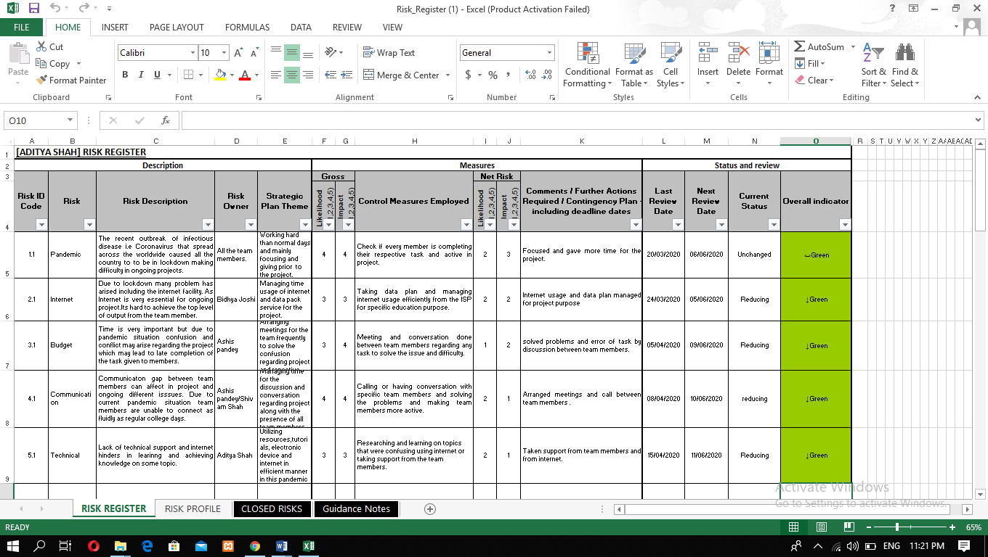

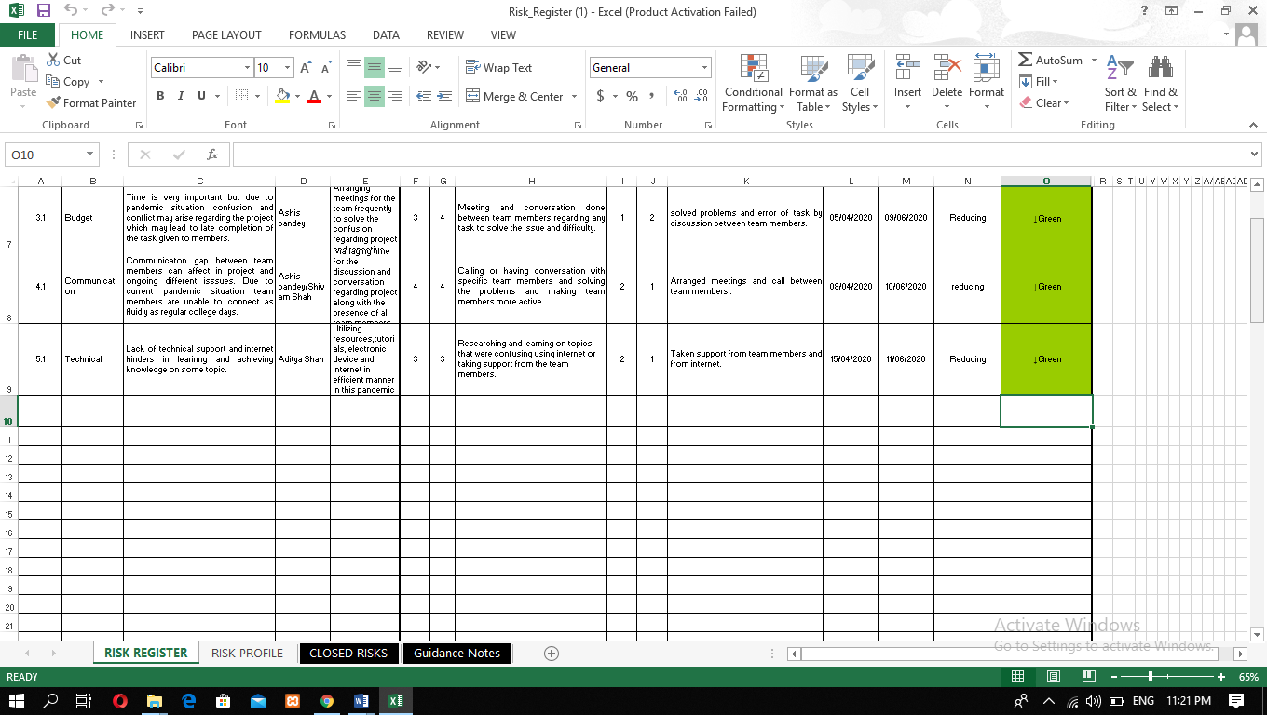

4. Monitoring & Controlling Phase

4.1 Testing and Evaluation

4.1.1 Trader Testing

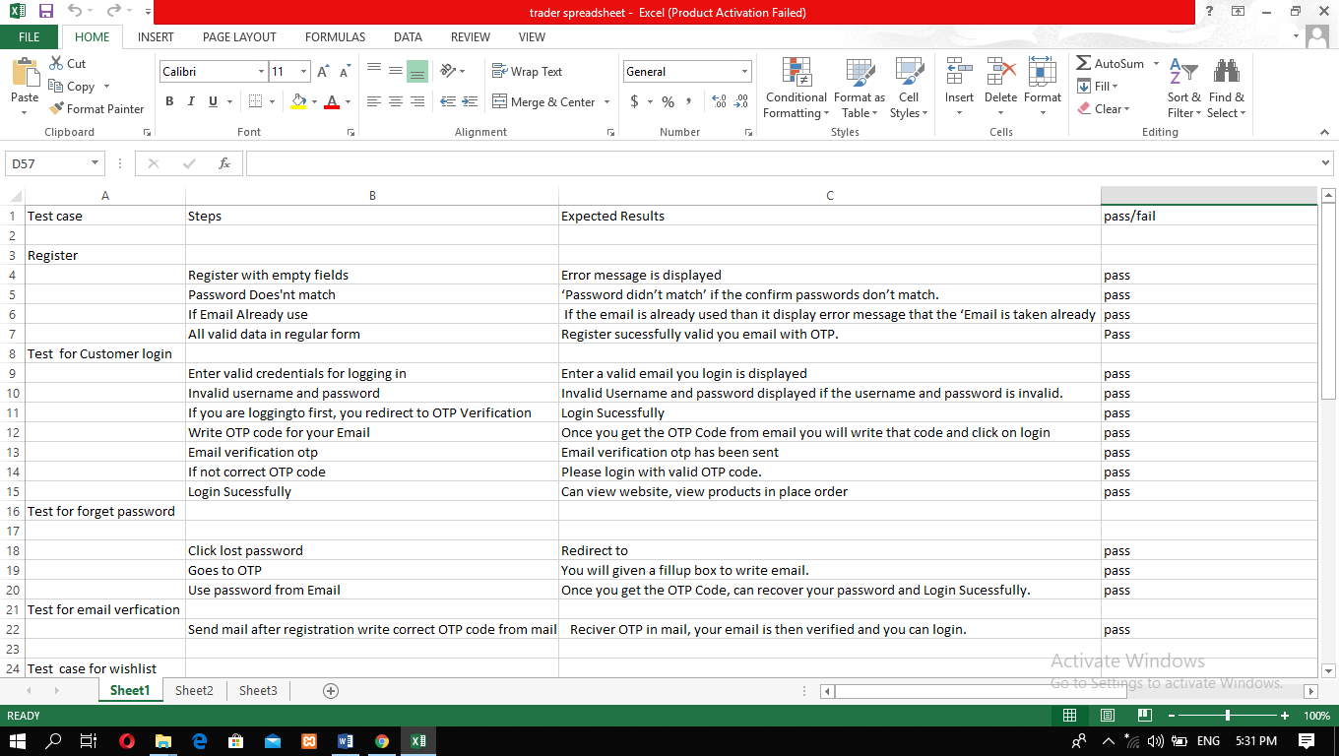

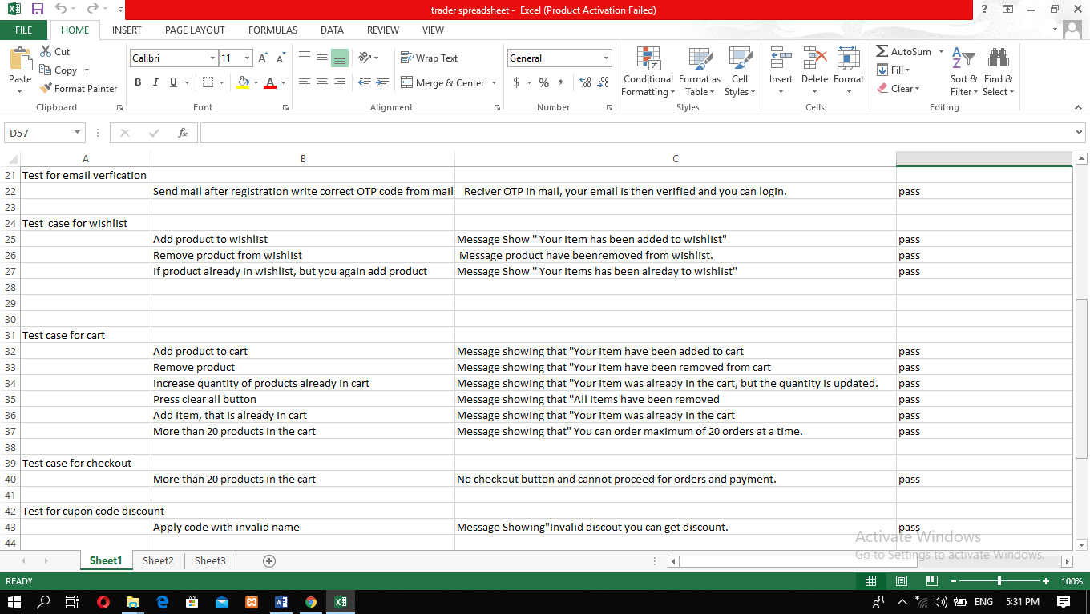

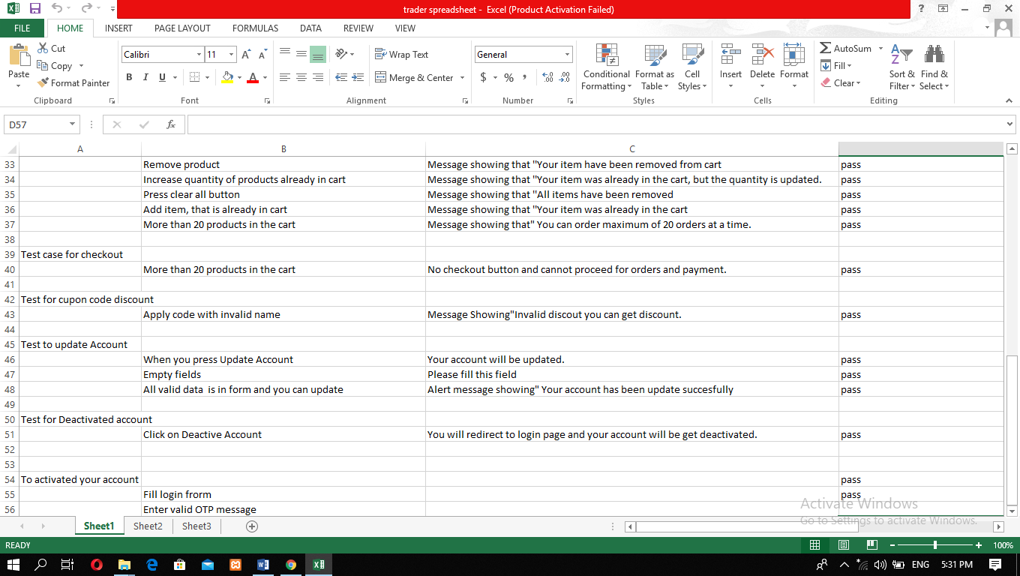

4.1.2 Customer Testing

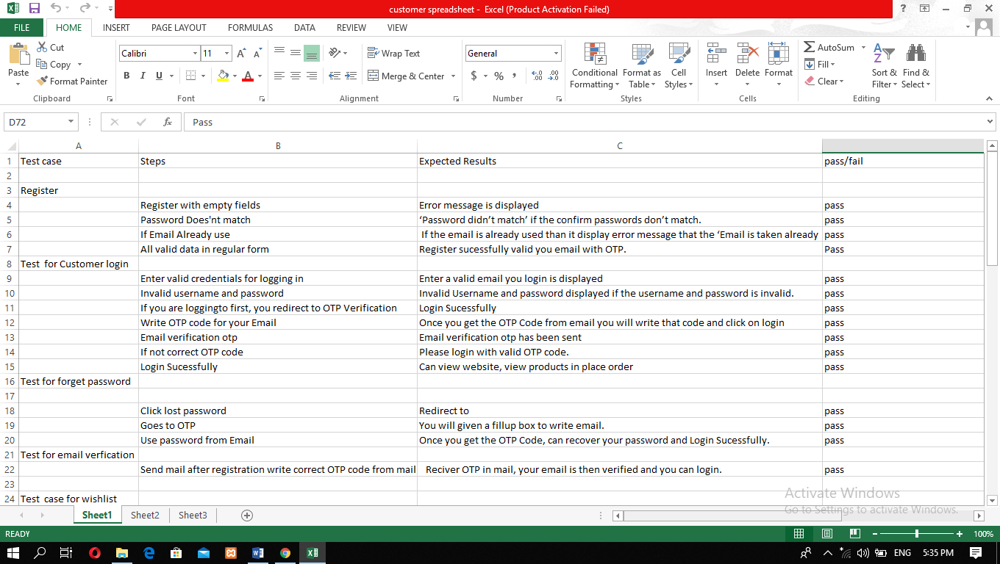

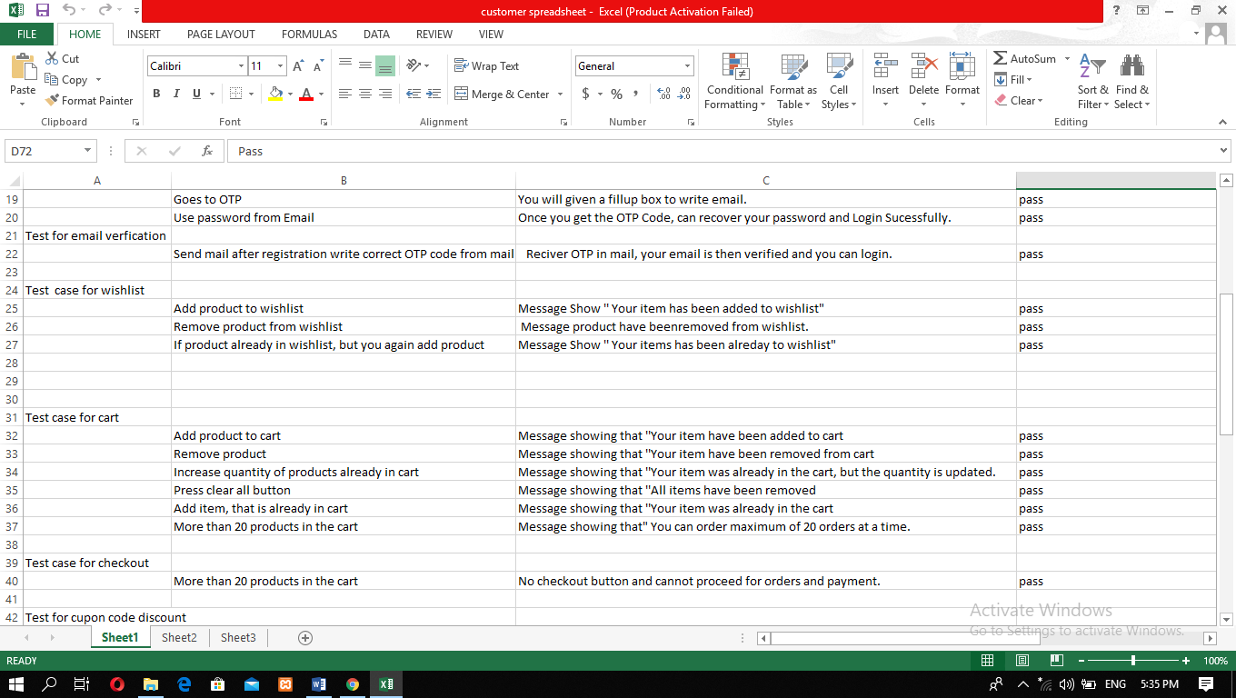

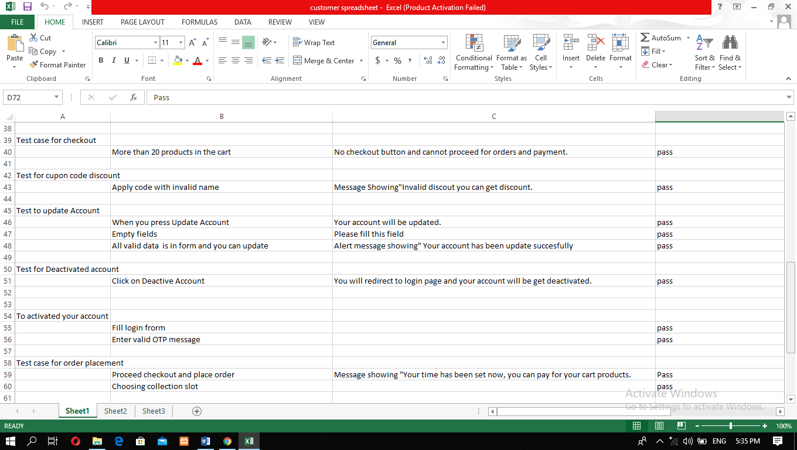

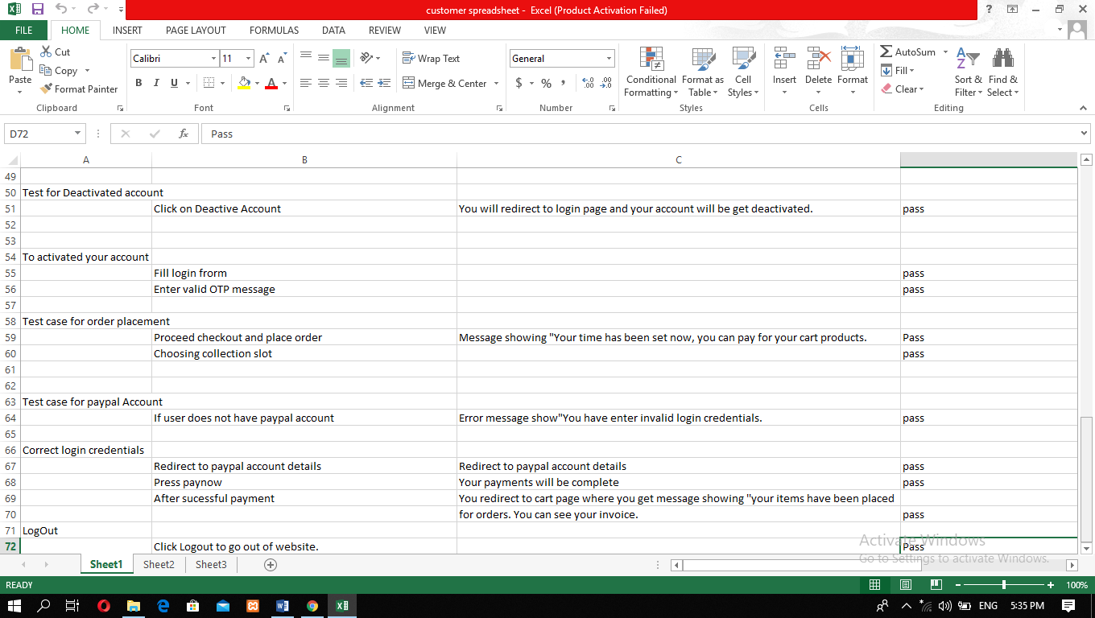

4.2 User Guidelines

Trader Web Interface

**Traders (PHP)**

Login

First traders need to Log in order to sell the product.

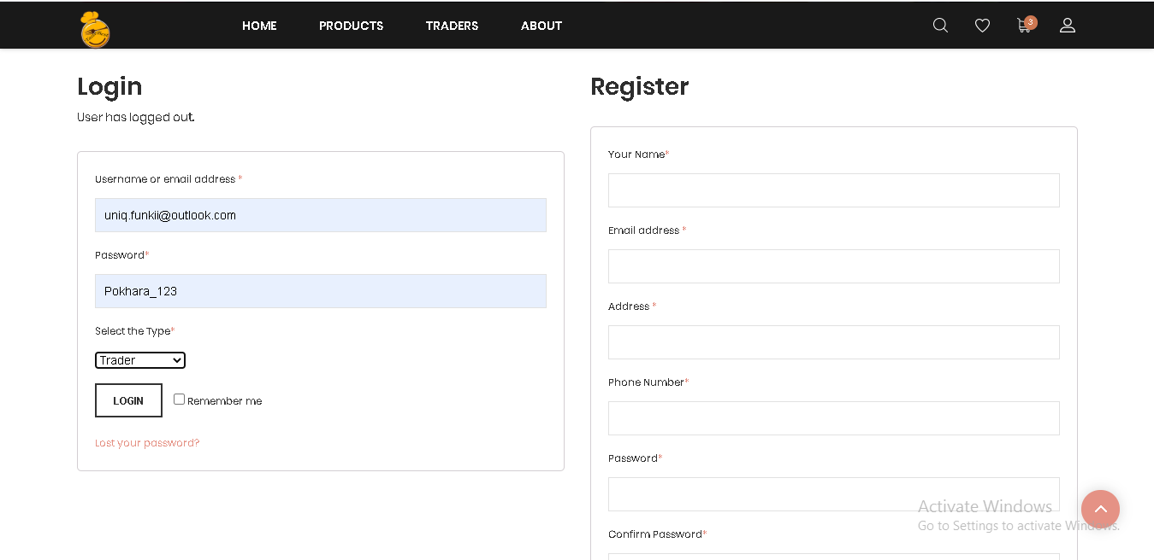

Customer will receive OTP in email after email verification and then applying valid OTP code person will be verified as a customer.

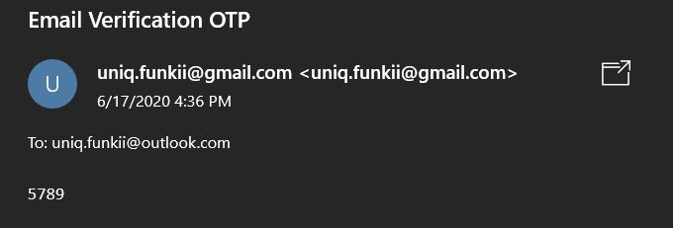

OTP and password sent in customer account. After pasting the valid password in required filled customer can log in again.

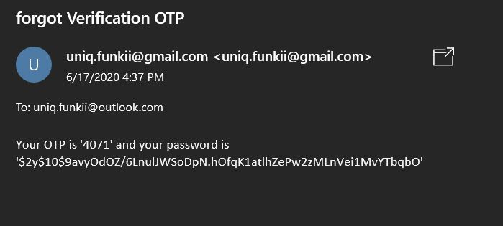

# 

# 

# Trader Products Dashboard

We have 5 products dashboard, this one is the butcher dashboard. Similarly we have same other dashboard .From the trader product dashboard we can insert,view,edit and delete our products easily and edit the butcher account too. In trader dashboard We can also display 10 products and also have the product categories . We can easily view the details of that products . We can also view our website from this dashboard.

Click on butcher name on the top right side of the trader dashboard and then click on logout. We are successfully logged out.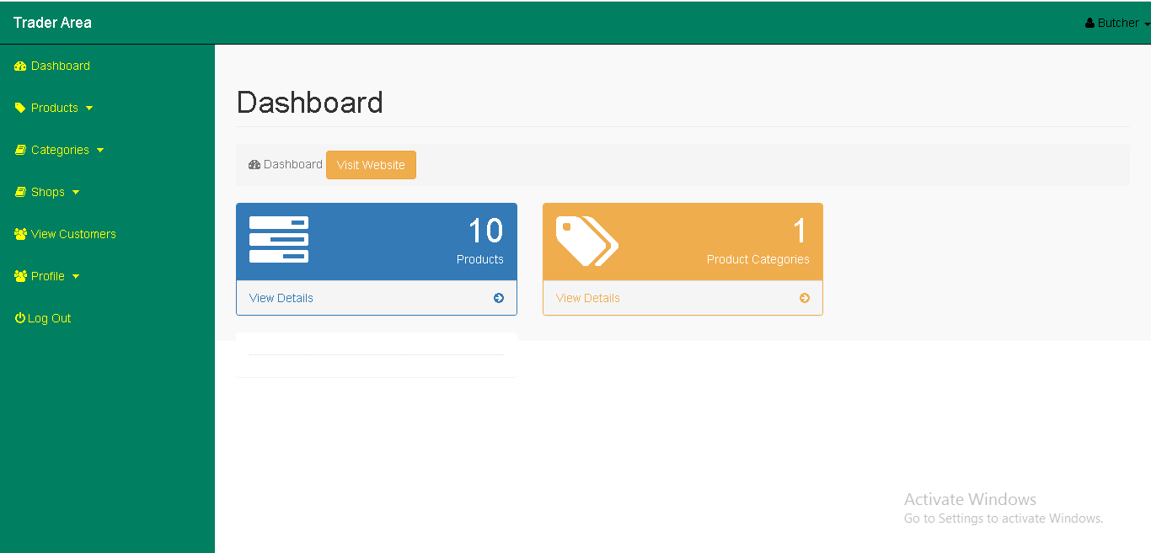

# 

# Insert products

Click on product drop down and click on insert product an insert product form will appear fill the details and click on insert product.

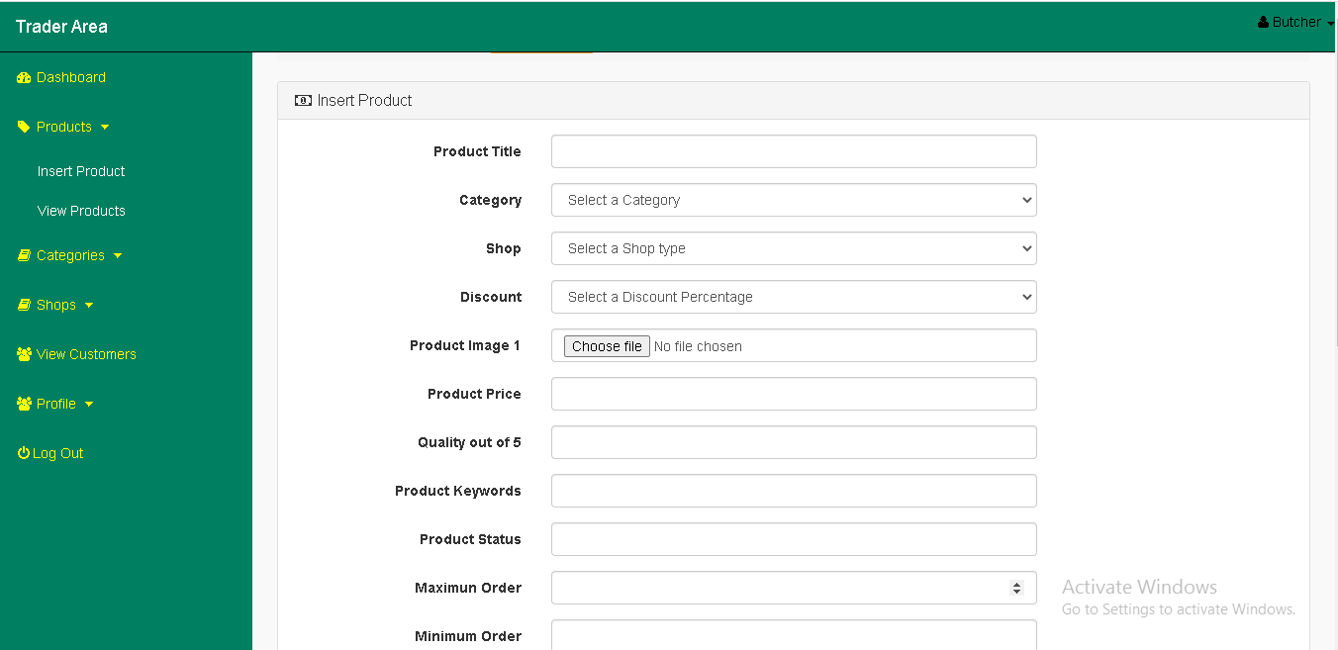

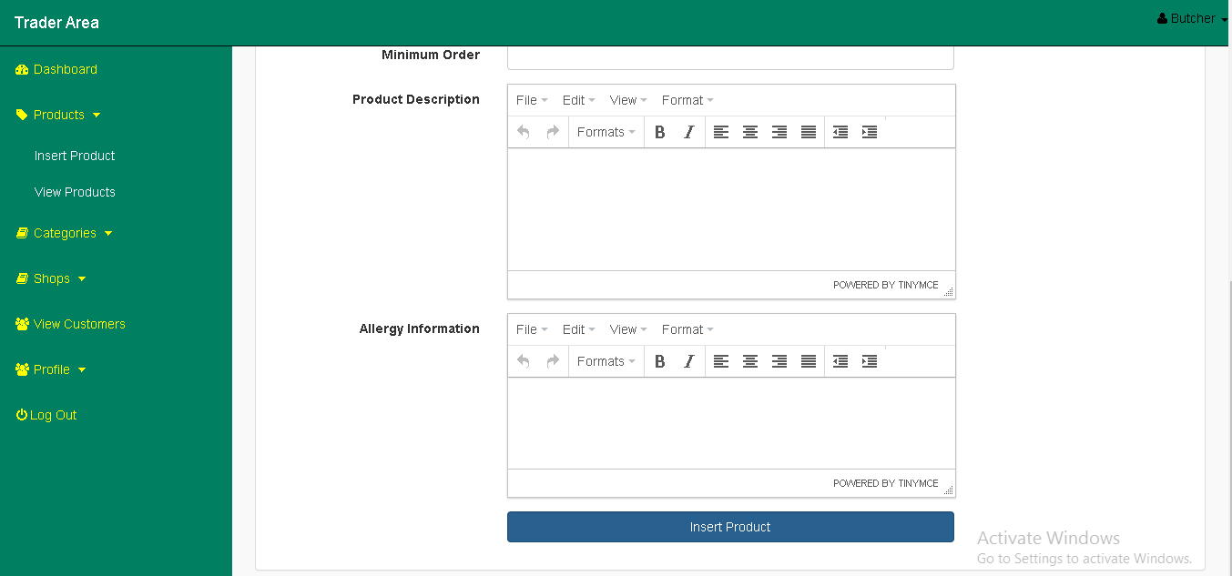

# View products

Click on product drop down click on view products here you can see the inserted products.

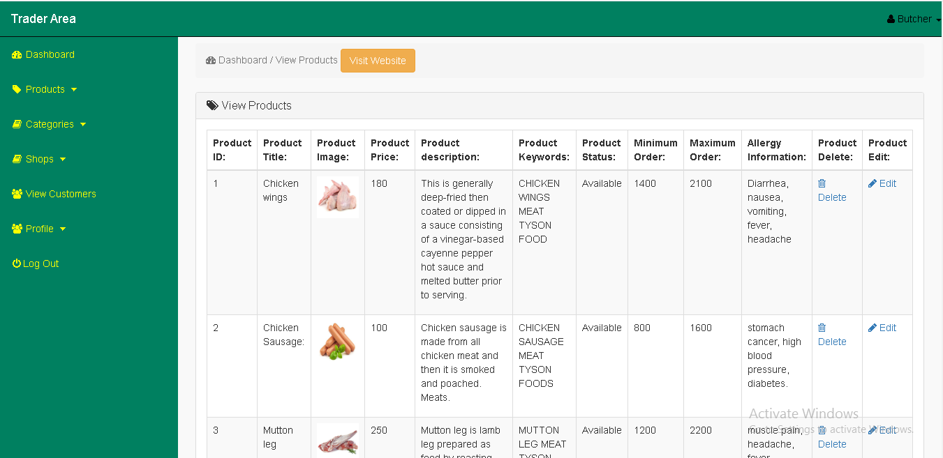

Edit Products

On the view products page you will see an edit button on the right hand side of the page click on edit an edit form will change the details and click on update product.

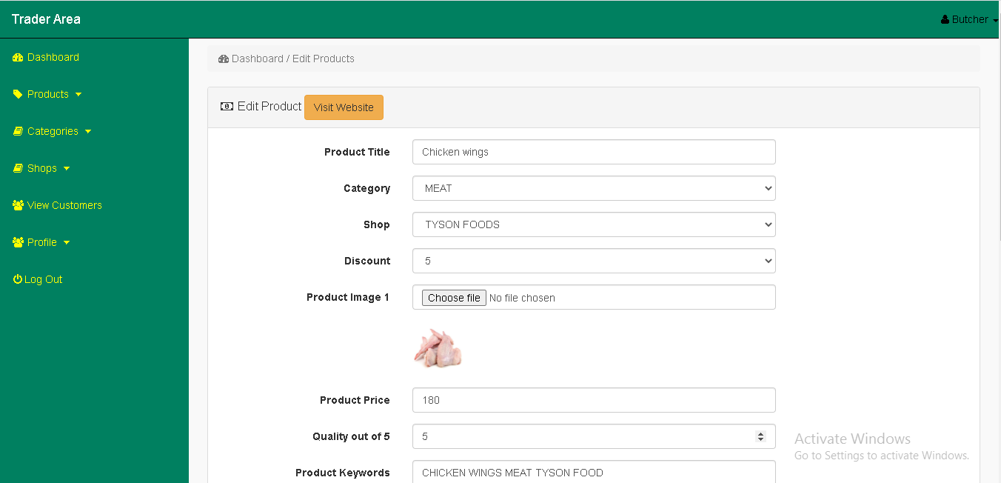

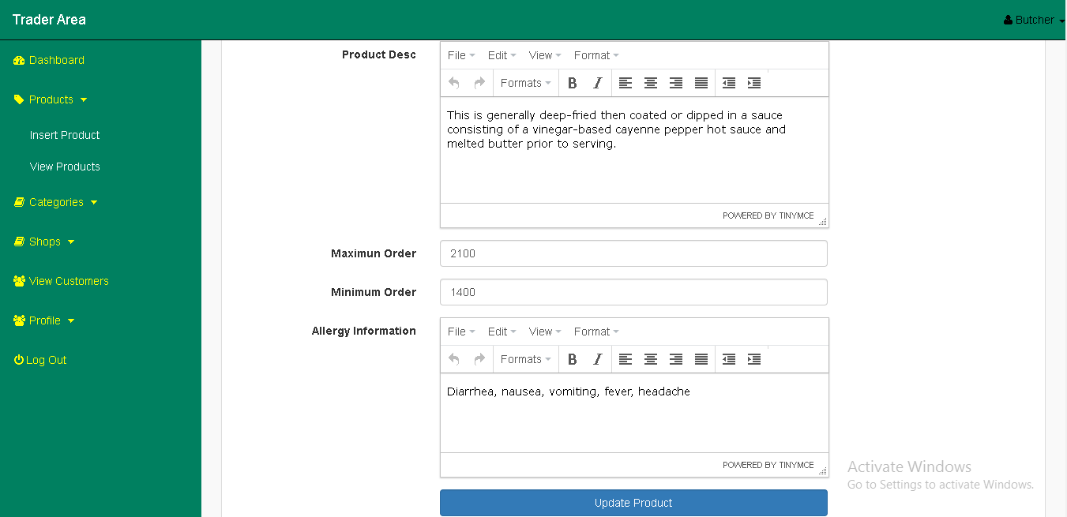

# Delete products

On the view products page you will see a delete button on the right hand side of the site. When you click on it, it will delete your product.



View Product Category

At the left hand side of the site you can see categories page when you click on it we can easily view our product category ID, Category Name and Product Quality.

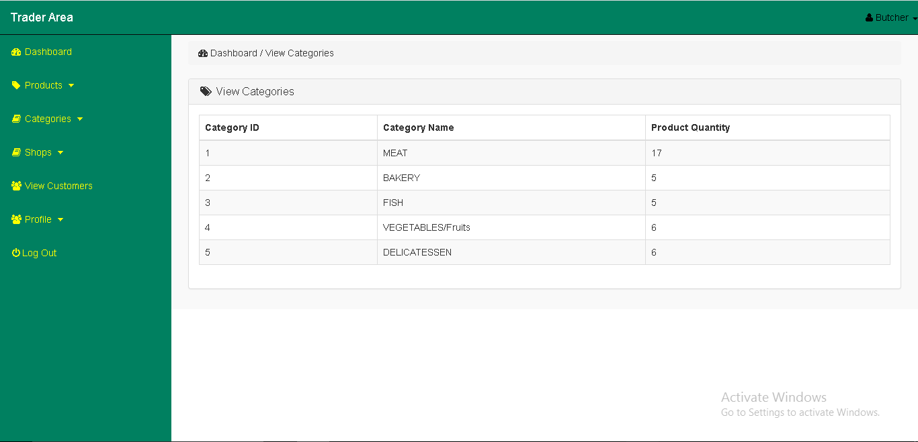

Insert Shop

On the shop page you will see insert shop on the right hand side of the page click on insert shop you can easily insert shop name and description

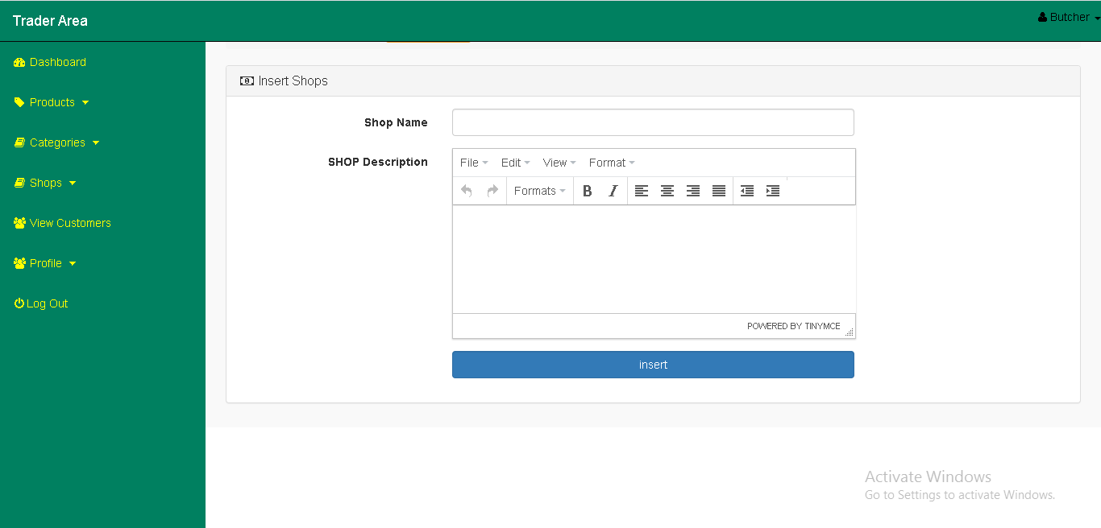

aaaaaaaaaaaaaaaaaaaaaaaaa

View Shop

On the shop page you will see view shop on the right hand side of the page click on view shop you can see all shop ID, Name and Description. You can also edit and delete your shop ID, Name and Description.

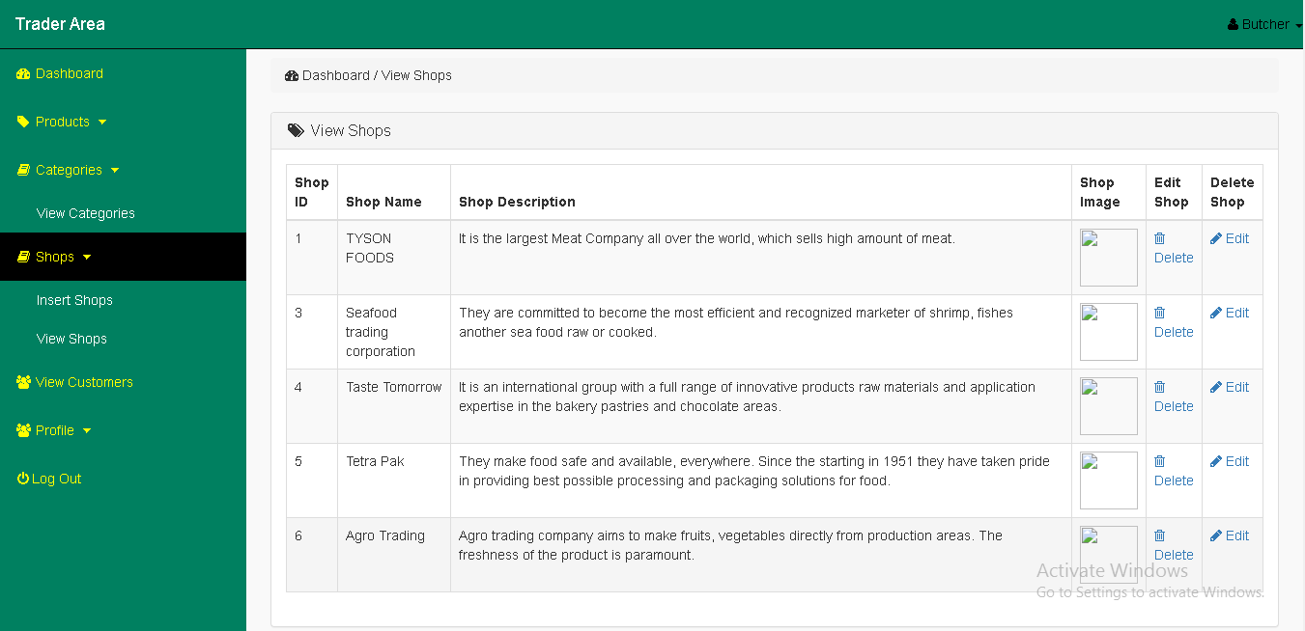

Update Shop

We can easily edit your shop name and shop description as your wish.

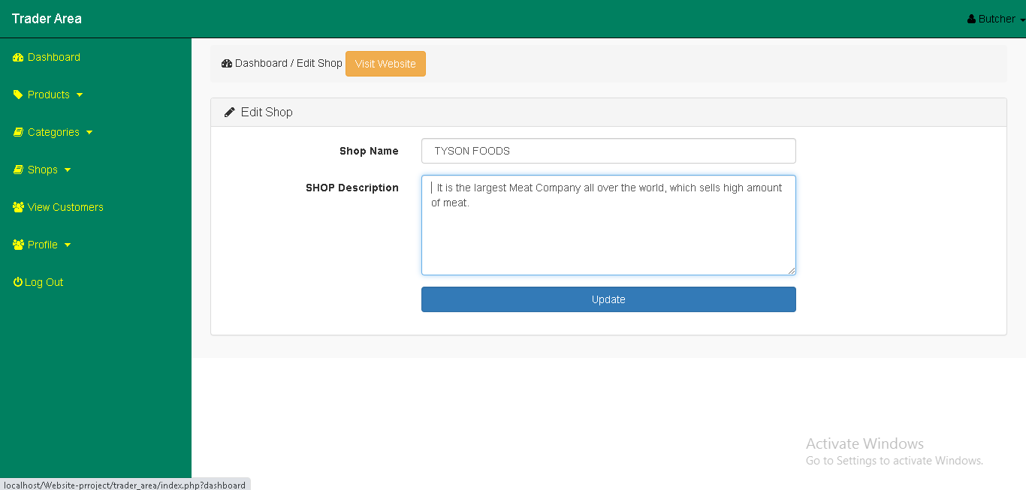

View Profile

On the profile page on the right hand side of the site you will see view profile and edit profile. When you click on view profile we can see the information about the user.

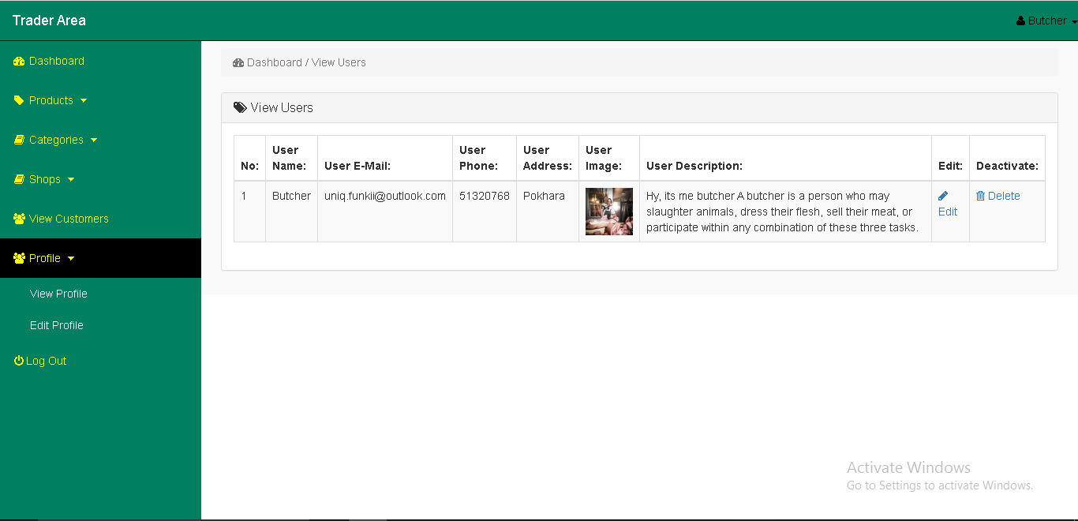

Edit Profile

On the profile page on the right hand side of the site you will see view profile and edit profile. When you click on edit profile we can edit all the information of user.

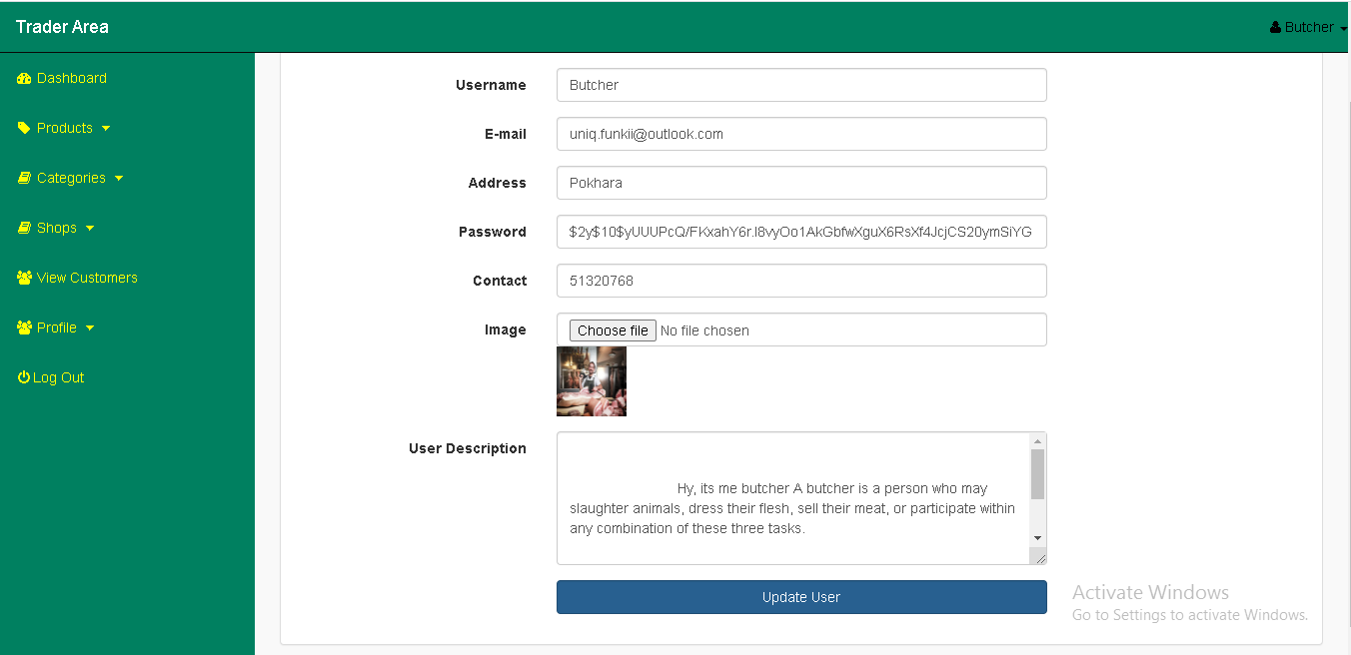

Deactivate Account

If we click on deactivate account, trader dashboard goes at the login page so when we login with our email and password then you can see the otp page, when we write activate in that OTP page then it immediately activate.



Customer Interface

1. New guest can register as customer by filling the required fields in register form.

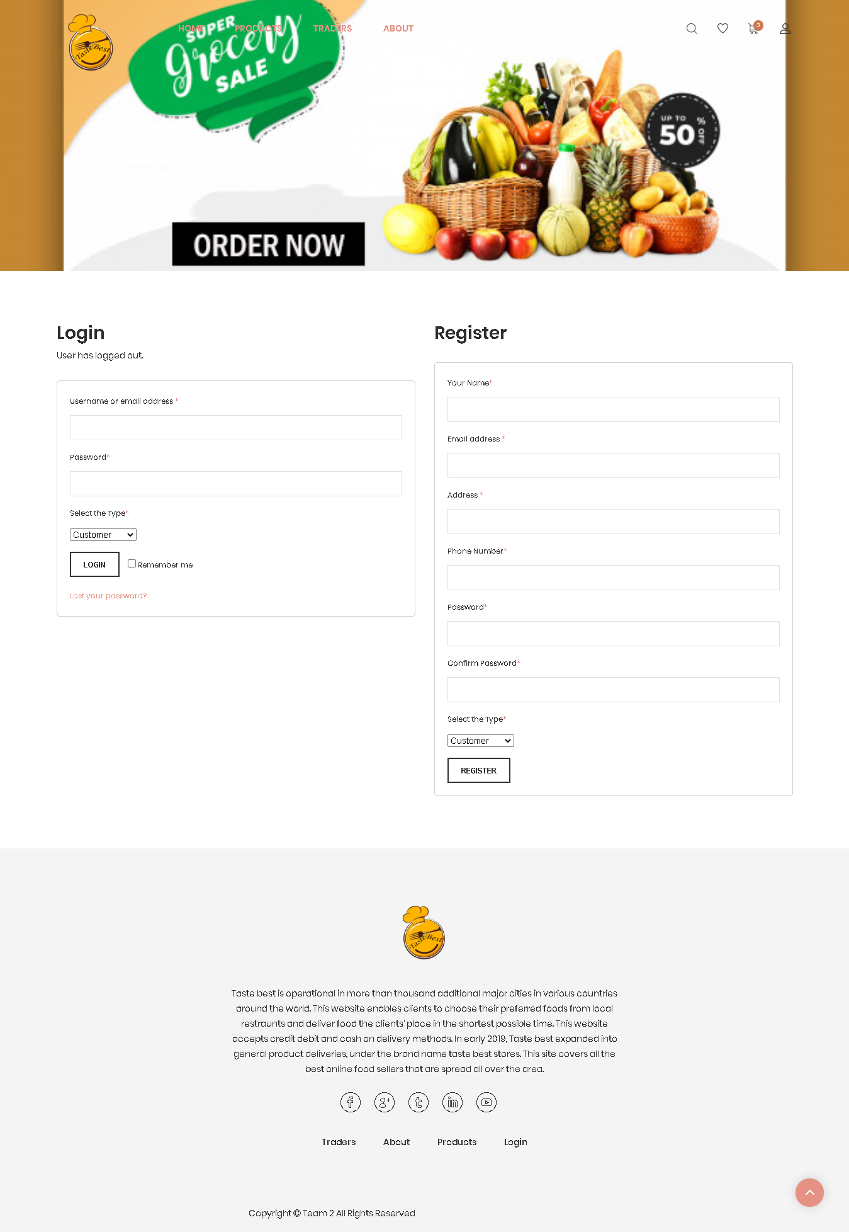

2. Customer will receive OTP in email after email verification and then applying valid OTP code person will be verified as a customer.



3. After valid registration customer can log in with their username or email address and password.

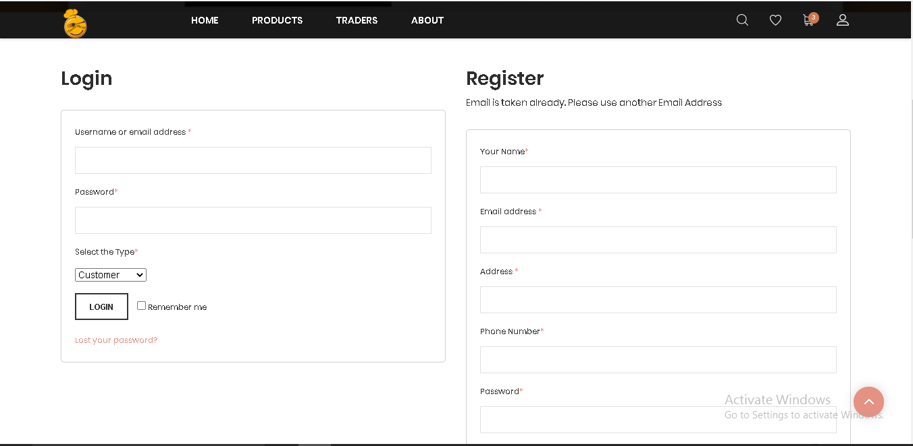

1. Incase customer forget their password , customer can reset it by clicking on ‘Lost your password?’ where OTP will be sent in customer email with password.

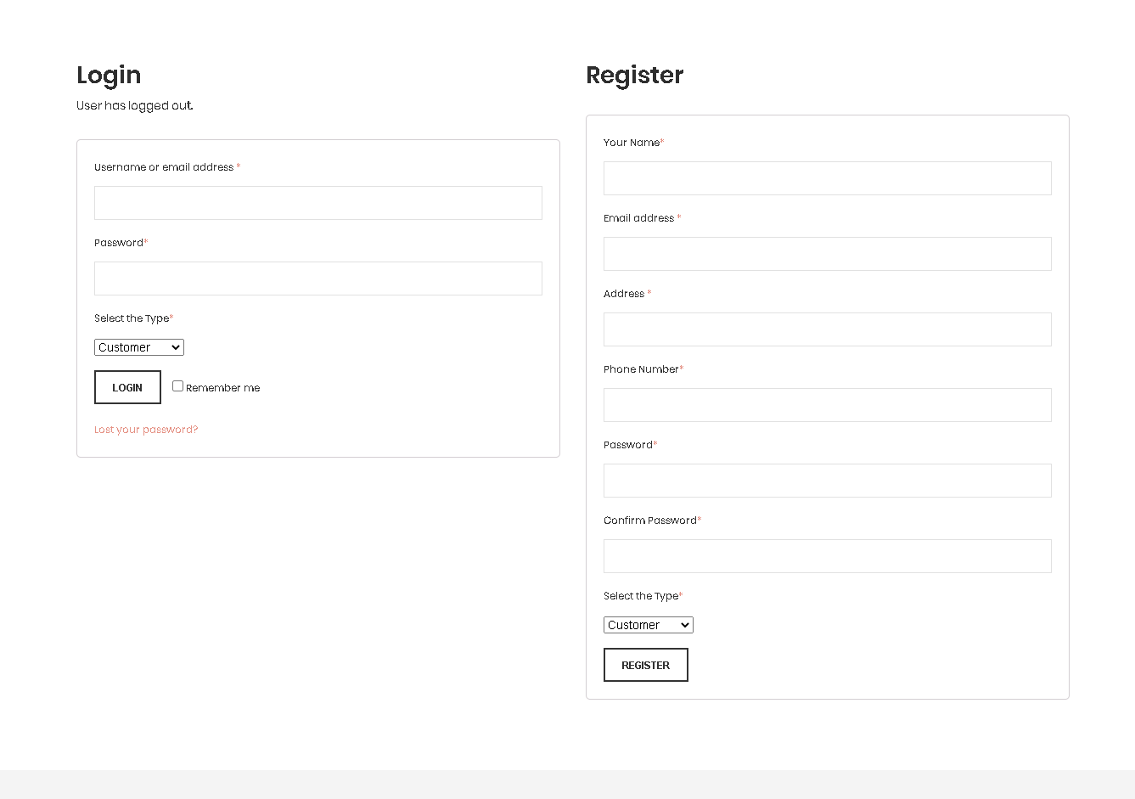

4. OTP and password sent in customer account. After pasting the valid password in required filled customer can log in again.



5. After login in customer can visit the home page and shop the products. Click on products to view products page.

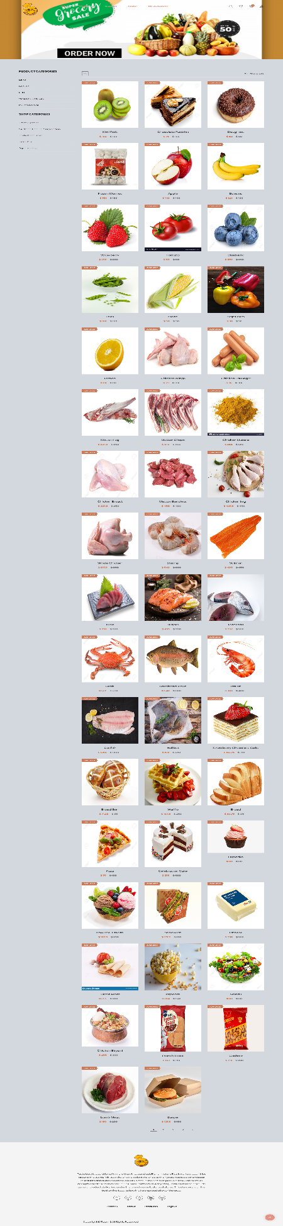

6. Customer can search for the specific product from search bar.

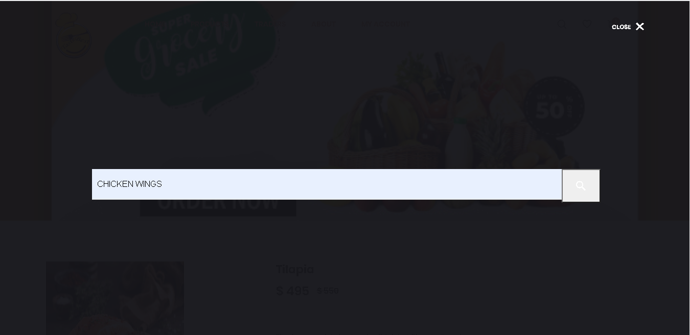

7. Customer can now shop products through product categories and shop categories in product page.

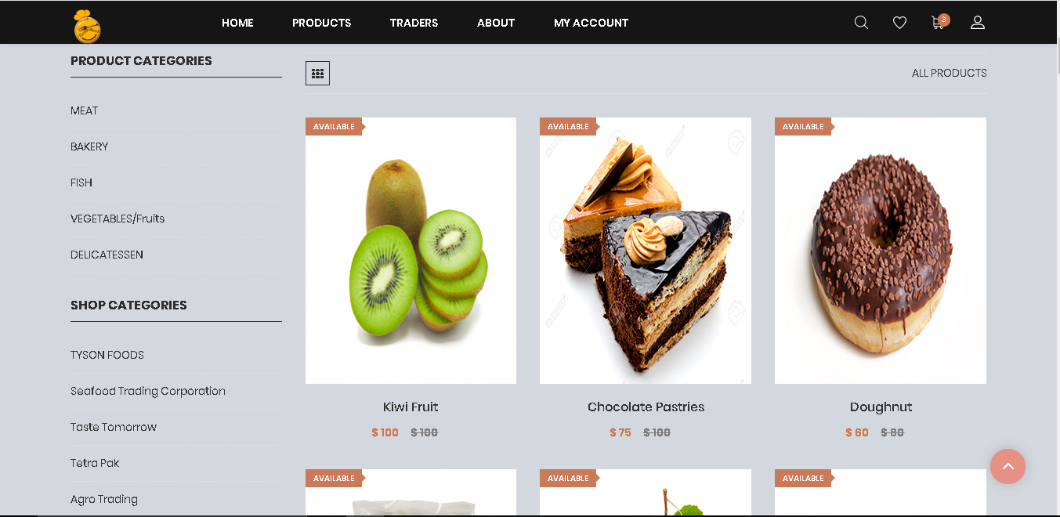

8. When customer clicks on the meat page products are sorted by meat items and this process applies to all the product categories available.



9. Similarly, customer can buy products by clicking on shop categories where products are sorted according to shops. When Customer clicks on Seafood Trading Corporation and particular products of this shop are shown.

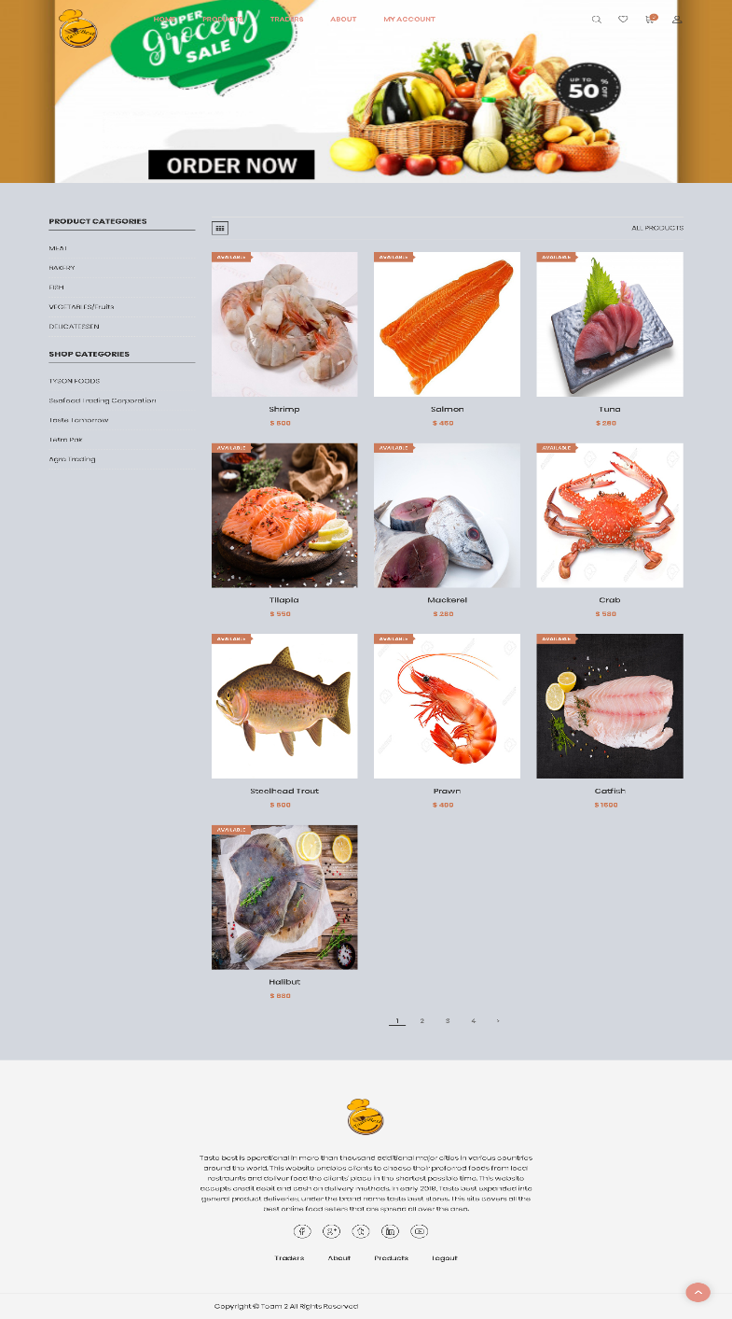

1. 10. Customer can add products in Wishlist and to the cart by clicking icons below the products.

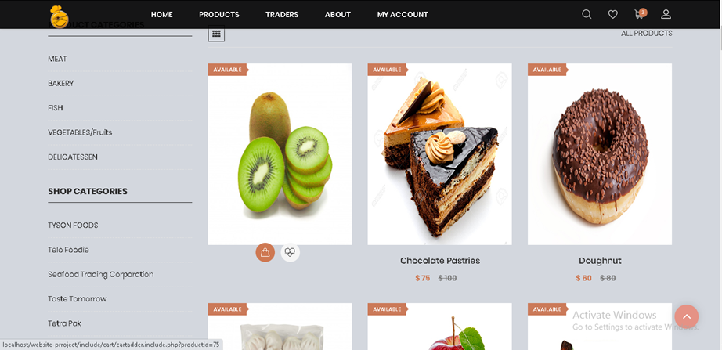

11. When wishlist icon is clicked by customer in navigation bar wishlist page along with product description appears.

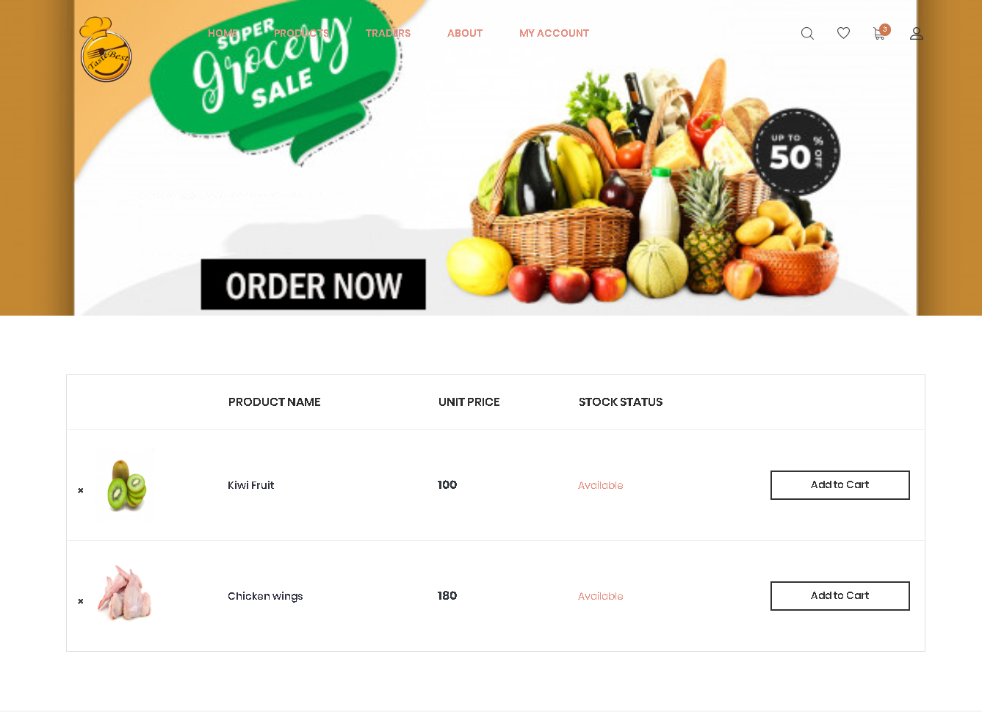

13. When customer clicks in specific product, price detail with the product information along with add to cart button are shown. 

14. Customer can give reviews and ratings on products by clicking review where rating and summary of products are given and clicking on submit button reviews and rating will be stored.

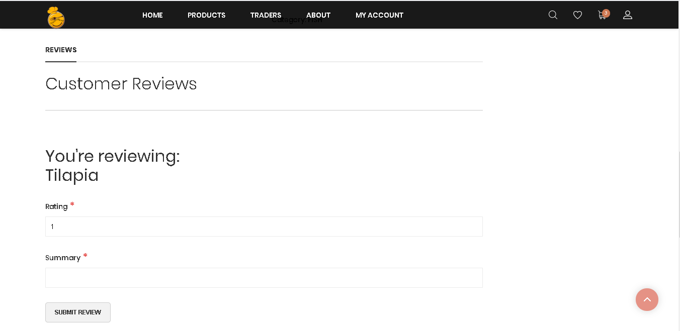

15. When customer clicks on add to cart button then add to cart page will pop up with all the product information, coupon code, discount added and grand total price.

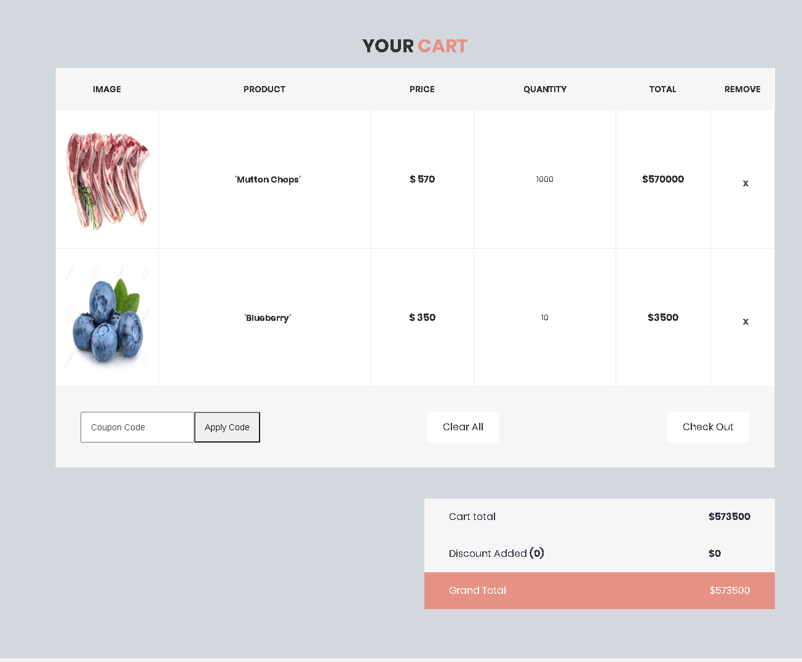

16. By clicking in checkout button customer will proceed to the next step where customer will place order by filling username, your message and collection slot field. 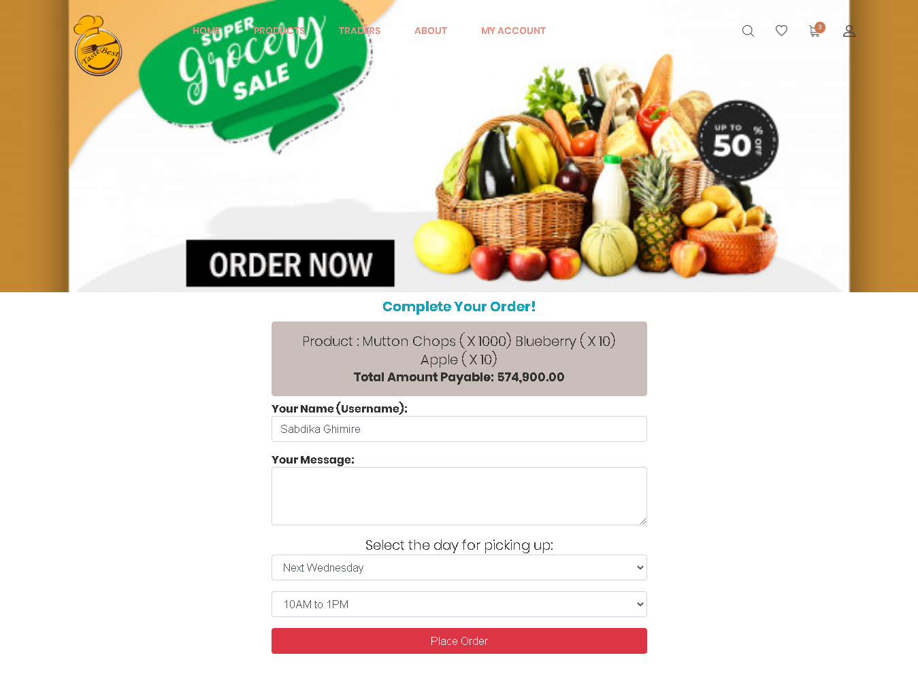

17. By clicking on PayPal logo customers are requested for payment procedure where method of payment is PayPal sandbox.



18. Now the PayPal will show the details of your order, card credential and shipment address and method of payment. Receipt will form and after clicking on pay now your payment will be completed.

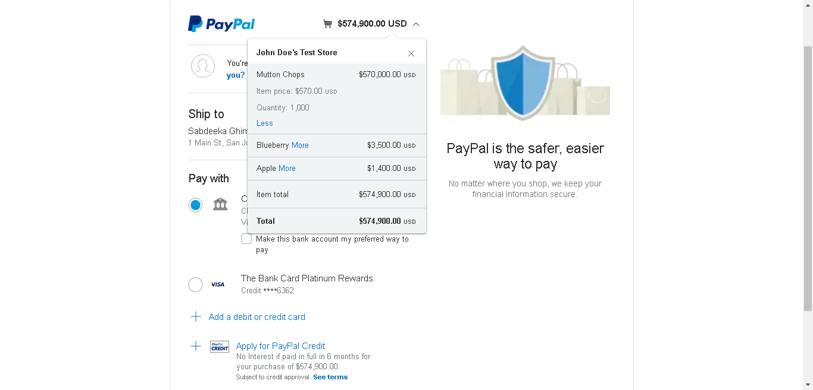

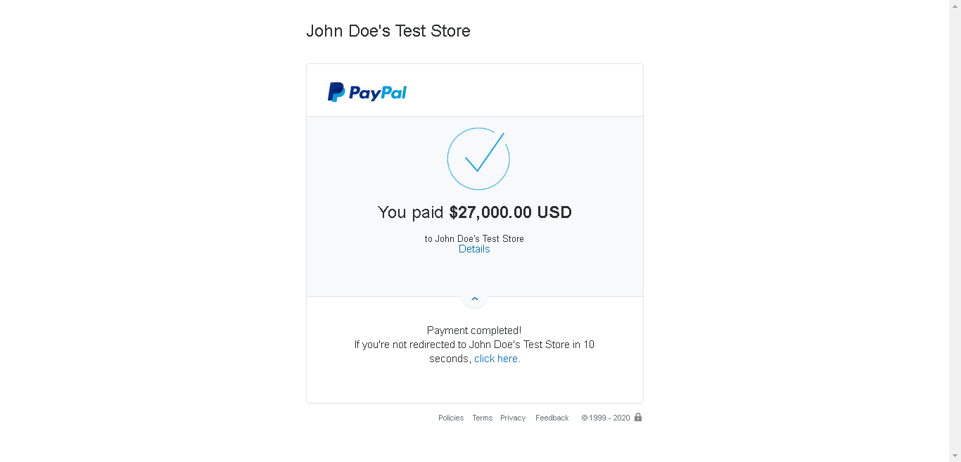

19. After payment is completed customer cart will be empty because product is placed for order and invoice with every information will be sent to customer account.

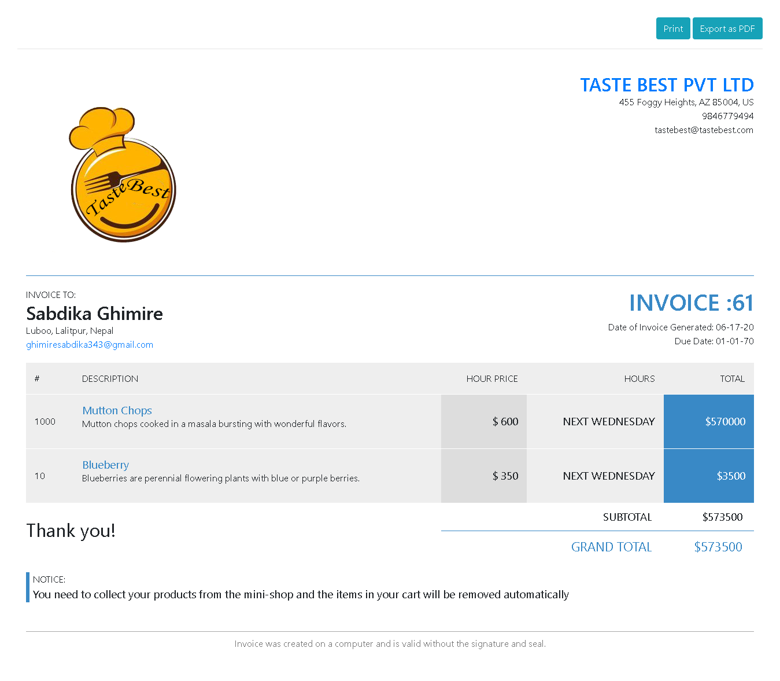

20. Customer can view traders and their shop information by clicking traders in navigation bar and will show all the details.



21. Customer can also view about page by clicking on about in navigation bar where all the information about our site, team members and advantage of online shopping are mentioned.

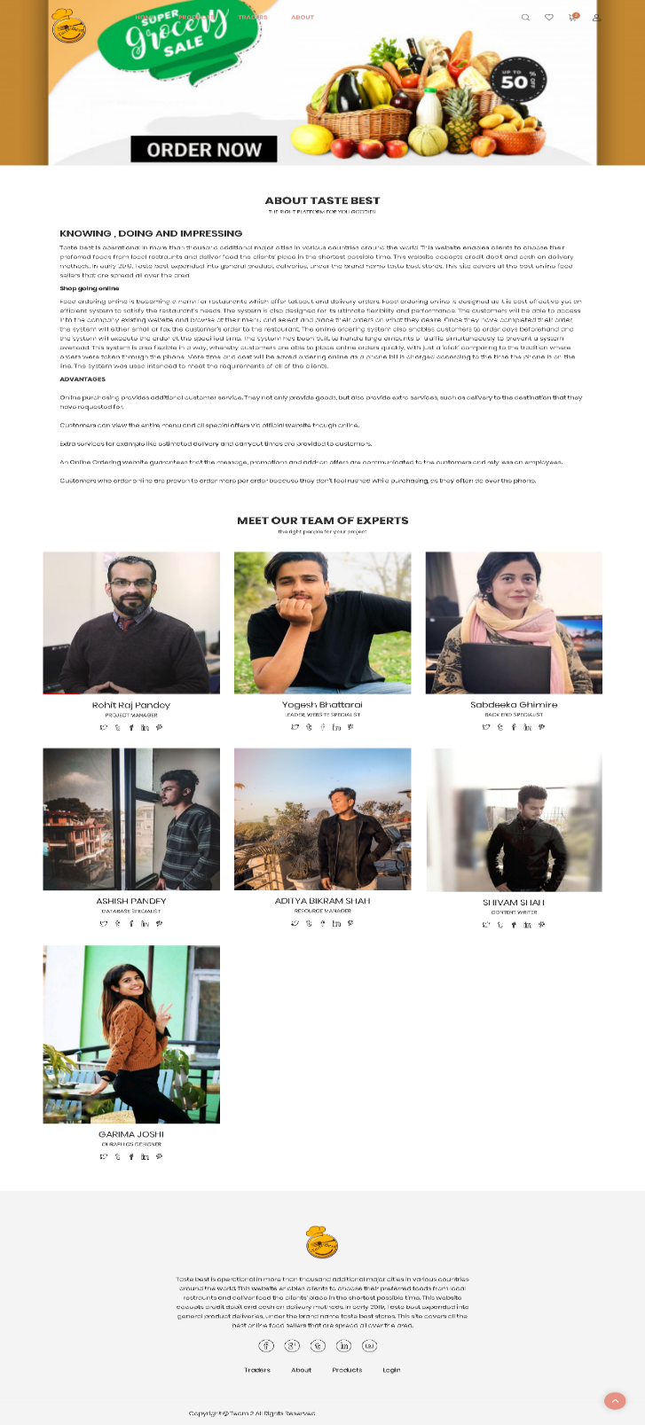

22. Customer can access my account page from navigation bar where they will be able to edit their profile by clicking on edit account button.

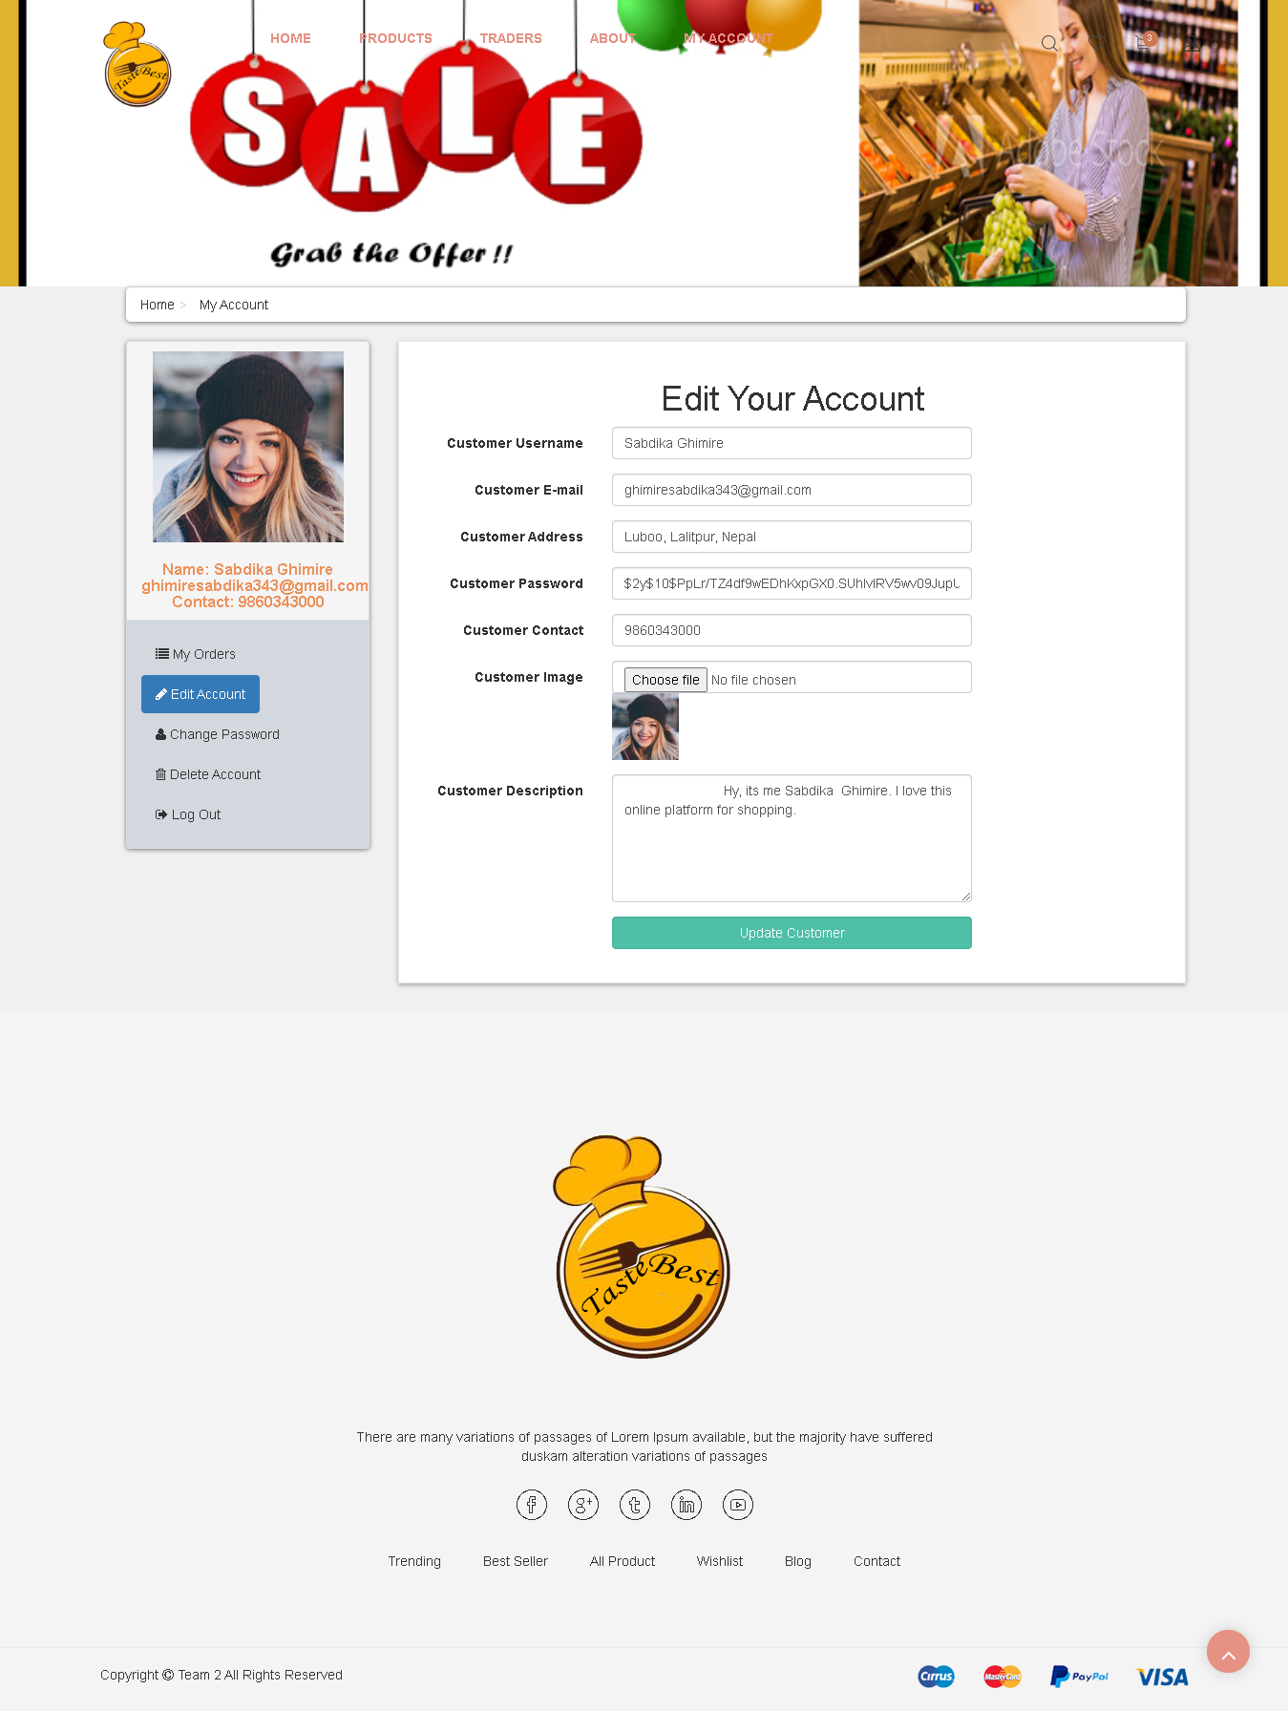

23. Similarly, clicking on my orders customer will able to see detail of their recent placed orders from where customer can access invoice by clicking on view invoice button.

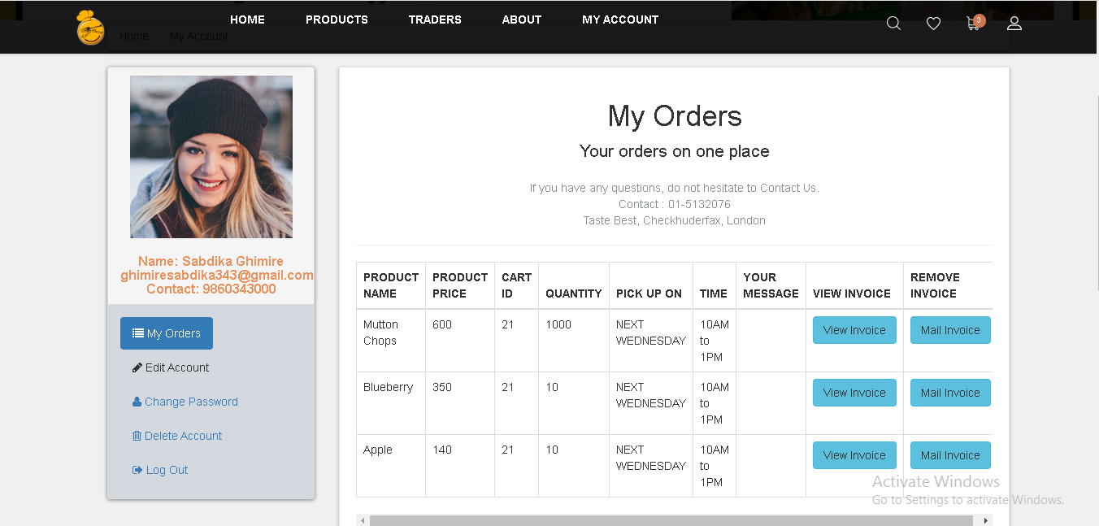

24. Customer also have access to deactivate their account from my account page by clicking on deactivate account.

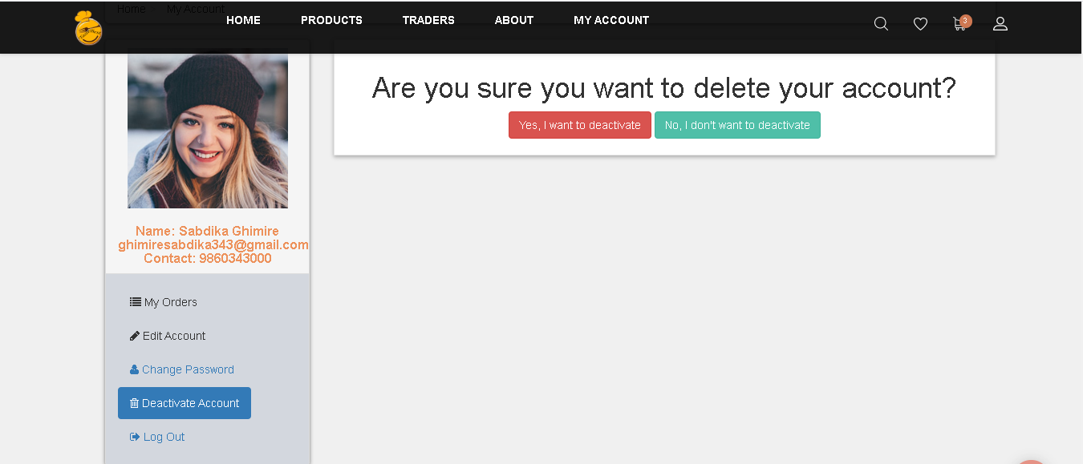

25. After clicking on ‘yes, I want to deactivate’ button customer will be redirected to log in page. As the account is deactivated customer cannot access and so in order to activate again ‘ACTIVATE_AGAIN’ should be keep in the field and clicking on activate button will again activate the customer account.

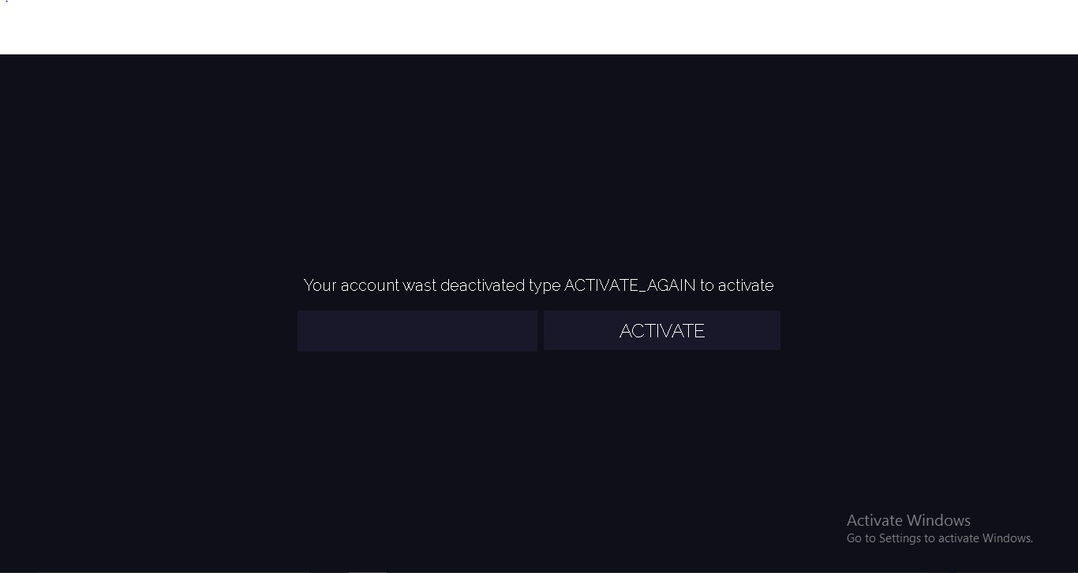

26. Clicking in Log Out in my account page customer will proceed to the next page where red ‘Logout’ button will help customer to log out and customer can only view login and registration page.

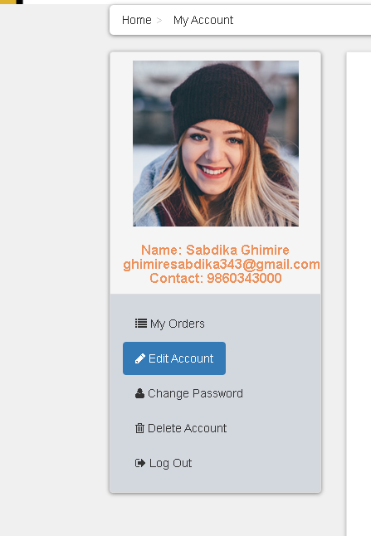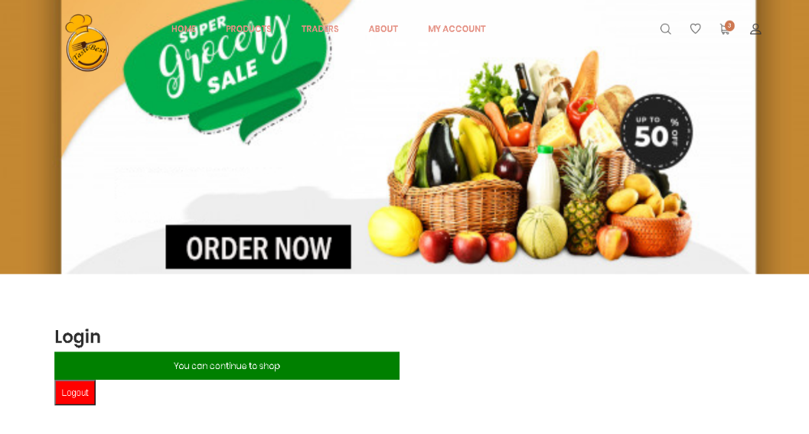

**Guideline of Apex interface (ADMIN)**

1. Admin can access the oracle by login with valid username and password.

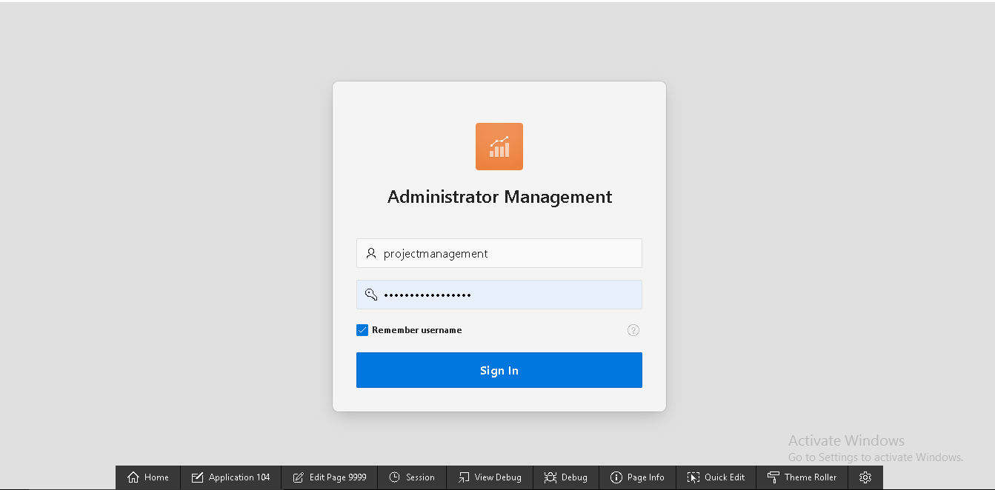

1. After log in, admin will go on the homepage of administrator management where admin can access review details, user details, shop, products, order and dashboard.

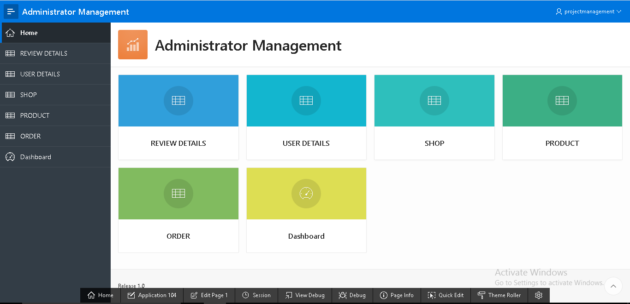

1. Clicking on “Dashboard” tab admin will be able to see the details of bar graph and chart of product max stock and product price.

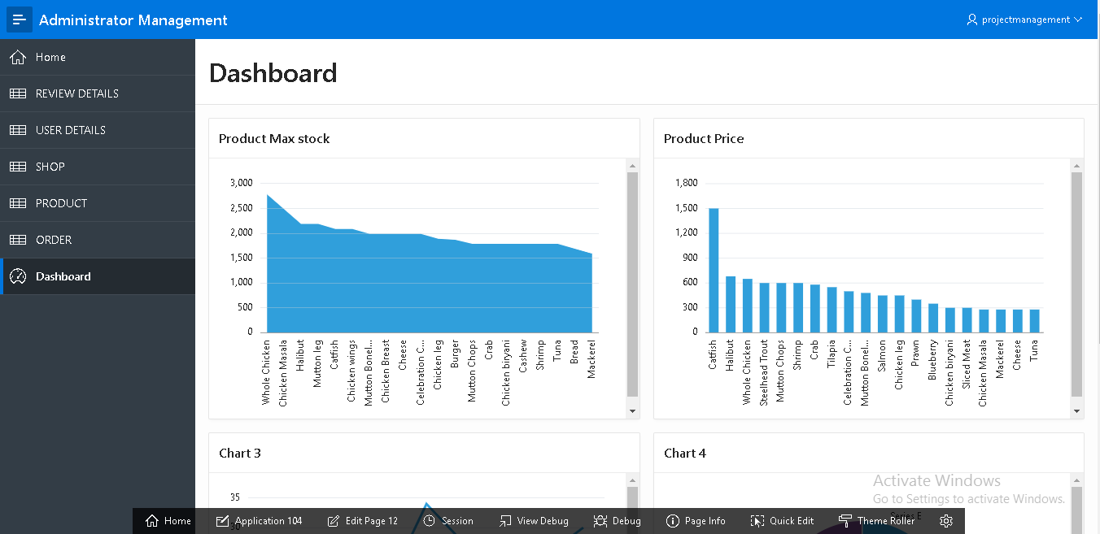

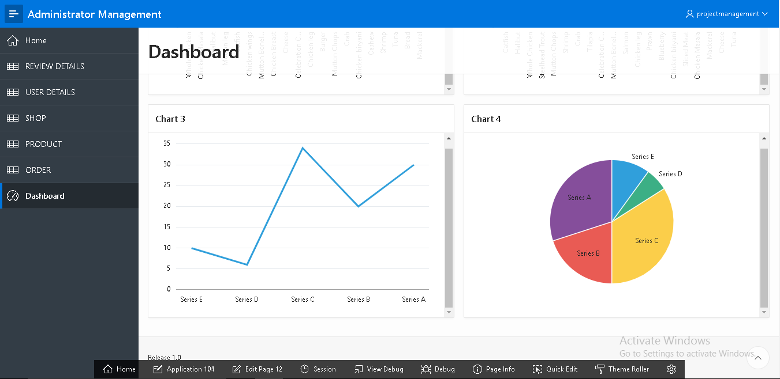

1. Similarly, admin can access details of reviews by clicking on “REVIEW DETAILS” tab.

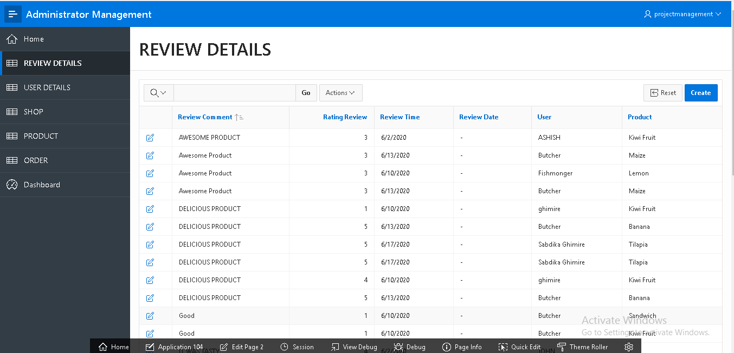

1. On clicking “USER DETAILS” admin can view the detail information of user and user type. Likewise, admin can access data of every tab.

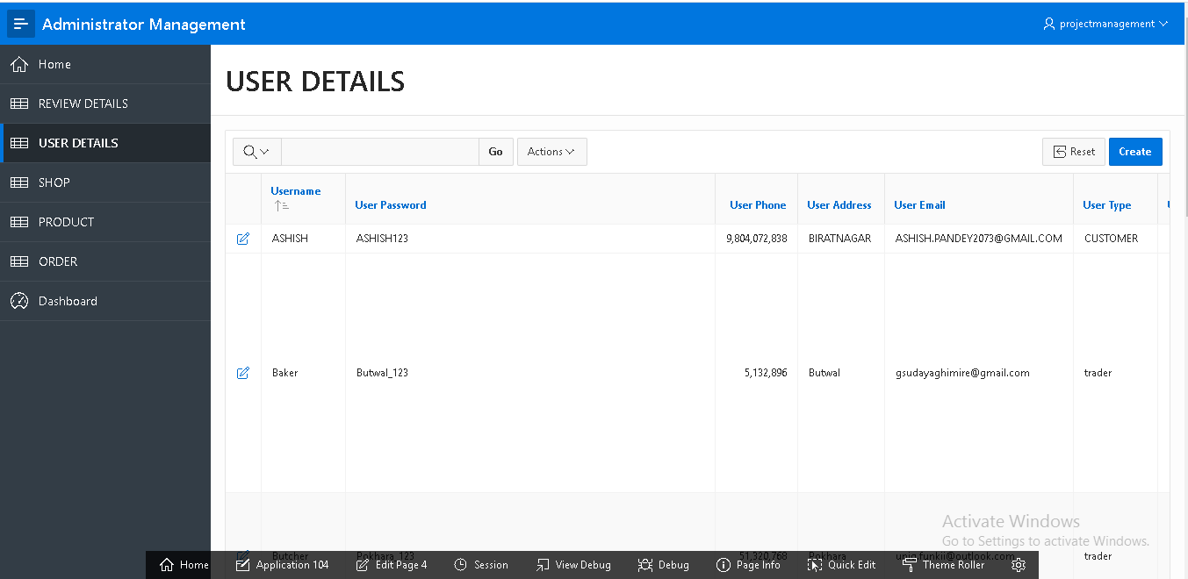

1. Admin have access to insert a shop by going on “SHOP” and filling required field in the form and clicking on “Create” button a new shop will be created.

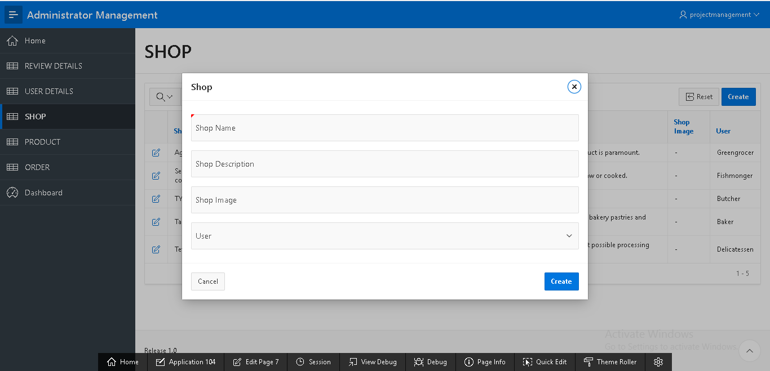

Similarly, admin have access to insert a product, order, user and reviews.

1. Admin can update product and its details by editing any field in the “Product” form. After clicking on “Apply Changes” button product will be updated.

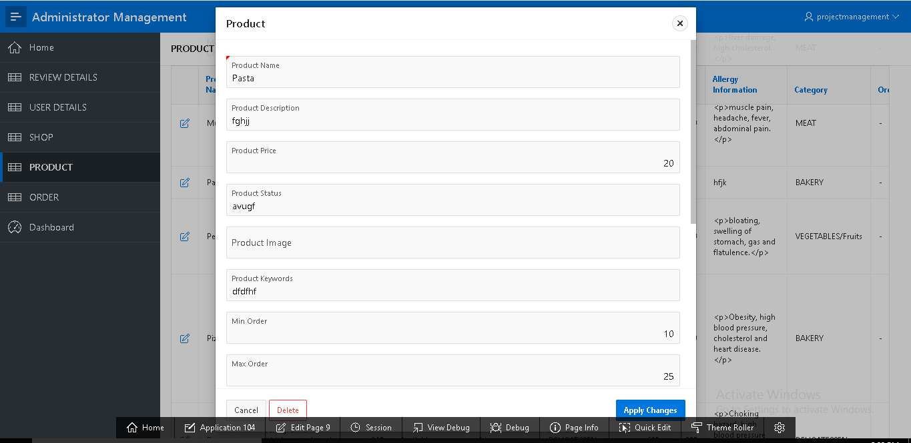

Admin have access to edit reviews details, shop, order and user.

1. Admin can delete specific review details by clicking on “REVIEW DETAILS” tab and opening detail of review and after clicking on “delete” button message will appear and if “OK” button is clicked then review will be deleted.

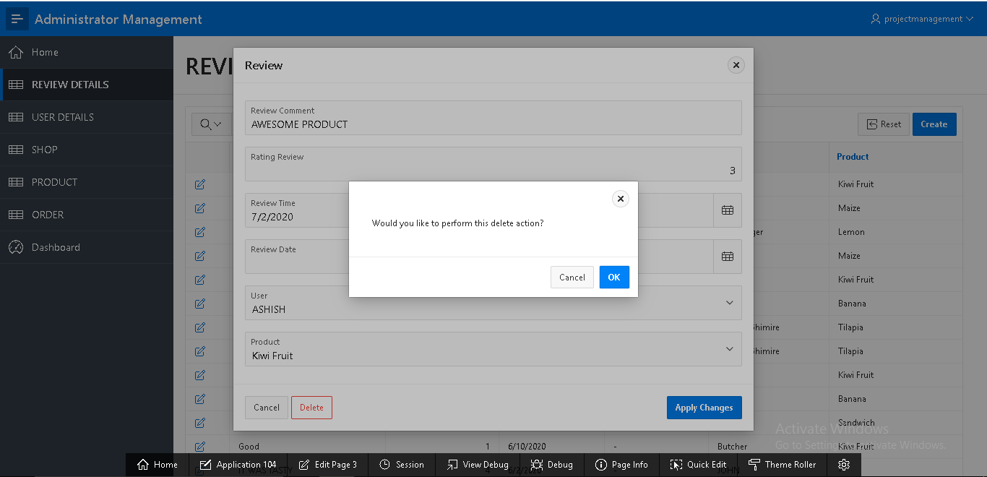

Likewise, admin have authority to perform delete action on user, shop, products and order.

1. Admin can view weekly report and monthly report of order by clicking “ORDER” tab. After clicking orders tab the weekly reports are displayed in “WEEKLY REPORT” tab and monthly reports “MONTHLY REPORT” tab as below.

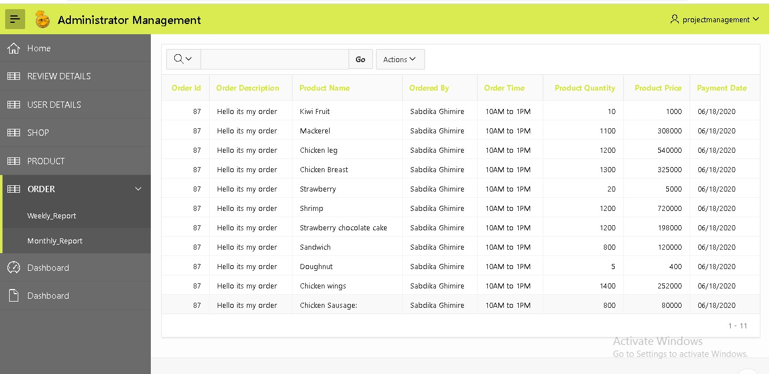



1. In order to sign out admin can click on top right corner in the username a “Sign Out” will pop up after clicking on it admin will sign out from oracle.

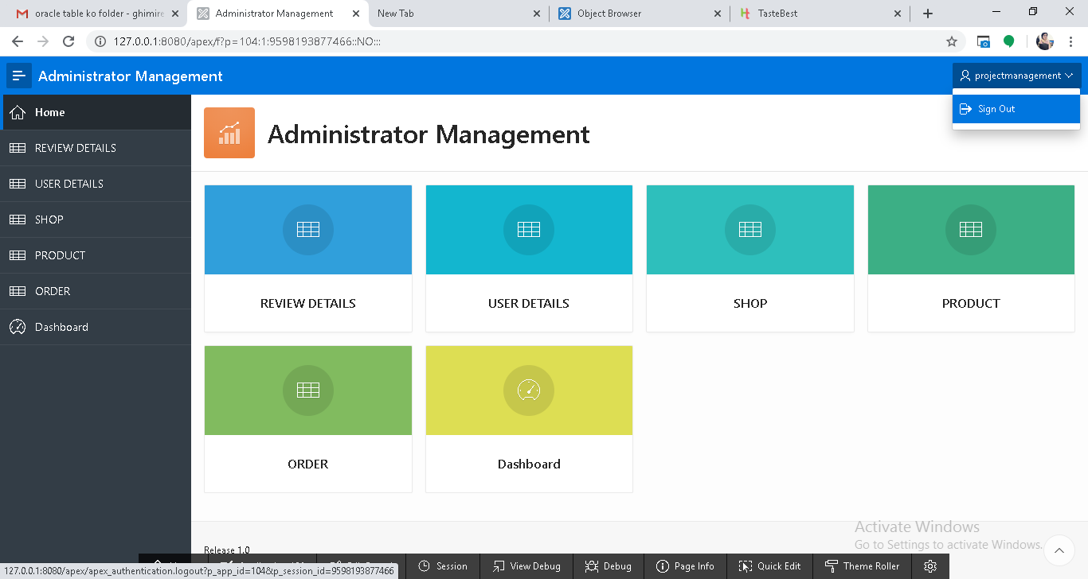

**Guideline of Apex interface (Trader)**

1. Trader can access the oracle by login with valid username and password.

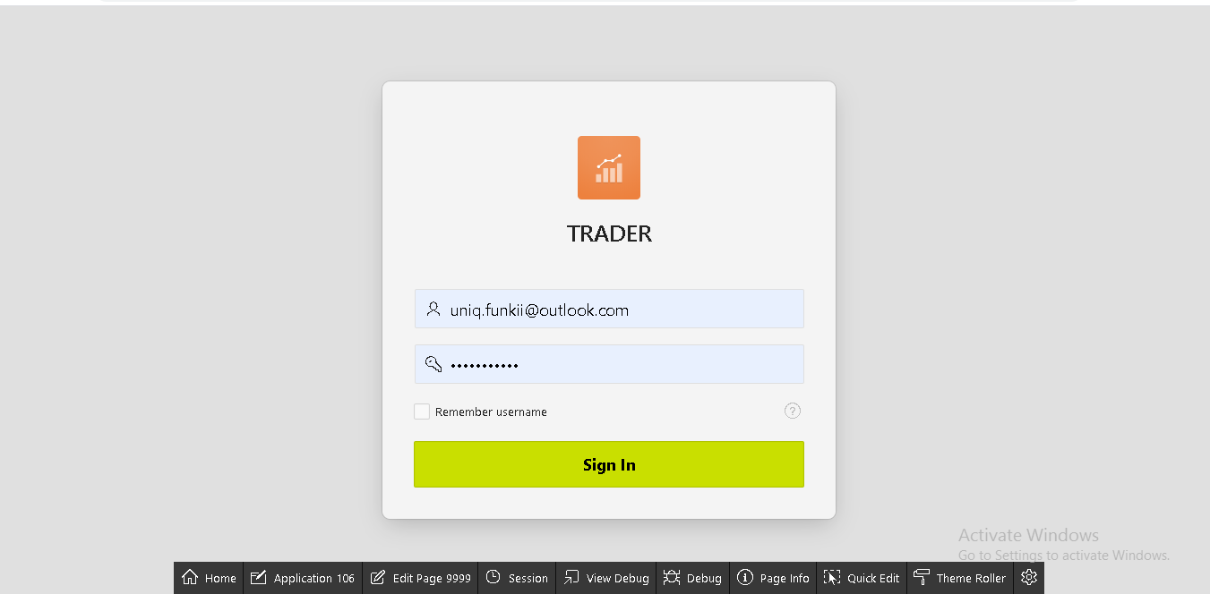

1. Clicking on ‘Shop detail’ gives the clear view about the trader and the shop related to the trader

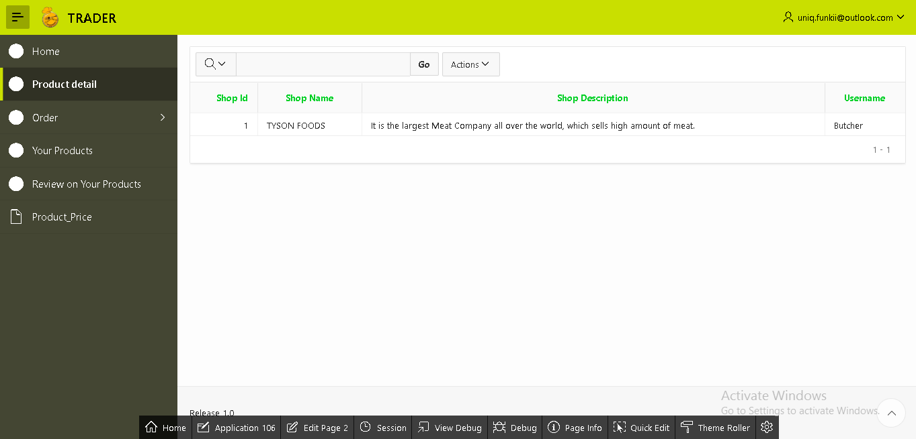

1. Similarly, clicking on Order generates the drop down options for weekly and monthly report of orders by the customer.

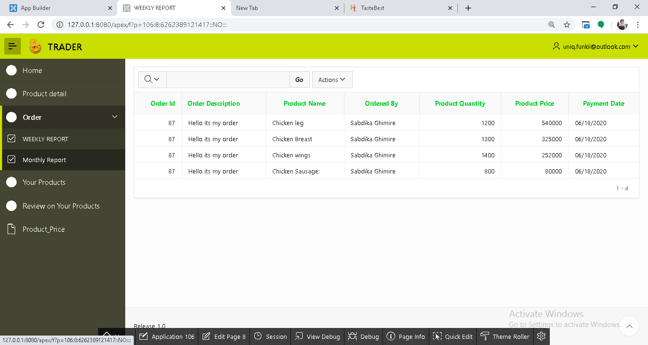

Monthly report

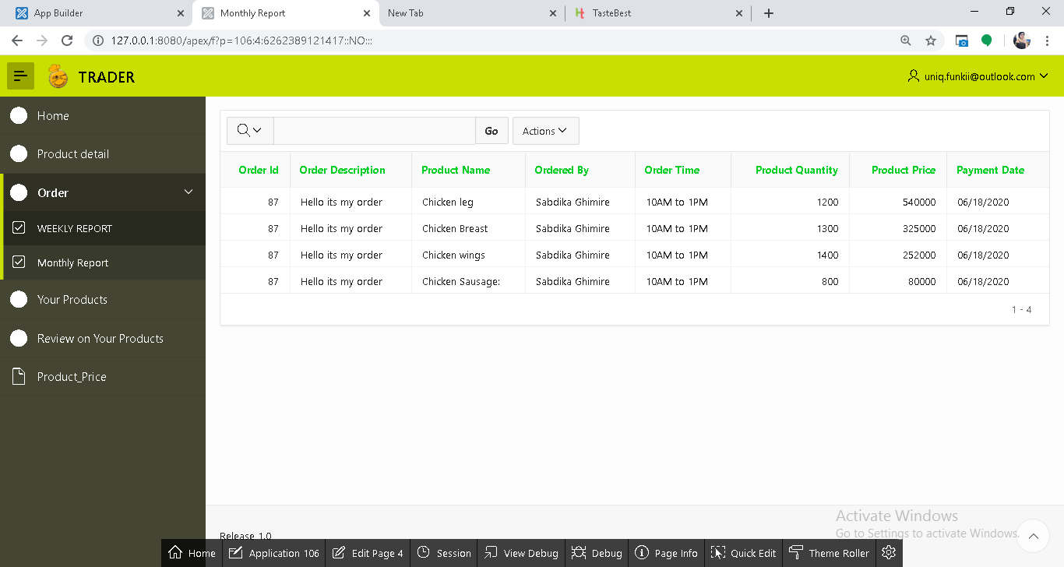

Weekly report

1. Clicking on ‘Your Products’ views the detail information table about product related to the respective trader.

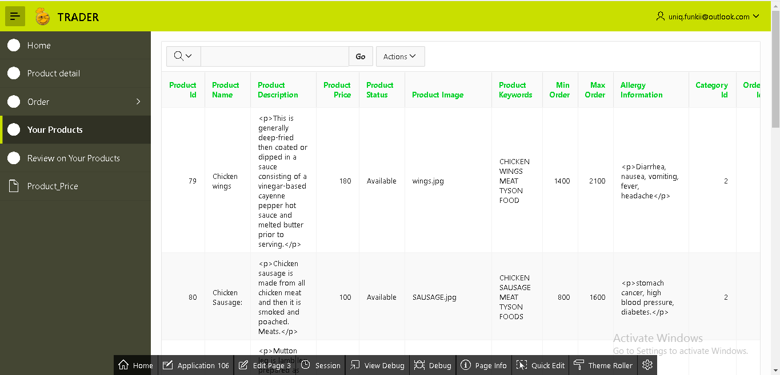

5. Similarly, clicking on ‘Review on your Products’ views the comment passed by customers on the products.

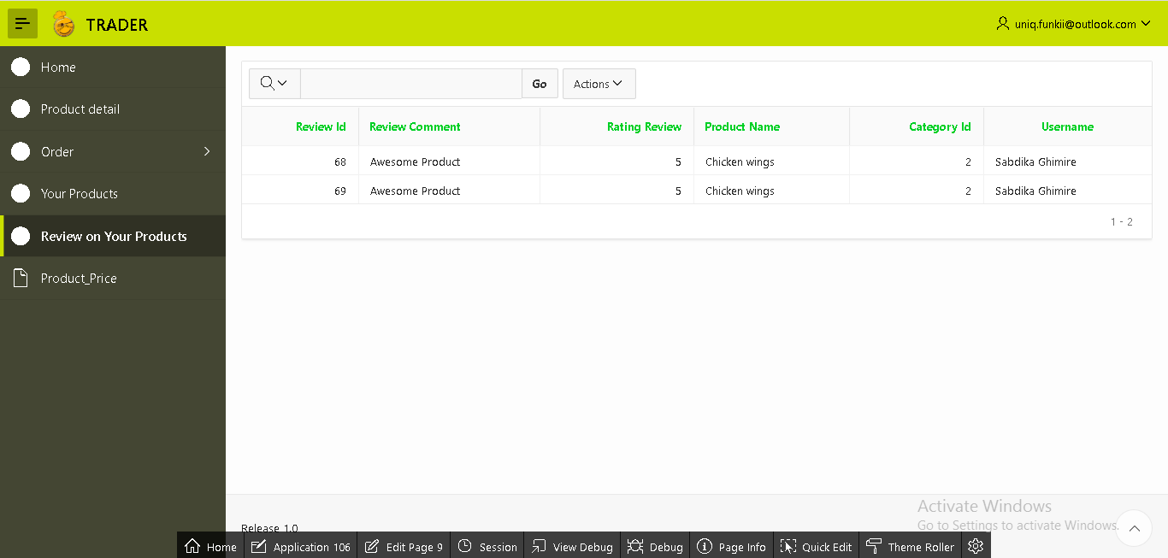

6. As well as, if you select ‘Product_Price’ in this interface it will show the bar diagram about the price of product which helps to remember which product is expensive and which is not.

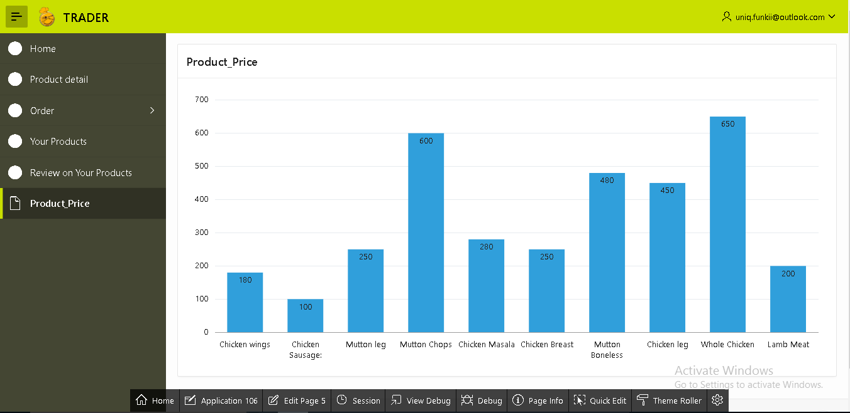

7. Lastly, the sign out option is on the top right side of the page through which trader can sign out their account.

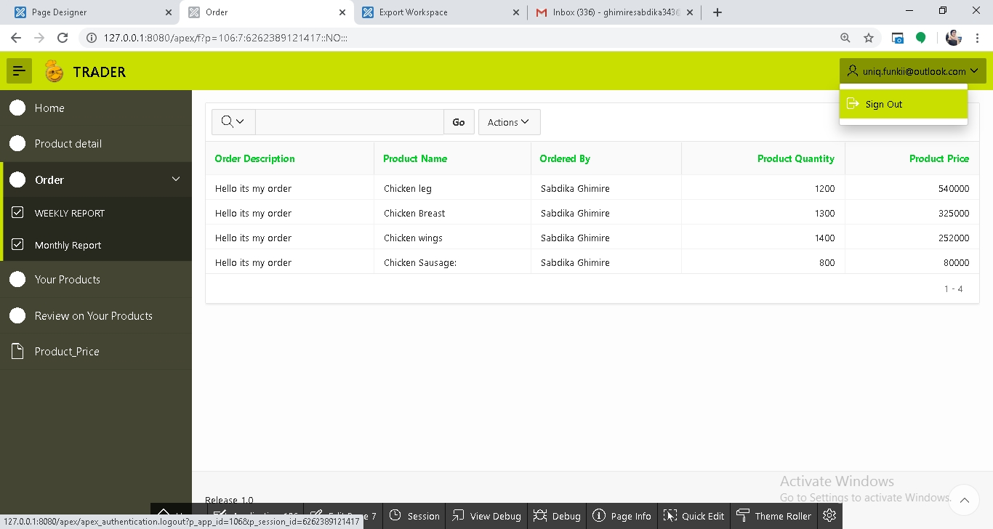

**Taste Best Installation Guide**

1. Install XAMPP program

In order to download the XAMPP visit the link given below

<https://www.apachefriends.org/download.html> then you can download XAMPP for Windows (64 bit). You have to select PHP 7.2.3 version, then the file will be begin to download automatically.

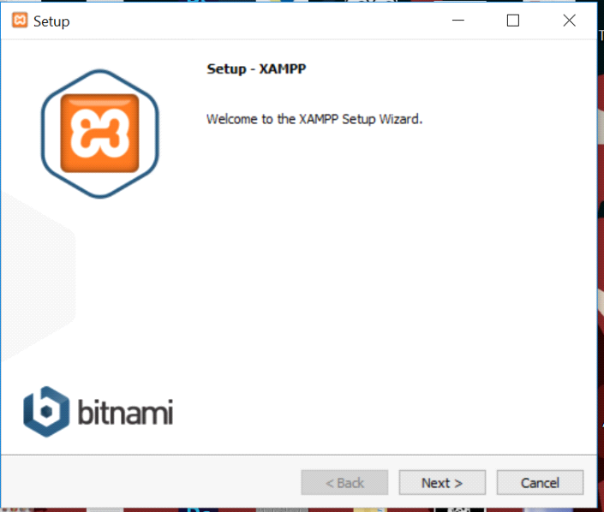

Click Next…

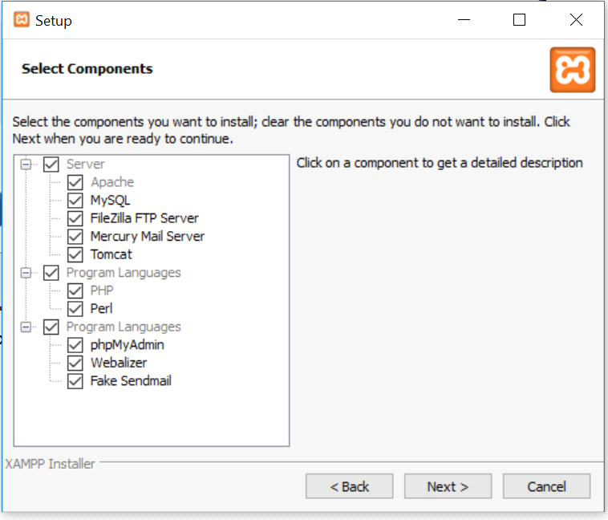

Choose the default selected checkboxes and click on Next….

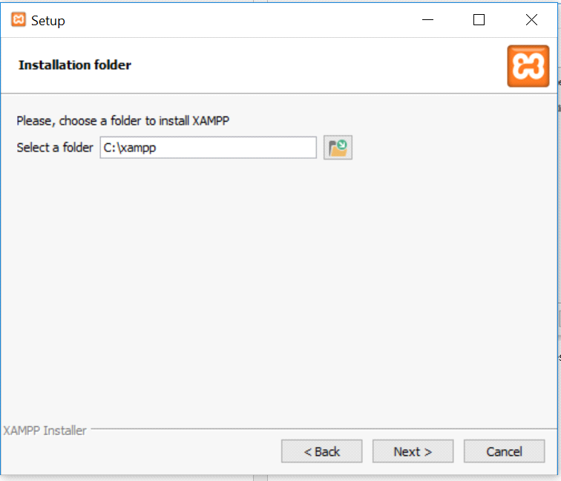

Install in C:\xampp and click Next…..

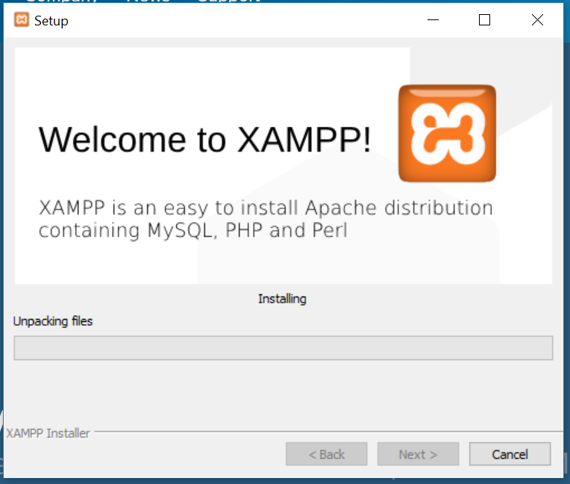

wait for the installation to complete

After installation process is completed open XAMPP and start apache server to test.

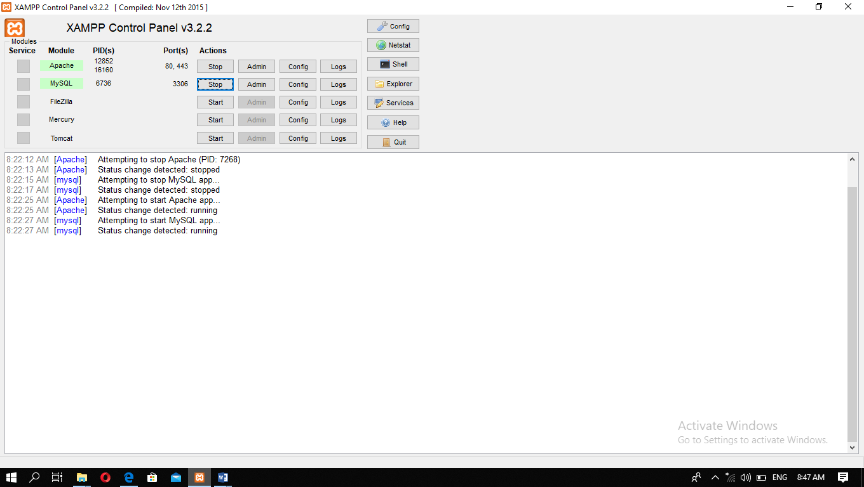

2. Install Oracle Database

Please visit the link given below to download:

<https://www.oracle.com/tools/downloads/apex-downloads.html>

And select Oracle Database Express Edition 11*g* Release 2 for Windows x64

Click on the setup file .

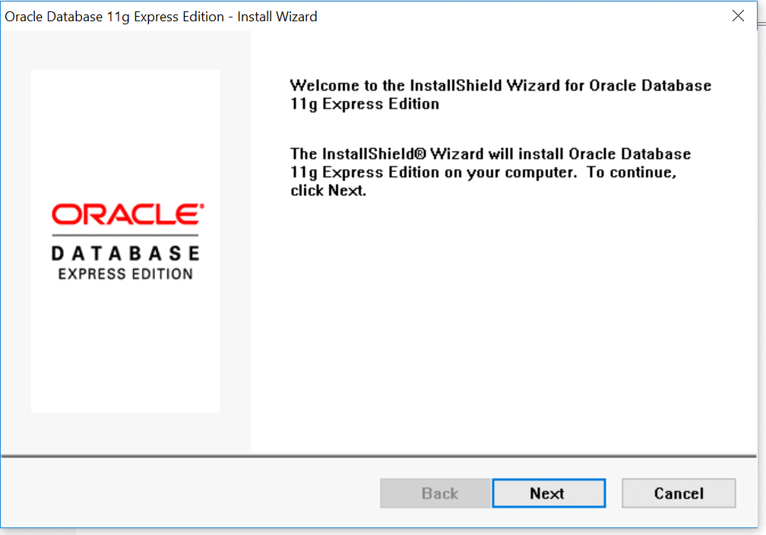

Click Next…..

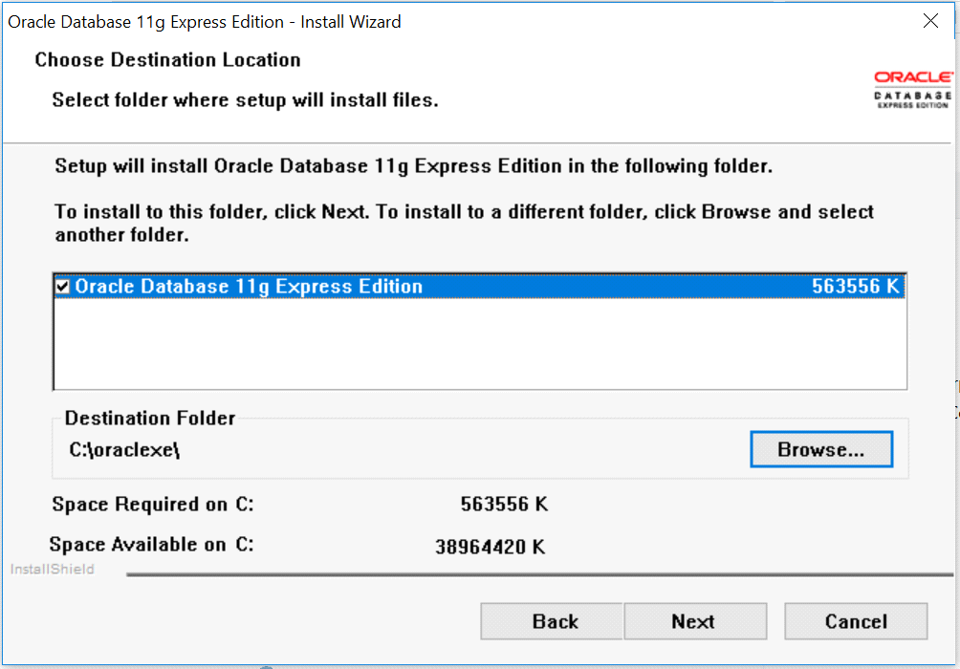

Browse to the directory you want to install and then click next.

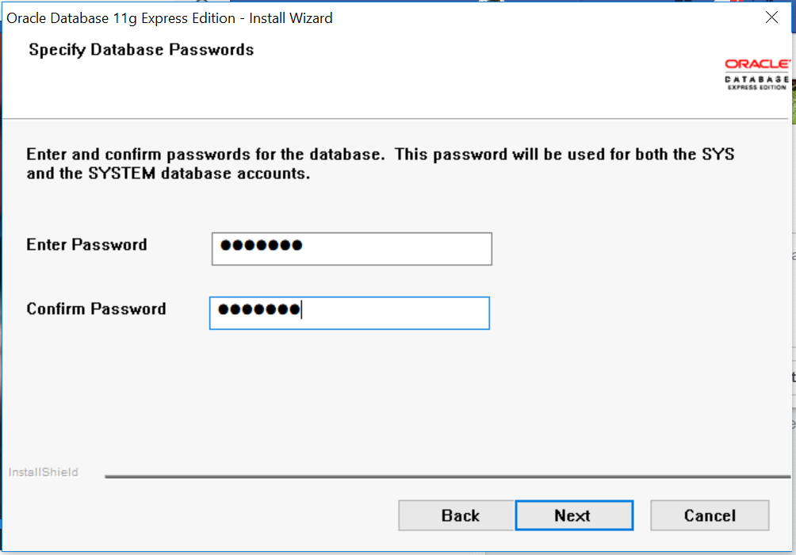

Set the password to confirm and proceed.

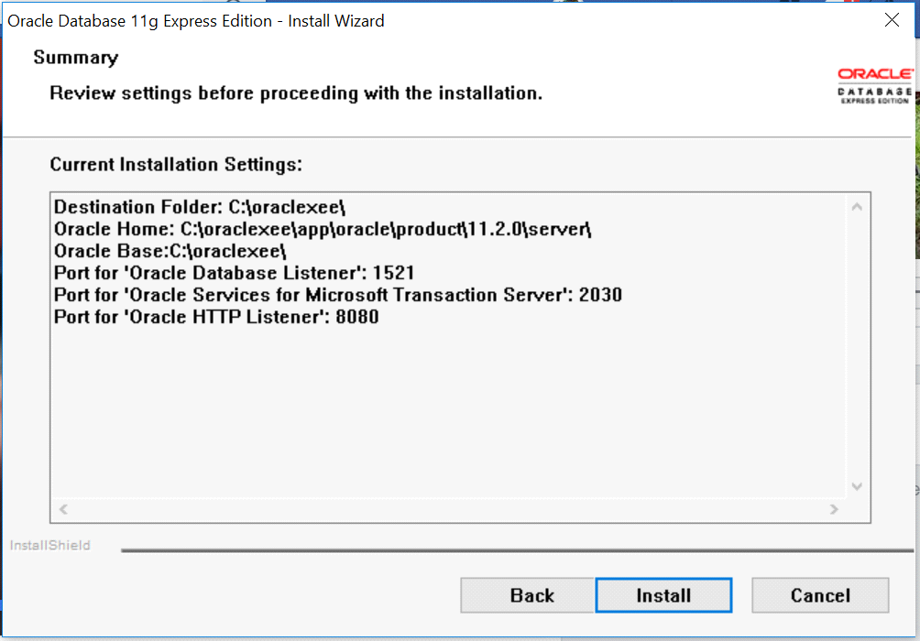

Click on Install…….

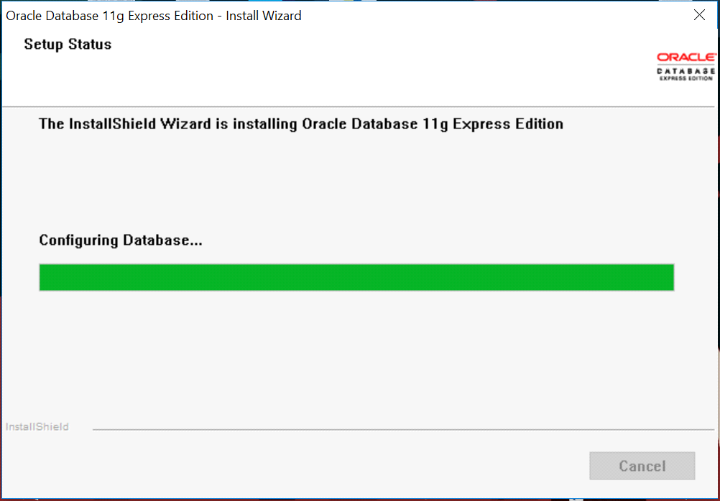

Wait for installation process to complete.

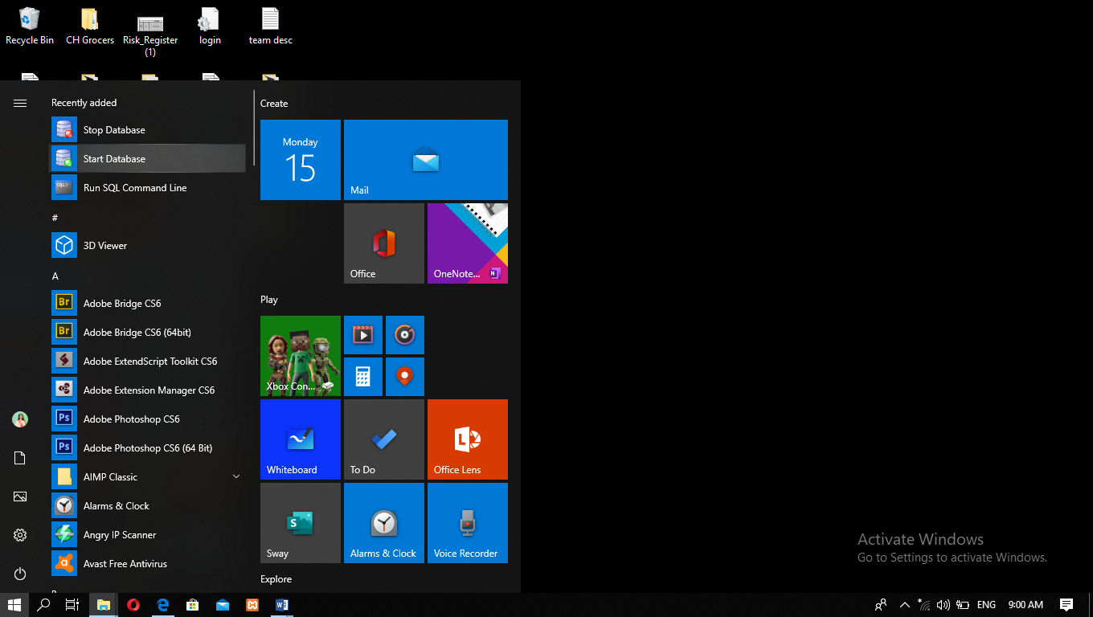

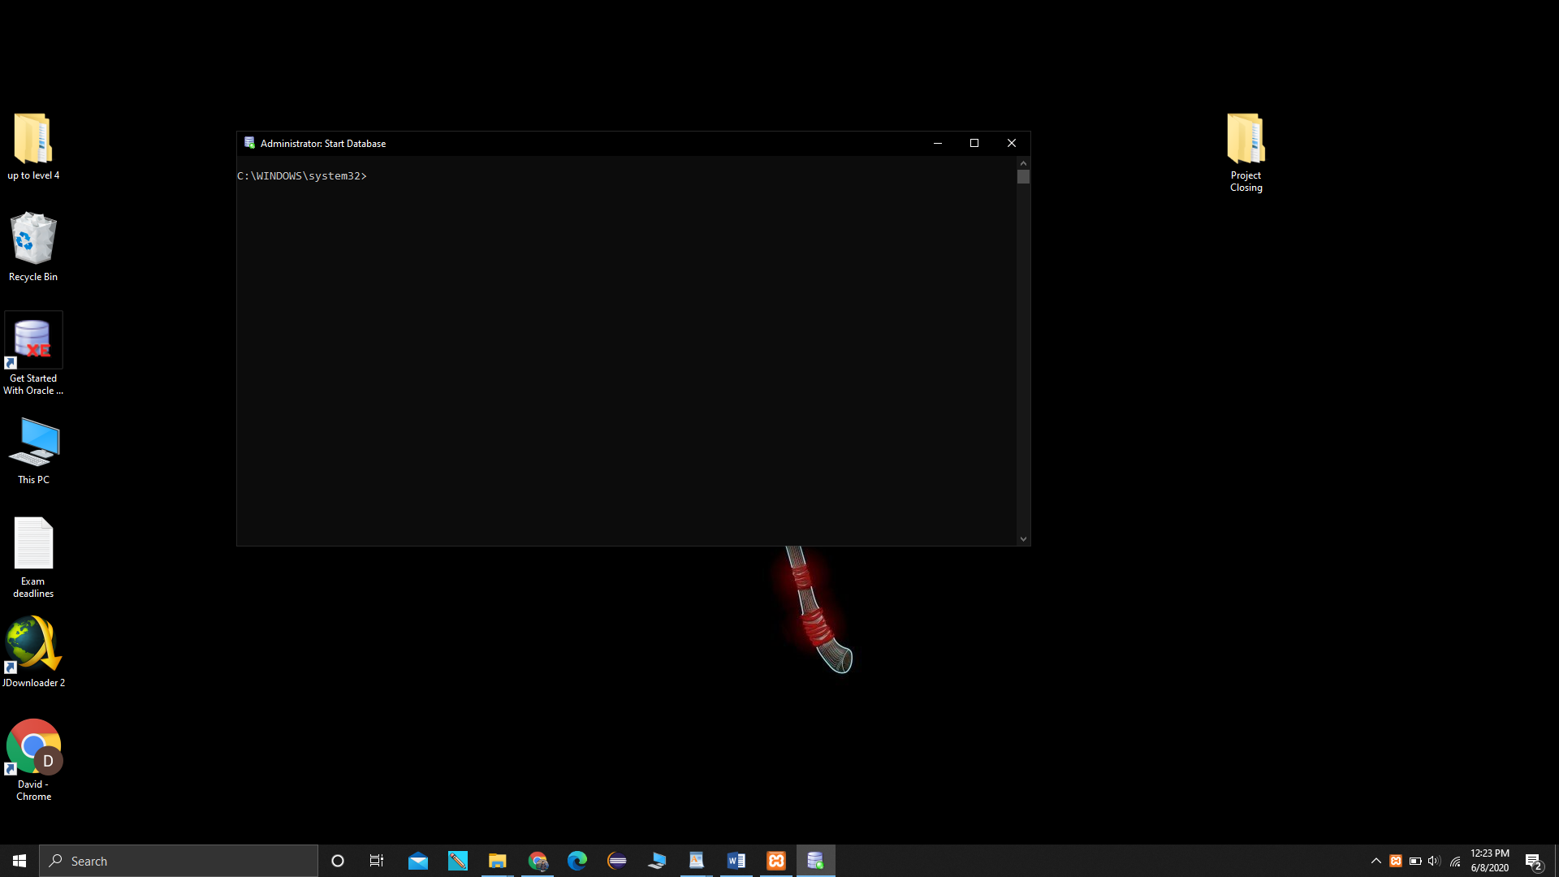

Close the Command prompt after this shows on the screen.

Then, open any browser you like and go the link given below:

[**http://127.0.0.1:8080/apex/f?p=4950:1:1204799924348321:::::**](http://127.0.0.1:8080/apex/f?p=4950:1:1204799924348321:::::)

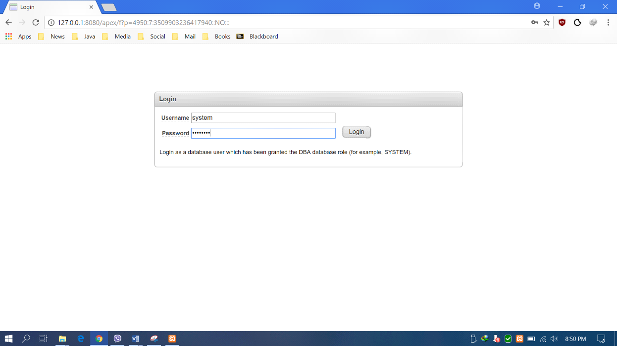

Enter username: hello

Enter password: hello1234

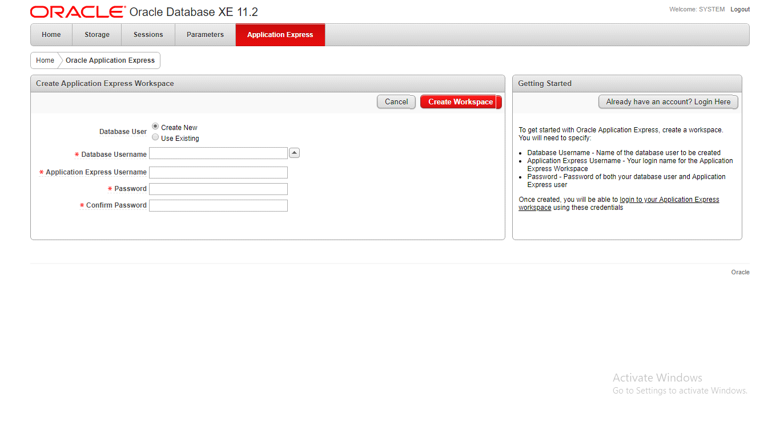

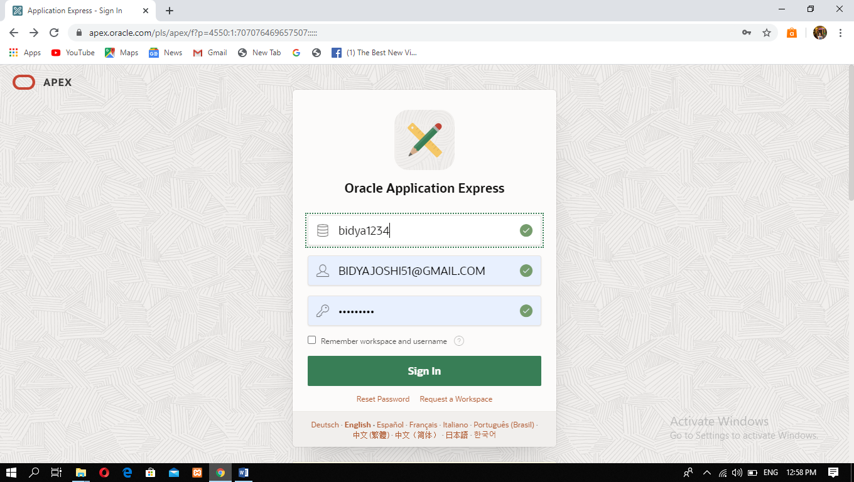

Click here to login.

Workspace name: bidya1234

Use your password: british1234

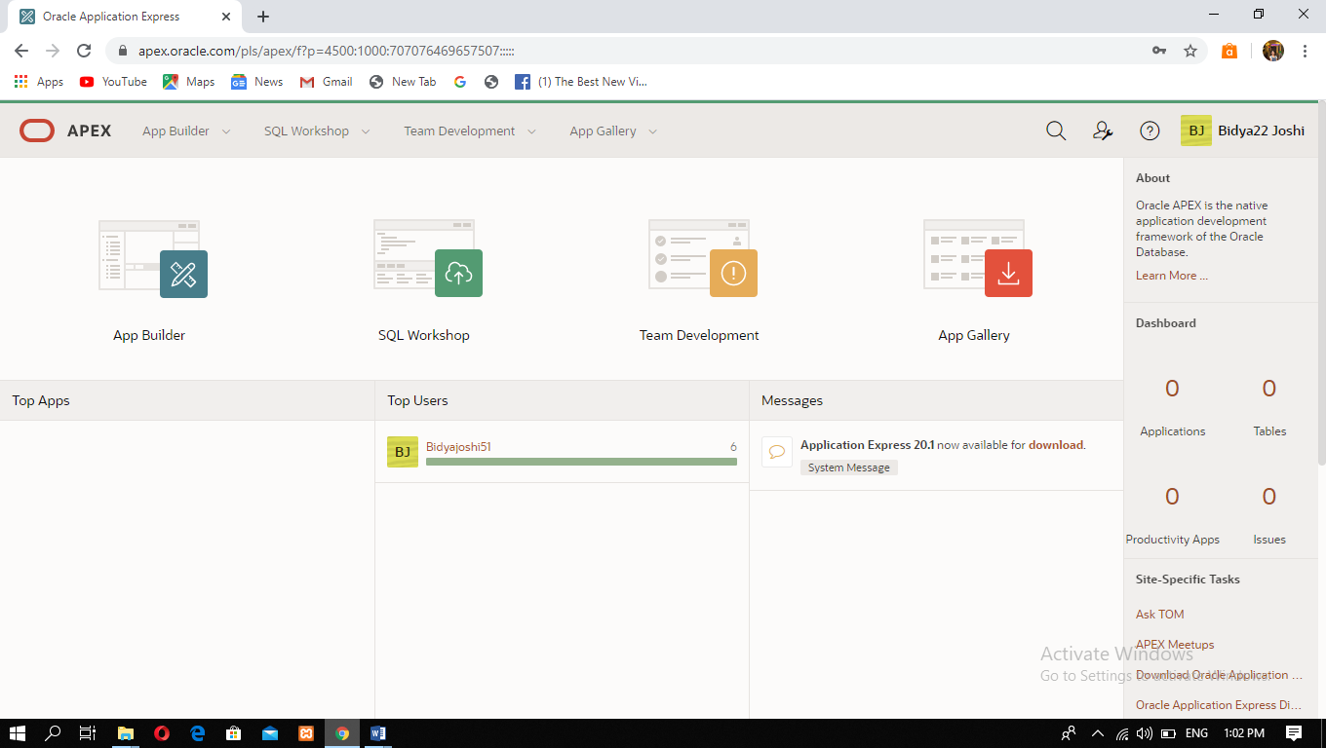

This is the home page of oracle apex.

**Thank you !!!**